Disney Shares Its Six Ingredient Recipe For Storytelling Success As The Company Looks To The Future
By Megan duBois, Forbes, Sep 23, 2024
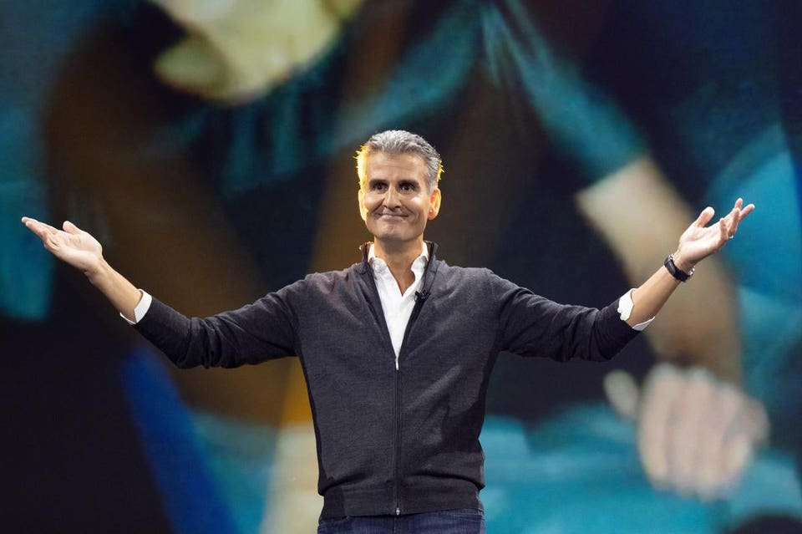
D23 EXPO 2022 - The Ultimate Disney Fan Event presented by VISA - brings together all the worlds of Disney under one roof for three packed days of presentations, pavilions, experiences, concerts, sneak peeks, shopping, and more. The event, which takes place September 9, 10, and 11 at the Anaheim Convention Center, provides fans with unprecedented access to Disney films, series, games, theme parks, collectibles, and celebrities. (The Walt Disney Company via Getty Images) Josh D'Amaro (Chairman, Disney Parks, Experiences and Products)
The Walt Disney Company is known for excelling at storytelling. From its long lineage of movies to its theme parks, telling stories is the core of everything Disney does. During a recent speech at the INBOUND conference in Boston, Massachusetts, Josh D’Amaro, Chairman of Disney Experiences at The Walt Disney Company, shared Disney’s six steps for storytelling success.
On the heels of the overload of Disney Experiences announcements that came out of D23: The Ultimate Disney Fan Event in August, D’Amaro’s INBOUND presentation touched on what he called, “the how” of Disney creating new experiences for parks fans. Over the past 70 years, 4 billion people have walked through a gate at a Disney park around the world and the expectations about what Disney delivers are high. He stated that the company “absolutely has to get this right.”
Ingredient One: Emotional Connection
Disney thrives on making emotional connections with its fans. Whether that’s at the theme parks as guests hug Mickey Mouse for the first time, or whether that’s while a family is watching a new Disney movie. D’Amaro says that when they bring movies that the Disney-owned studios create into the theme parks, “it’s amazing.”
It’s also notable that parents pass their own Disney memories down to their children, making a full lineage of Disney fans, all because of emotional connections to characters from a movie or a theme park attraction.
Ingredient Two: Innovation
“Do you know what innovation is driven by?” D’Amaro asks. “It’s curiosity and you can trace this thread through Disney’s entire history,” he says. The fact that Disney continues to push itself to create bigger and more technological theme park attractions is a testament to this. When Tiana’s Bayou Adventure opened at Walt Disney World’s Magic Kingdom, it was the first time that a domestic theme park would utilize next-gen Audio-Animatronics that move and speak in an almost hyper-realistic way thanks to the programming and engineering that go into each figure.
Ingredient Three: Relatability
“Our audience needs to see themselves in our stories, or they need to see who they aspire to be,” says D’Amaro. Disney Experiences employs about 180,000 people, and each of them has an impact on the guest experience. Many times, these guest experiences get shared on social media and go viral. Not only does this further the relatability of a Disney story or in-park experience, but it also showcases the impact of Disney stories where people are willing to share a video or photo millions of times, creating buzz for the theme parks organically.
Ingredient Four: Attention to Detail
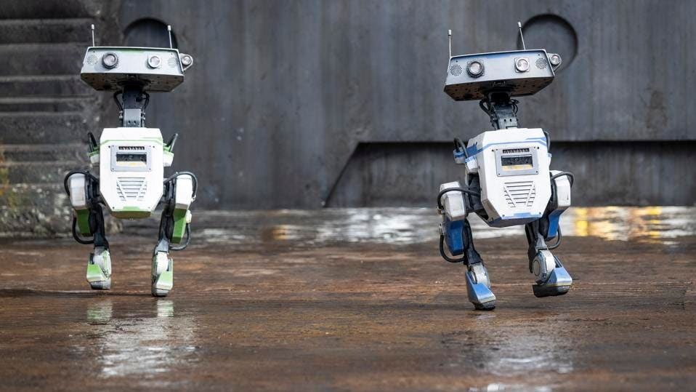
ANAHEIM, CA - April 05: The new droid BDX makes an appearance during Star Wars Season of the Force at Disneyland in Anaheim, CA on Friday, April 5, 2024. Season of the Force is an annual event that celebrates all things Star Wars, including themed attractions, food offerings and merchandise, at Disneyland.

This may be the most important ingredient when it comes to new attractions and lands at a Disney park. Details make the difference to make people believe in the make-believe. One example of this is inside Star Wars: Galaxy’s Edge at Walt Disney World and Disneyland. Within the land, there are two major attractions, but there’s also a lot of space to walk around and enjoy food, drinks, merchandise and more. One of the coolest details of the land is some droid tracks, which are actually made by the original R2-D2 droid from the Star Wars films.
Now Disney is bringing even more detail into the land with one of Imagineering’s newest innovations, a BDX droid. The robots started as an experiment, but are fully immersive with an incredible range of movement showcasing how robots can be emotive. During play testing with Walt Disney Imagineers, the droids have the chance for guests to interact with them, furthering the Star Wars story and place-making.

Ingredient Five: Courage
“Imagineers are constantly taking big swings at ideas even if they aren’t quite sure how they are going to pull them off,” says D’Amaro. With Walt Disney Imagineering, courage comes in all forms, whether it’s standing up for a new idea in a meeting or showing a new robot that’s going to fly above someone’s head in a theme park.
Ingredient Six: Boundless Thinking
According to D’Amaro, Disney is always looking ahead to the next big challenge. “We want to be boundless in our thinking as a tribute to our past,” he says.
How storytelling impacts the future
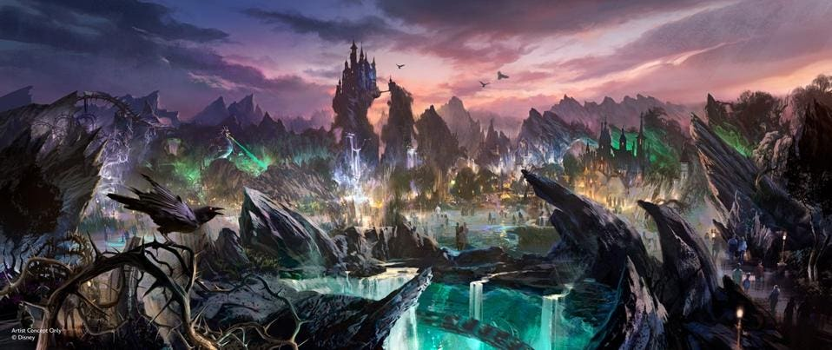
The new Villains Land coming to Magic Kingdom will feature fan-favorite Disney Villains from popular Walt Disney Animation Studios films and two new attractions.

As Disney looks forward to its next challenge and its next big anniversary, it’s got a lot to live up to. Fans and investors are expecting big things, and like D’Amaro said, the company has to get every step right.
One announcement that Disney fans can’t seem to get over is the new villains-themed land coming to Magic Kingdom. The space will be an expansion to the park and feature rides and more all themed to Disney baddies. The overwhelming amount of applause at D23: The Ultimate Disney Fan Event when this was announced showed that this announcement was a big one.
While some of these announcements were received well, some were not. One example of this is a new Cars-themed area coming to Magic Kingdom. This was also announced at D23: The Ultimate Disney Fan Event earlier this year. During the Disney Experiences panel, it wasn’t said where this new land would go. Then the other shoe dropped, and it was announced that it would be taking over the park’s Rivers of America and Tom Sawyer Island. The feedback from fans on the internet was almost instant, and it wasn’t generally positive.
Over the next decade, Disney will spend $60 billion in expansions to the Disney Experiences portfolio, including a handful of new cruise ships, a complete overhaul of Walt Disney Studios Park at Disneyland Paris, the expansion of Avengers Campus at Disney California Adventure Park at the Disneyland Resort and the unveiling of its first Audio-Animatronic figure of Walt Disney at Disneyland Park.
For Disney, these new experiences will come to life in a multitude of ways. At the center of each will be a central story that every guest can connect with, and that’s a superpower that Disney can continue to wield for decades to come.

Hidtil uset
Samlerobjekter
Udmærke sig
Kort efter
Bekendtgørelse
Slægt
Bevis
Dyrelignende robotter
Stræbe efter
Organisk
Medrivende
Følelsesladet
Promovere
An imagineer is a person who combines imagination and engineering to turn creative ideas into innovative, practical designs.
Grænseløs
Modtaget
Grundigt eftersyn
Udvidelse
Afsløring
Anvende

