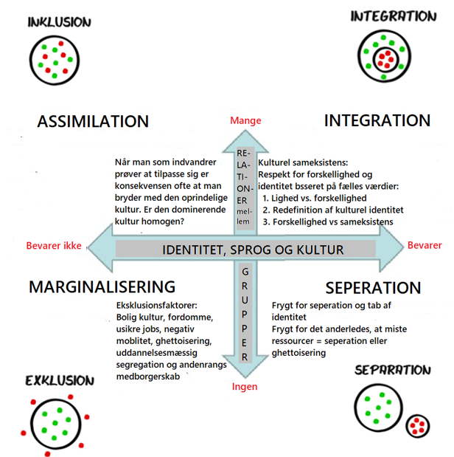

**Berrys akkulturationsmodel**

|  |  |  |
| --- | --- | --- |
|  | Fastholde egen kultur | Nedtone/fravælge egen kultur |
| Positiv over for majoritetskulturen | **INTEGRATION** | **ASSIMILATION** |
| Negativ over for majoritetskulturen | **SEPERATION** | **MARGINALISERING** |

