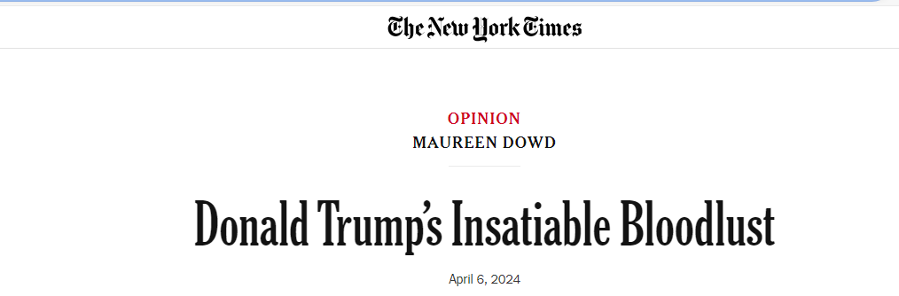
Opinion | Donald Trump’s Insatiable Bloodlust - The New York Times (nytimes.com)
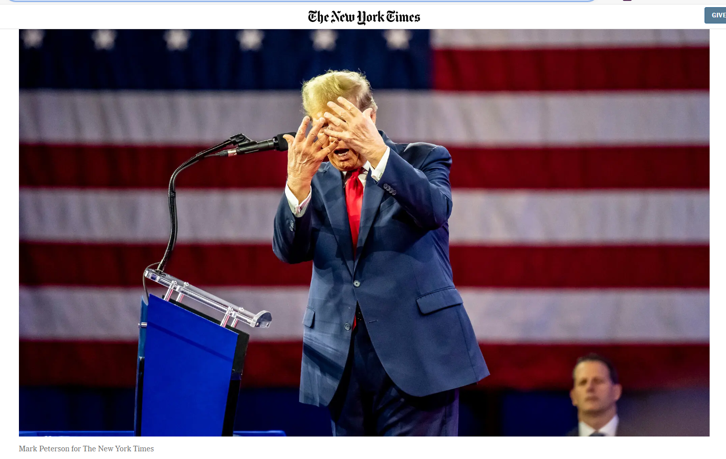
An earthquake. An eclipse. A bridge collapse. A freak blizzard. A biblical flood. Donald Trump leading in battleground states.
Apocalyptic vibes are stirred by Trump’s violent rhetoric and talk of blood baths.
If he’s not elected, he bellowed in Ohio, there will be a blood bath in the auto industry. At his Michigan rally on Tuesday, he said there would be a blood bath at the border, speaking from a lectern with a banner reading, “Stop Biden’s border blood bath.” He has warned that, without him in the Oval, there will be an “Oppenheimer”-like doomsday; we will lose World War III, and America will be devastated by “weapons the likes of which nobody has ever seen before.”
“And the only thing standing between you and its obliteration is me,” Trump has said.
An unspoken Trump threat is that there will be a blood bath again in Washington, like Jan. 6, if he doesn’t win.
That is why he calls the criminals who stormed the Capitol “hostages” and “unbelievable patriots.” He starts some rallies with a dystopian remix of the national anthem, sung by the “J6 Prison Choir,” and his own reciting of the Pledge of Allegiance.
The bloody-minded Trump luxuriates in the language of tyrants.
In “Macbeth,” Shakespeare uses blood imagery to chart the creation of a tyrant. Those words echo in Washington as Ralph Fiennes stars in a thrilling Simon Godwin production of “Macbeth” for the Shakespeare Theater Company, opening Tuesday.
“The raw power grab that excites Lady Macbeth and incites her husband to regicide feels especially pertinent now, when the dangers of autocracy loom over political discussions,” Peter Marks wrote in The Washington Post about the production with Fiennes and Indira Varma (the lead Sand Snake in “Game of Thrones”).
Trump’s raw power grab after his 2020 loss might have failed, but he’s inflaming his base with language straight out of Macbeth’s trip to hell.
“Blood will have blood,” as Macbeth says. One of the witches, the weird sisters, urges him, “Be bloody, bold and resolute.”
Another weird sister, Marjorie Taylor Greene, is predicting end times. “God is sending America strong signs to tell us to repent,” she tweeted on Friday. “Earthquakes and eclipses and many more things to come. I pray that our country listens.”
Like Macbeth, Trump crossed a line and won’t turn back. The Irish say, “You may as well be hanged for a sheep as a lamb.” Macbeth killed his king, then said: “I am in blood. Stepped in so far that, should I wade no more, returning were as tedious as go o’er.”
The Washington Post’s Josh Dawsey reported that since Trump put his daughter-in-law in charge of the Republican National Committee, prospective employees are asked if they think the election was stolen. Republicans once burbled on about patriotism and defending America. Now denying democracy is a litmus test for employment in the Formerly Grand Old Party.
My Irish immigrant father lived through the cruel “No Irish need apply” era. I’m distraught that our mosaic may shatter.
But Trump embraces Hitleresque phrases to stir racial hatred. He has talked about immigrants “poisoning the blood of our country.” Last month he called migrants “animals,” saying, “I don’t know if you call them ‘people,’ in some cases. They’re not people, in my opinion.”
Trump’s obsession with bloodlines was instilled by his father, the son of a German immigrant. He thinks there is good blood and bad blood, superior blood and inferior blood. Fred Trump taught his son that their family’s success was genetic, reminiscent of Hitler’s creepy faith in eugenics.
“The family subscribes to a racehorse theory of human development,” the Trump biographer Michael D’Antonio told PBS. “They believe that there are superior people and that if you put together the genes of a superior woman and a superior man, you get a superior offspring.”
Trump has been talking about this as far back as an “Oprah” show in 1988. The “gene believer” brought it up in a 2020 speech in Minnesota denouncing refugees.
“A lot of it is about the genes, isn’t it, don’t you believe?” he told the crowd about their pioneer lineage, adding: “The racehorse theory, you think we’re so different? You have good genes in Minnesota.”
As Stephen Greenblatt writes in “Tyrant: Shakespeare on Politics,” usurpers don’t ascend to the throne without complicity. Republican enablers do all they can to cozy up to their would-be dictator, even introducing a bill to rename Dulles Airport for Trump. Democrats responded by introducing a bill to name a prison in Florida for Trump.
“Why, in some circumstances, does evidence of mendacity, crudeness or cruelty serve not as a fatal disadvantage but as an allure, attracting ardent followers?” Greenblatt asked. “Why do otherwise proud and self-respecting people submit to the sheer effrontery of the tyrant, his sense that he can get away with saying and doing anything he likes, his spectacular indecency?”
Like Macbeth’s castle, the Trump campaign has, as Lady Macbeth put it, “the smell of blood,” and “all the perfumes of Arabia will not sweeten” it.

Tasks:
- The genre of this text is an opinion article. Find examples in the text that show that and include them with a reference to page and line number.
- On the first page of this article, the author, Maureen Dowd, argues that Trump often makes use of a specific rhetorical device that we worked with in class. Which one is it?

- Find the following in the article. Include line and page number for each example.
5 adjektiver | 5 substantiver | 5 verber | 5 pronominer | 5 præpositioner

- Use the rhetorical pentagram to analyse the opinion article.
- Obs. Husk at du skal kommentere på ’the intention’ – altså intentionen – hvorfor har forfatteren, Maureen Dowd skrevet denne artikel? Denne intention skal du supporte ved at bruge det retoriske pentagram. Du behøver ikke have alle 5 underområder med, men kan udvælge dem (f.eks. de to vigtigste) som bakker din påstand om intentionen op mest muligt.

