The Message vs. Fuck the Police

Vi skal lave en sammenligning af Melle Mels rap i The Message og Ice Cubes i Fuck The Police.

# The Message

Tekstuddrag - starten af 1. vers, fra ca. 0:43:

<https://www.youtube.com/watch?v=MLpv_HtEaks>

Broken glass everywhere

People pissing on the stairs, you know they just don't care

I can't take the smell, can't take the noise

Got no money to move out, I guess, I got no choice

## Flowskema

**#1** Rytmer noteres:

|  |  |  |  |  |  |  |  |  |  |  |  |  |  |  |  |  |
| --- | --- | --- | --- | --- | --- | --- | --- | --- | --- | --- | --- | --- | --- | --- | --- | --- |
| Tak-ter | **1** | x | y | z | **2** | x | y | z | **3** | x | y | z | **4** | x | y | z |
| 0 |  |  |  |  |  |  |  |  |  |  |  |  |  |  |  |  |
| 1 |  |  |  |  |  |  |  |  |  |  |  |  |  |  |  |  |
| 2 |  |  |  |  |  |  |  |  |  |  |  |  |  |  |  |  |
| 3 |  |  |  |  |  |  |  |  |  |  |  |  |  |  |  |  |
| 4 |  |  |  |  |  |  |  |  |  |  |  |  |  |  |  |  |

**#2** Rim (farve) og betoninger (fed skrift) markeres.

## Artikulation:

Lyt til nummeret og justér skyderne:

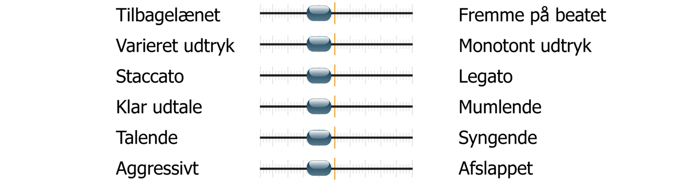

# Fuck tha Police

Fra Ice Cubes vers lige op til .. omkvædet, fra 1:28:

<https://www.youtube.com/watch?v=c5fts7bj-so>

Ice Cube will swarm

On any motherfucker in a blue uniform

Just 'cause I'm from the CPT, punk police are afraid of me

(A young nigga on a warpath

And when I'm finished, it's gonna be a bloodbath

Of cops, dyin' in L.A.

Yo Dre, I got somethin' to say)

*Du kan evt. lave over de næste 4 takter også (i parentes), hvis du er ”on a roll”.*

**#1** Rytmer noteres:

|  |  |  |  |  |  |  |  |  |  |  |  |  |  |  |  |  |
| --- | --- | --- | --- | --- | --- | --- | --- | --- | --- | --- | --- | --- | --- | --- | --- | --- |
| Tak-ter | **1** | x | y | z | **2** | x | y | z | **3** | x | y | z | **4** | x | y | z |
| 0 |  |  |  |  |  |  |  |  |  |  |  |  |  |  |  |  |
| 1 |  |  |  |  |  |  |  |  |  |  |  |  |  |  |  |  |
| 2 |  |  |  |  |  |  |  |  |  |  |  |  |  |  |  |  |
| 3 |  |  |  |  |  |  |  |  |  |  |  |  |  |  |  |  |
| 4 |  |  |  |  |  |  |  |  |  |  |  |  |  |  |  |  |

**#2** Rim (farve) og betoninger (fed skrift) markeres.

## Artikulation:

Lyt til nummeret og justér skyderne:

