Analyzing the World According to Disney
From: Janet Wasko: Understanding Disney. 2001.
Snow White and the Seven Dwarfs
Zipes and other critics cite Snow White as the film that established the model for Disney’s reinterpretation of children’s literature. The film has attracted a good deal of critical attention from different perspectives, but, most importantly, it represents a prime example of Classic Disney.
Snow White and the Seven Dwarfs premiered in December 1937 and was Disney’s first animated feature. It is claimed as the first American animated feature and the first Technicolor feature and received special Academy Awards in 1939. Before its release, however, it was also known as “Disney’s Folly,” as many in the film industry were not convinced that audiences would sit through a feature-length cartoon. Nevertheless, by some accounts, Disney persevered primarily because he was convinced that the introduction of the double bill would eventually squeeze out short cartoons, and that the only profitable future for animation was in features that would attract more revenues.
Snow White was started in 1934 and took more than three years to complete. By the time it was finished, the cost was reported to be $1.5 million, although Schickel claims it was $1.7 million. The film earned $8 million on its first release and had been reissued six times by 1983, with revenues increasing to $47 million. With its fiftieth anniversary release in 1987, the film attracted $40 million in less than eight weeks.
Even though the story had already been produced as an animated film (Betty Boop was featured as Snow White by Max Fleischer in 1933), Disney considered Snow White to be the perfect narrative, replete with humor, romance, and pathos. According to Zipes, “it was in Snow White and the Seven Dwarfs that Disney fully appropriated the literary fairy tale and made his signature into a trademark for the most acceptable type of fairy tale in the twentieth century . . . Snow White became the first definitive animated fairytale film — definitive in the sense that it was to define the way other animated films in the genre of the fairy tale were to be made.”

Most analysts agree that Disney adapted the story of Snow White to suit an American audience, incorporating numerous changes from the printed Grimm brothers’ tale. The following is a summary of these changes, following Zipes:
 | Grimms’ Version |  | Disney’s Version
Mother dies and father is alive |  |  | No parents
Snow White does not work |  |  | Snow white works as a maid, cleans the castle
Prince: “negligible role” |  |  | Prince featured at beginning of film
Queen: “negligible role” |  |  | Queen: Jealous of Snow White
Animals: ““negligible role” |  |  | Animals: Snow White’s friends/protectors
Dwarfs: Anonymous, play humble roles |  |  | Dwarfs: Have names, personalities, starring roles
Queen visits three times |  |  | Queen visits only once
Queen is punished by dancing in hot iron shoes at Snow White’s wedding |  |  | Queen is killed while trying to kill the dwarfs
Snow white returns to life when dwarf stumbles while carrying the coffin |  |  | Snow white returns to life when kissed by the prince

While some analysts have found these changes problematic, Stone reminds us that the Grimms’ version was also a revision of the original oral versions of the Snow White tale, which were altered and adapted according to who was telling the story. Stone notes that textual and contextual sacrifices are inevitable when shifting from oral to printed to filmic forms. but concludes that the film version represents the most rigid and manipulative interpretation of the story. The Disney film “isolates creators and' receivers, and offers them even less possibility of interaction since it furnishes sights, sounds, and motivations. The filmed text thus provides the narrowest bridge of all, with the most closed text and context. There is only one Snow White and the Seven Dwarfs.
While it is clear that the Grimms’ and Disney versions share similar approaches to the domestication of women, Zipes argues that Disney went much further in making the tale the “triumph of the banished and the underdogs” and again relates the film to Disney’s own life. The Prince is ultimately the champion of the film, just as Disney is the one who controlled the production process. In other words, for Zipes, the overriding sign is “the signature of Disney’s self-glorification in the name of justice," as well as (once again) the quest for control:
Disney wants the world cleaned up, and the pastel colors with their sharply drawn ink lines create images of cleanliness, just as each sequence reflects a clearly conceived and preordained destiny for all the characters in die film. For Disney, the Grimms’ tale is not a vehicle to explore the deeper implications of the narrative and its history. Rather it is a vehicle to display what he can do as an animator with the latest technological and artistic developments in the industry. The story is secondary... The manner in which he copied the musical plays and films of his rime, and his close adaptation of fairy tales with patriarchal codes, indicate that all the technical experiments would not be used to foster social change in America but to keep power in the hands of individuals like himself, who felt empowered to design and create new worlds. Disney always wanted to do something new and unique just as long as he had absolute control.
There have been many other discussions of Disney’s version of Snow White, focusing on how Disney used romantic elements to emulate love, sentiment, and romance and examining themes of beauty. However, we turn now to how Snow White combined these various elements, and exemplified Classic Disney, as outlined above.
Classic Disney and Snow White. The Disney version presented an Americanized Snow White and might be said to have fully established the Classic Disney formula. Above all, the film was entertaining, with emphasis on the dwarfs and their comic escapades. One technical reason for this change had to do with the limitations of animation at the time, since humans didn’t animate especially well. The more cartoonish dwarfs thus provided comic relief by way of gags, mostly physical and slapstick, and thus actually dominated much of the film.
The film also features music throughout, a characteristic shared by most Classic Disney films. The characters are revealed and developed through the music; themes are set up and developed by it. Again, Disney adds anthropomorphized animal characters, although the animals do not play as large a role as in other Disney productions. Childlike behavior is featured, as cute characters abound, including Snow White herself, the animals, and the dwarfs.
The work ethic is emphasized in the Disney version of the story, as the dwarfs sing and whistle as they dutifully go off to work ( Whistle while you work” and “Heigh ho, heigh ho, it’s off to work we go”). Snow White is industrious and hard-working, as evidenced in the first scene in which she is seen cleaning at the palace, as well as cleaning sequences at the dwarfs’ cottage.
Snow White’s theme song (“I’m Wishing”) sets the stage for the theme of escape and fantasy. Other scenes include the magic wishing apple (dreams will come true) and especially Snow White praying for her dreams to come true.
Innocence is represented overtly through Snow White’s name, but also by her character. She trusts the dwarfs, but also trusts the witch. There is an emphasis on cleanliness. Snow White seems always to be cleaning, and the dwarfs’ washing song also stresses cleanliness and purity.
Classic Disney is emphatic in its depiction of good triumphing over evil. The Queen/witch is obviously evil and therefore is punished eventually with death. Snow White is innocent and good and is therefore rewarded. Ultimately, she finds fulfillment through a romantic relationship with a prince. Optimism and happiness prevail, “With a smile and a song.” The essence of the story is romance, and, as usual, it’s love at first sight.
Someday my prince will come.” And he does. And there is the happy ending — in this case, a very quick ending, as the Prince appears and they exit to the castle. Snow White’s dream comes true, so we must assume that happiness followed. Anyway, we are told so: “They lived happily ever after.”

Tasks: the World According to Disney
- Snow White became one of Disney’s greatest successes, but what was it known as before its release?
- What was Disney’s motivation for making Snow White into a feature length film?
- Using the numbers in the text, how much has Disney earned on Snow White?
- What has the lasting effect of Snow White been?
- Using Zipes’ list of changes, explain why the changes to the story have been made
- What is your opinion on the changes that Disney has made to the Snow White story?
    - What is good about the Disney approach?
    - What is lost from the original
- Think back to our topic “American Values”. Do we see any of them in the text?

Grammar in context!
Analyze the following sentences by finding:
Subject (x)
Verb (o)
Object (/\)
Indirect object ([ ])
Adverbial phrases (~~~)
1: Classic Disney is emphatic in its depiction of good triumphing over evil
2: The Disney version presented an Americanized Snow White
3: While it is clear that the Grimms’ and Disney versions share similar approaches to the domestication of women, Zipes argues that Disney went much further

Film: Snow White and the seven dwarves
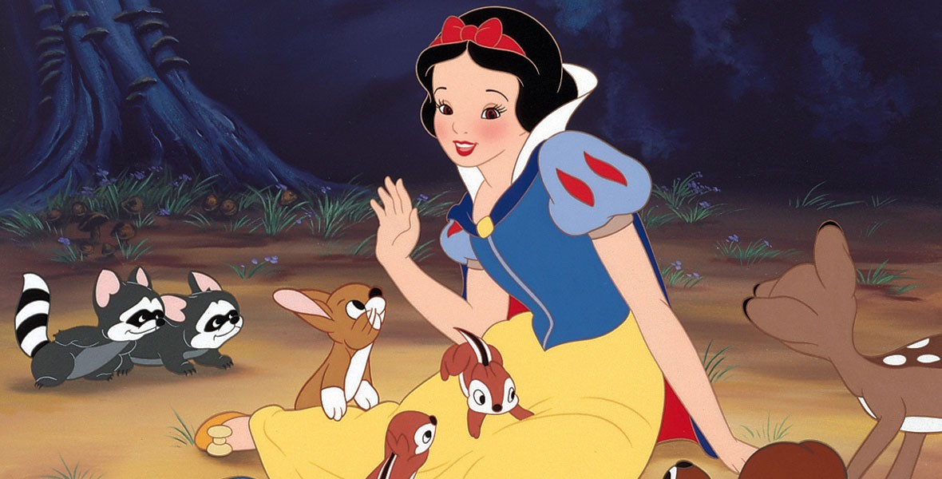

Find examples of classic Disney in the movie
Entertaining

Music which ‘helps’ developing the story

Animal Characters

Childlike behavior and cute characters

Work ethic - central

Cleanliness and purity

The theme of escaping and fantasy

Good triumphing over evil – the happy ending

Optimism and happiness prevail

Romance

Film: Vaiana
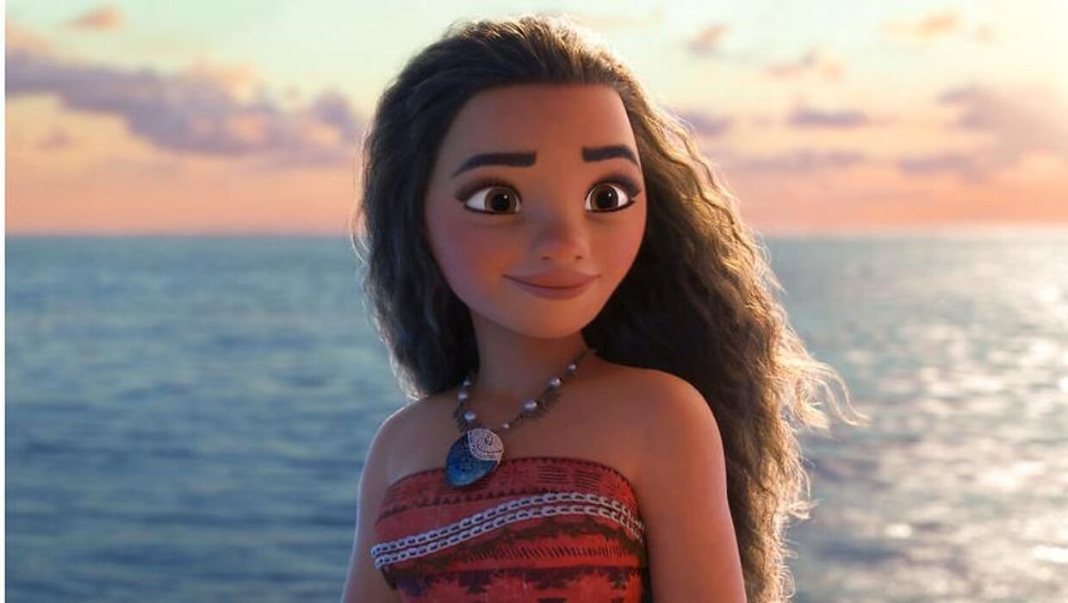

Find examples of classic Disney in the movie
Entertaining

Music which ‘helps’ developing the story

Animal Characters

Childlike behavior and cute characters

Work ethic - central

Cleanliness and purity

The theme of escaping and fantasy

Good triumphing over evil – the happy ending

Optimism and happiness prevail

Romance

