Film: Vaiana
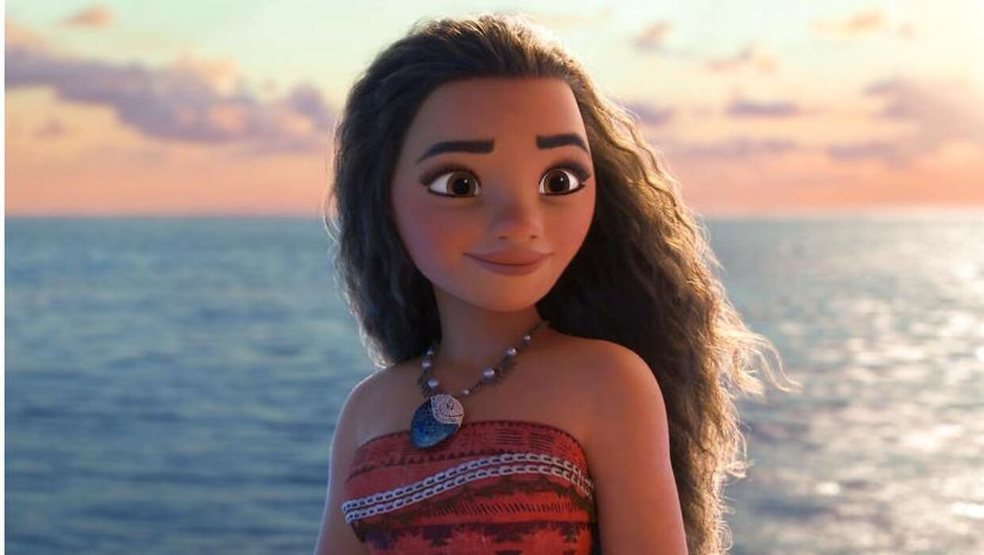

Find examples of classic Disney in the movie
Entertaining

Music which ‘helps’ developing the story

Animal Characters

Childlike behavior and cute characters

Work ethic - central

Cleanliness and purity

The theme of escaping and fantasy

Good triumphing over evil – the happy ending

Optimism and happiness prevail

Romance

