Manuscript for a speech – Disney and Its princesses.
Scenario: You are students at Harvard University, and you are going to conduct a speech at a student debate forum. Your task is to make a manuscript for that speech.
Topic: In your manuscript, you must comment on whether Disney has a problem with their princesses or not, and you must include both the negative and positive aspects of Disney princesses.
Remember to include at least three rhetorical devices – highlight then with yellow.
You must use the following sources:
- From Snow White to Moana: The Evolution of Disney Princesses [2,8 ns]
- CBS News: Report: Disney still has a big princess problem [1,25]
- Why children need better role models than Disney princesses | Mia Fisher | TEDxCCHS Youth [2,3 ns]
- Disney Princesses create your world, Disney Celebrates World Princess Week
https://thewaltdisneycompany.com/world-princess-week-2025/

- All sources must be documented, and all your references must be cited!
- Word count: 800-1200 words.

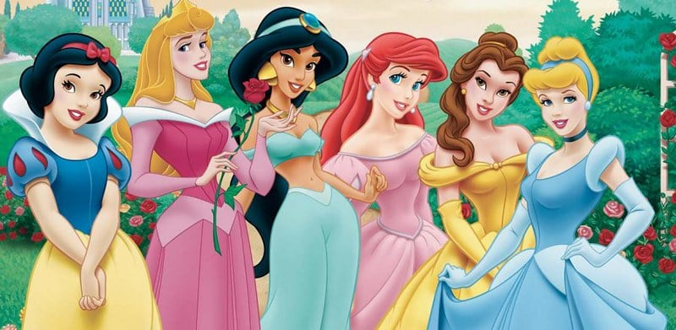
From Snow White to Moana: The Evolution of Disney Princesses
Most of us remember watching Disney princess movies growing up — it is safe to assume that almost everyone has seen at least one of them. Generations grew up with these fancy, beautiful princesses, sometimes even serving as role models with their kindness and loving personas. The impact of these princess movies, however, is far from benign. Many of them taught kids the stifling bonds of gender roles and emphasized the importance of looks and beauty standards. In recent years, though, Disney has attempted to redefine what it means to be a Disney princess. This move gives hope for young generations, especially girls, to be powerful on their own.
There are two types of Disney Princesses: traditional ones and new ones; and there are three eras: the Classics Era, the Renaissance Era and the New-Age Era.
Classics Era (1937-1959)
The Classics-Era princesses — Snow White, Cinderella and Sleeping Beauty — were primarily passive and temperate. They were waiting for someone to come rescue them. These princesses also fit squarely into conventional beauty standards.
Snow White is the typical, beautiful, gentle and innocent princess. The only thing she does in the movie is clean the house for seven guys and get saved by another one. Cinderella is more developed but still struggles to progress beyond the limits of needing someone to save her; she is curious about the world, but ends up with the strong Prince Charming that saves the day. In “Sleeping Beauty,” the fairies give Aurora the gift of beauty — not intelligence or personality — when she is a newborn. As the story continues, we don’t even get a chance to see Aurora’s depth of character —only her beauty and grace. In the Classics Era, these kinds of gender stereotypes and the objectification of submissive female characters were at their peak.
Renaissance Era (1989-1999)
The Renaissance Era of Disney princesses, also called the “rebel children era,” appears to have been in response to a wake-up call for a needed transition from being conventional to being a reformer. While the Renaissance Era improved on the Classics Era by making princesses curious about the world rather than doing the housework for others, Disney still stuck to the motif of princesses needing someone. This era includes Ariel, Belle, Jasmine, Pocahontas and Mulan.
With Ariel, Disney finally succeeded in creating a complex character. Out of all her sisters, Ariel can sing the best, yet she wonders about life on land. After seeing Prince Eric, she decides to exchange her singing voice for the opportunity to become a human. She develops into a self-sustained princess without reliance on another’s help, even at the cost of going against her family and community.
Another great example of Disney’s development is Belle from “The Beauty and the Beast.” In Belle, we see a woman whose key characteristic is not her beauty, but rather her intelligence and love of books. She doesn’t fit in society, and even sings a whole song about how she wants to break away from it. As the story continues, we see that she is not preoccupied with beauty but instead falls for the “ugly, terrifying” Beast’s kind personality and big heart. Like Belle, Jasmine continues to follow in her footsteps and resists society’s expectations for her to marry someone of political import. There are even a few times that Aladdin points out Jasmine’s intelligence and ambition, a rarity for Disney. Jasmine is also the first Disney princess of color, a revolutionary move at the time.
[…]
Pocahontas is Disney’s first attempt at basing a princess on a real person rather than a fairy tale; I still feel that it failed, though: they twisted the facts about her story, focusing on her romance with John Smith instead of her leadership abilities and brave soul. […] Mulan is one of the bravest and strongest princesses of all, as she is the best fighter in an all-male army. She fights for her country and her roots, showing that women can do anything they want, even if it defies tradition. Also, for the first time, a princess’s love interest remains in the background, a relief after many years of male dominance in a princess movie.
New-Age Era (2009-present)
The latest era of Disney princesses, the New-Age Era, also known as the “independent woman era,” is the most recent and most equal era of Disney. It includes Tiana, Rapunzel, Merida, Elsa, Anna and more. Tiana definitely embodies the new definition of a princess. She works hard to achieve her dreams and keep her promise to her father, and she doesn’t turn to shortcuts or a man to help her get there. She is straightforward in every situation, even if it’s hard, a virtue making her the best role model out of all the Disney princesses.
Another Disney princess wanted to see life outside of her tower, where she was locked up and spent all of her childhood and young adult life. Rapunzel is free-spirited, artistic and stubborn. Even though Mother Gothel told her that the outside world is full of evil and that she wouldn’t be able to handle it, Rapunzel followed her instincts and pursued her dream. Rapunzel represents a strong, determined personality, defying the stereotype of women as innocent, weak and inadequate by themselves.
[…]
In the story of Elsa, a powerful girl is afraid of those powers and is seen as evil. She isolates herself because of her “evil” power, but as the story continues she embraces it with the help of her sister. Instead of romance, Frozen focuses on the undying bond between two sisters, Anna and Elsa. Even though Elsa hurt Anna with her powers unintentionally, Anna forgives Elsa and wants to be there for her, in bad and better times. Anna even rejects her love interest, Kristoff, to help Elsa, who she loves the most and would do anything for her. They represent the importance of independence, women’s unity and doing just fine without a man by their side.
One of Disney’s newest princesses, Moana, continues to carry on the theme of the independent, brave women. She doesn’t have any love interest, and she is determined to save her people no matter how dangerous the journey. She is another inspiration for girls who do not need a man to accomplish their goals.
Disney has come a long way after many years, and is still continuing to make progress over time. I remember not liking iconic Disney princesses when I was a kid because they needed a man or magic to realize their goals. I have since noticed many changes in the meaning of being a princess over the years, and I’m glad that Disney decided to change their stories and let female characters define themselves without a need for someone else.
[…] I hope that Disney continues to progress, because we still live in a male-dominated society, and in many facets of life women still aren’t allowed to be what they want. I believe with open-minded and egalitarian princess movies, a new generation will rise to solve these problems for a better society.
Aslıhan Alp is a high schooler writing as part of The Daily’s Summer Journalism Workshop. Contact them at workshop 'at' stanforddaily.com.

Report: Disney still has a big princess problem
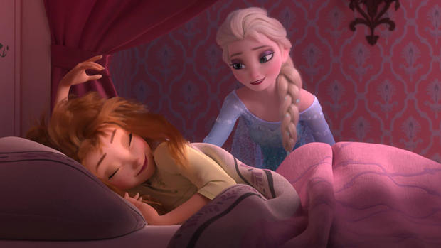
In the Disney universe, gone are the days when men are necessary to save the damsel in distress. No prince's kiss is needed to wake the girl. The prince's hand in marriage is not the ultimate goal anymore.
Today's Disney princesses have saved China, saved each other, fought bears, and generally taken on kick-butt personas.
Still, there's a problem, according to new research that was first reported on by the Washington Post.
Simply put, the women in modern Disney movies just aren't allowed to open their mouths and talk as much as the men, according to research by linguists Carmen Fought and Karen Eisenhauer, who have been working on a project to analyze all the dialogue from the Disney princess franchise.
They told the Post that because so many girls around the world watch Disney princess movies, often on repeat, it was important to understand better what they were teaching.
"We don't believe that little girls naturally play a certain way or speak a certain way," Fought, a professor of linguistics at Pitzer College, told the Post. "They're not born liking a pink dress. At some point we teach them. So a big question is where girls get their ideas about being girls."
A paradoxical discovery in their research found that in the classic Disney princess films - "Snow White," "Sleeping Beauty," and "Cinderella" - women give a majority of the dialogue in the movies, 72 percent, despite taking on roles that are traditionally subservient to men.
In modern Disney princess films, despite being more independent, women talk less.
The Post report: "Men speak 68 percent of the time in 'The Little Mermaid'; 71 percent of the time in 'Beauty and the Beast'; 90 percent of the time in 'Aladdin'; 76 percent of the time in 'Pocahontas; and 77 percent of the time in 'Mulan.'"
Even in the modern blockbuster, "Frozen," where two princess sisters are the centerpiece and heroes of the film, men speak 59 percent of the time.
The researchers found two modern exception: "Tangled," the retelling of the Rapunzel story, in which women have 52 percent of the lines; and "Brave," about a fraught mother-daughter relationship, women speak 74 percent of the time.
There has been one important and positive shift, however, researchers found. In the old Disney princess classics, an overwhelming majority of the time female characters were complimented on their looks. In modern princess films, their abilities and accomplishments were given most of the compliments.
As for the dialogue problem, the linguists chalked it up largely to an oversight, as well as the likelihood for the quirky sidekick character and most other supporting characters to almost always being male.
"My best guess is that it's carelessness, because we're so trained to think that male is the norm," said Eisenhauer, a graduate student at North Carolina State. "So when you want to add a shopkeeper, that shopkeeper is a man. Or you add a guard, that guard is a man. I think that's just really ingrained in our culture."

Why children need better role models than Disney princesses | Mia Fisher | TEDxCCHS Youth
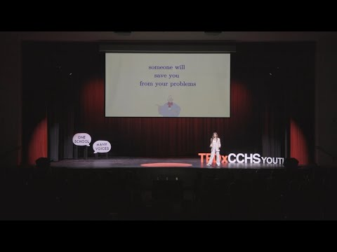
A happy ever after is the necessity for every princess fairytale but what comes next? Reality. In this talk, Mia Fisher addresses the impact of Disney Princess media on both children's self-image and societal beliefs. Mia Fisher is a sophomore at Cathedral. She is a member of the CCHS cheer team and finds joy through photography and painting. Mia is president of her National Charity League class, and has completed a total of 235 philanthropy hours through this organization. Her talk was inspired by her childhood love of Disney animated films and her realization of their impact on young children. This talk was given at a TEDx event using the TED conference format but independently organized by a local community.

Disney Princesses create your own world
August 25, 2025
Disney Celebrates World Princess Week
Today marks the start of World Princess Week and Disney is celebrating with an all-new musical brand spot, a spectacular concert performance at Disneyland Park from the voices behind some of Walt Disney Animation Studios’ most beloved princesses, a ride-along video featuring a Disney Legend, and much more. World Princess Week celebrates the incredible legacy of beloved Disney princesses and their special connection with generations of kids and fans of all ages around the world. From exciting new product launches to exclusive, one-of-a-kind content, this week will highlight the magic and fun that Disney princesses bring to every part of life. World Princess Week is part of the multi-year “Create Your World” campaign, Disney’s ongoing commitment to give kids the opportunity and tools to use their imaginations, try new things, believe in themselves, and discover their own brand of princess magic that lies within them.
“For over a century, Disney has enchanted audiences across generations with timeless stories that ignite the imagination, and Disney princesses remain an enduring part of our storytelling — inspiring kids and fans of all ages to go beyond dreaming big, to doing big things. We created this special musical brand spot in celebration of World Princess Week, the countless Disney Princess fans around the world, and the limitless power of their imaginations,” said Mallory Wang, Vice President of Brand Marketing at The Walt Disney Company.
Be Our Guest During an All-New Musical Brand Spot
To kick off World Princess Week, Disney released today an all-new musical brand spot entitled All Princesses Make Magic. With music by seven-time Grammy® Award winner Jacob Collier, the new brand spot shows that with a little inspiration, a lot of heart, and a touch of magic, anyone can create their own world. When two young sisters throw their mom a surprise birthday party, they turn to the magic of Disney princesses for inspiration and craft a world of handmade decorations, royal costumes, and big-hearted surprises — with a little help from Dad, played by Santino Fontana, Tony Award® winner and voice of Hans in the acclaimed Walt Disney Animation Studios film, Frozen (2013). As the celebration unfolds, reality blends with fantasy and their dining room becomes a magical world forged from their imaginations.
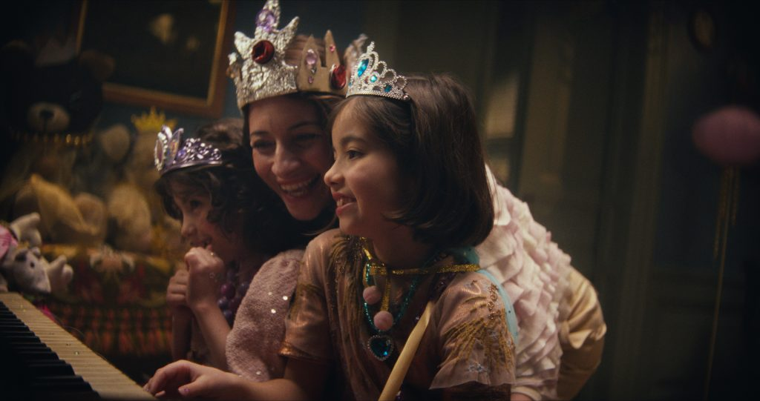
Celebrate Disney Princesses with a One-Of-A-Kind Concert at Disneyland Park
On August 29 on YouTube — and later on Disney+ — fans of all ages will have the chance to enjoy a magical performance during Disney Princess Concert: Celebrating 70 Years of Disneyland featuring admired Disney Princess voice talent such as Auli‘i Cravalho, the voice of the title character in Moana (2016) and Moana 2 (2024); as well as Disney Legends Jodi Benson, the voice of Ariel in The Little Mermaid (1989); Paige O’Hara, the voice of Belle in Beauty and the Beast (1991); and Anika Noni Rose, the voice of Tiana in The Princess and the Frog (2009). In honor of not only World Princess Week but also the Disneyland Resort 70th Celebration, Disney Princess stars will come together for a spectacular performance of some beloved Disney Princess music filmed in front of the iconic Sleeping Beauty Castle at The Happiest Place on Earth with hosts Ginnifer Goodwin — the voice of Judy Hopps in Zootopia (2016) as well as the upcoming November 2025 release of Zootopia 2 and Snow White in ABC’s Once Upon a Time television series — and Susan Egan — the voice of Megara in Hercules (1997) and the original Belle in Beauty and the Beast on Broadway.
Dive Under the Sea in a Royal Ride Along with Disney Legend Jodi Benson
In an all-new YouTube video entitled Exclusive Journey on The Little Mermaid – Ariel’s Undersea Adventure with Jodi Benson & Lauren Paley, creator and princess fan Lauren Paley interviews Jodi Benson during a ride through The Little Mermaid – Ariel’s Undersea Adventure at the Disneyland® Resort, reminiscing on the indelible impact Ariel and the Disney princesses have made on fans around the world. The video will be available on August 27 on the Disney YouTube channel.
Create Your World with All-New Disney Princess Products
The love for Disney princesses extends beyond the silver screen with magical experiences at home through specialty products that ignite imaginative play. Disney Consumer Products is celebrating the second year of the Disney Princess “Create Your World” campaign bringing the magic into families’ everyday lives with new collaborations, spotlighting the princesses’ playful animal sidekicks, and adding a heartwarming layer to playtime and storytelling across generations.
Starting today, fans can discover exciting new products including new Jakks Pacific Majestic Dresses and a Pampered Pup set from their Style Collection, princess bracelets from Little Words Project, new DIFF Eyewear princess designs, and Pandora’s reimagined Disney Princess rings, including an upcoming launch featuring a fan-favorite character.
Disney Store will also carry a brand-new lineup of merchandise launching today, including the new Disney Princess and Sidekicks Squishmallows Box Set, Disney Princess Cakeworthy apparel collection, and the Once Upon a Story Doll Advent Calendar.
Readers across all ages can also now enjoy newly released princess-themed books including “Disney Princess: Princesses Love School!,” “Disney Princess Enchanted Character Guide,” a special boxed set of Little Golden Books, and Tiana’s Perfect Plan, the debut picture book released last October from Anika Noni Rose showcasing Princess Tiana on an all-new adventure through New Orleans.
Recent standout Disney Princess product launches include Mattel’s Pet Palace and Disney Princess Animal Friend Carriages, and the Princess Castle & Royal Pets set from the LEGO Group, both featuring some fan-favorite sidekicks like Pascal, Flounder, Rajah, and Pua. Fans can also tune in to Good Morning America on August 28 to learn more about these products and enjoy an exclusive reveal.
Disney+ Hosts a Royal Celebration Featuring New Programming and Perks
Disney+ is joining the princess celebration with exciting programming and exclusive Perks. Beginning today, fans can stream LEGO Disney Princess: Villains Unite exclusively on Disney+ and enjoy a brand-new “Disney Princess” Stream featuring all the beloved heroes and their loyal sidekicks. Available to Premium subscribers, the 24/7 Stream delivers non-stop stories that show strength lies in standing together with courage, compassion, and companionship.
Plus, three magical new Princess Disney+ Perks are here! Starting today, eligible subscribers can enter a series of limited-time flash sweepstakes for the chance to win enchanting prizes like a Snow White vinyl record prize pack, a dazzling Disney Princess toy bundle, and the complete 5-book Meant To Be series box set. For more details, please visit disneyplus.com/perks.
Enjoy the Magic with New Content for Disney Princess Fans
Launching today on the NatGeoKids YouTube channel, families are invited to go behind-the-scenes at Disney’s Animal Kingdom Park and learn from animal specialists about the real-life species that inspired some of the lovable sidekicks of Disney princesses, including tigers like Rajah from Aladdin; a Kunekune pig like Pua from Moana; a spiny mouse like Jaq and Gus from Cinderella (1950); and chameleons like Pascal from Tangled (2010). These princess sidekicks are the perfect companion for any adventure and remind fans that even the greatest heroines don’t have to face challenges alone. The video is filled with exploration, animation, and popup quizzes for the whole family.
Additional content will continue to roll out throughout the year, including a princess-themed episode of Storytellers Spotlight on ABC and Hulu.
Exciting New Ways to Experience the Music of Disney Princesses
The songs of Disney Princess films have become anthems around the world as the inspirational soundtrack for fans of all ages who dare to explore a whole new world and see how far they’ll go. Available for pre-order now on Disney Music Emporium, celebrate the 15th anniversary of Disney’s Tangled with a special collector’s edition zoetrope vinyl, featuring some favorite songs from the film including “I’ve Got a Dream,” “I See the Light,” and “When Will My Life Begin?” The “Disney Princess Strings: Garden Soirée” album brings a new take to some treasured songs, including “Once Upon a Dream,” “A Dream is a Wish Your Heart Makes,” “A Whole New World,” and more — now available on Spotify, Apple Music, Amazon Music, YouTube Music, and other digital platforms.
Disney Concerts and AMP Worldwide are also proud to present Disney’s Moana Live-To-Film Concert North American Tour, featuring a full-length screening of the beloved movie accompanied by live performances of a unique on-stage musical ensemble of top Hollywood studio musicians, Pacific Islands rhythm masters and vocalists, celebrating the music and songs from this award-winning Walt Disney Animation Studios’ classic. The 37-city tour kicks off Friday, October 3, 2025, at the Mayo Performing Arts Center in Morristown, New Jersey. More information on tour dates and tickets can be found here.
Granting Princess Wishes for Kids Around the World
In celebration of World Princess Week this year, Disney granted princess wishes for more than 100 kids around the world, including:
- 12 wish kids and their families received a royal invitation to attend the live taping of Disney Princess Concert: Celebrating 70 Years of Disneyland, where they will have a front row seat to the one-of-a-kind show.
- At Disneyland Resort, cast members granted the wish of seven-year-old Amelia, who dreamed of meeting Moana. Amelia was crowned as “Princess for a Day” as she and her entire family enjoyed a day of fun at the park. As part of her wish, Amelia and Moana embarked on their own wayfinding adventure together.
- In Latin America, nine princess wishes were granted for young girls who were able to pick their favorite princess dresses, delight in a makeover, enjoy meet and greets and tailored experiences, as well as share the kind of impact they’d like to make on the world.
- Disney Cruise Line granted 38 wishes for Make-A-Wish children from Italy aboard the Disney Fantasy while the ship was docked in Rome. The families experienced character meet and greets, a Royal Tea Party, playtime in the Oceaneer’s Club, a dance party with Mickey Mouse and friends, and more.
- Later this week, 60 wish children will enjoy a princess-themed three-day, two-night stay at Disneyland Paris with exciting character meet and greets and multiple princess surprises.
Each year, thousands of Make-A-Wish kids choose Disney princesses for their most heartfelt wish. These timeless stories and characters bring kids comfort, hope, and confidence, especially for those facing critical illnesses. As the world’s largest wish granter for Make-A-Wish, Disney grants a wish every hour of every day.
Follow @thedisneyprincesses on Instagram and @disneyprincess on Facebook for exciting announcements and magical princess fun. Fans can use #DisneyPrincessCreateYourWorld and #WorldPrincessWeek to join the conversation.

