Punching the Air 297-332 (the page before art school 3)

- What does the butterfly which Amal has drawn symbolize? (pages 302-313)

- Why are the chapters called brotherhood III and brotherhood IV and brotherhood V?

- Find two crucial quotations from today’s reading in Punching the Air. Use the following Pee structure with your two quotations. Furthermore, you must generate your own pictures using Ai. (Bing Copilot etc.) Two groups will be selected for a presentation of their quotations in our next English class.

Point: Your point needs to introduce your quotation and your argument
Example: This is where you need to find evidence to show that the point you have made is valid in relation to the chosen text. This can be a quote from within
the text itself. You MUST copy the quote exactly.
Explanation: This is the part where you have to analyze your quotation. Explain why the quote is important, what impact does it have on your analysis of the text, what argument does it support, why did the author choose to use such words.

- Fill in the narrator/pov task sheet on the following page.

Narrator/POV task sheet

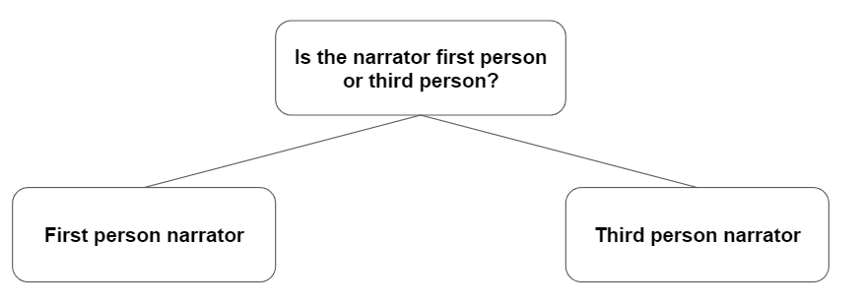

If first person narrator: If third person narrator:
Write an X in all the boxes that can Write an X in all the boxes that can describe the narrator in Punching the Air: describe the narrator in Punching the Air:

is an I speaker and events are told through the eyes of the I (subjective) |  |  | can be a character in the story
only allows the reader to know what the I knows |  |  | is an observer outside the action
can be a character in the story |  |  | is referred to as he/she
can be a less important character witnessing events |  |  | makes it harder for the reader to identify with the characters
can be a character re-telling a story he/she was told by someone else |  |  | know the thoughts of all characters or one character
gives a closeness to the character
makes it easier for the reader to identity with the character

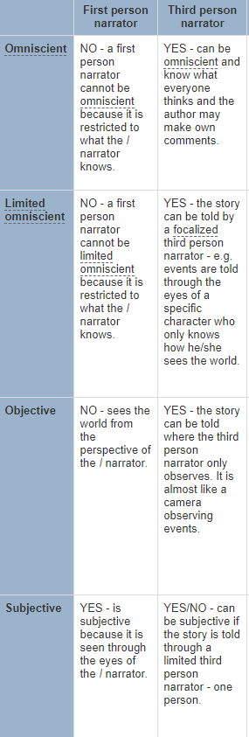
2. Use the list from The English Handbook to check what criteria match the narrator in Punching the Air:

3. Now that you have determined the type of narrator, discuss the following questions in your group:

- How does the choice of narrator affect your reading of the story?
- Where in the chapters you have just read do you as readers feel a particular strong connection to the narrator? And why?
Find 3-5 examples from the text that you are ready to present in class.

