Sustainability, primarily in the USA



Trump’s views on climate change (module 1)

- Analyze Trump’s main claim about climate change in his speech at The United Nations Conference (excerpt 5 min.), 23 September 2025. What is his main claim and his data?

https://www.youtube.com/watch?v=G7Y8_0zAzXc

More information about his speech:

https://www.pbs.org/newshour/politics/trump-called-climate-change-a-con-job-at-the-united-nations-here-are-the-facts-and-context

- How does Trump argue his case? Which type of arguments?
https://theenglishhandbook.systime.dk/?id=168#c449
https://hbdansk.systime.dk/?id=205#c628

- Which modes of persuasion does Trump use?
https://theenglishhandbook.systime.dk/?id=155#c281

Cartoon
Describe the cartoon below. Describe what you see in the foreground, in the middle ground and in the background… Use three different relative pronouns to describe the painting and one possessive pronoun. What is the cartoon trying to communicate to the reader?

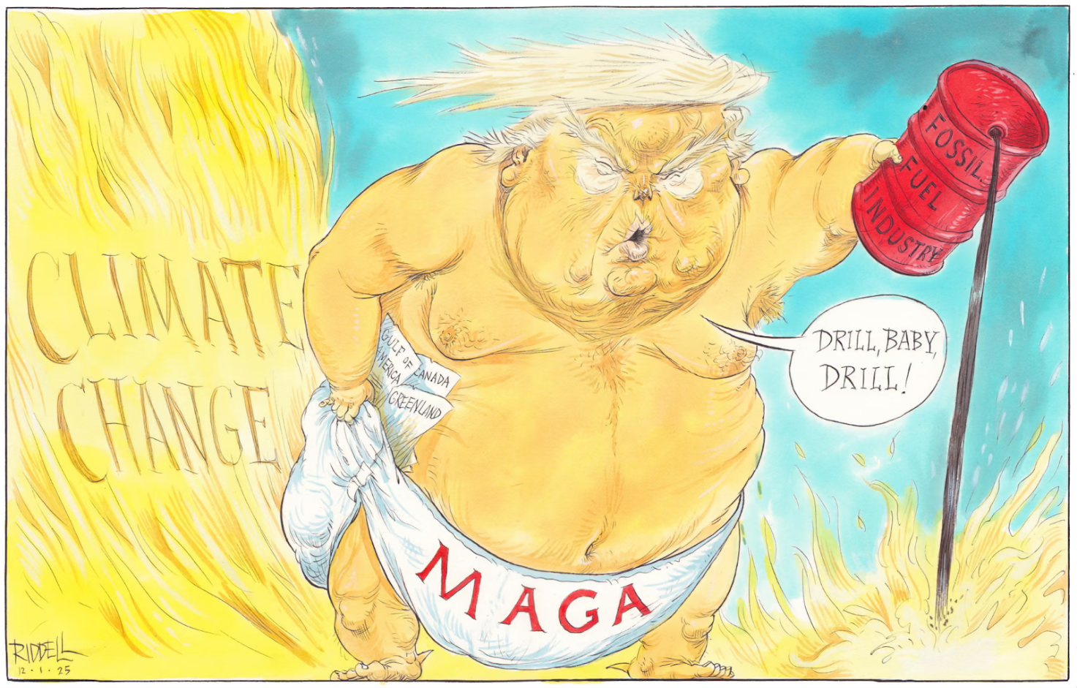
https://www.theguardian.com/commentisfree/picture/2025/jan/11/chris-riddell-on-donald-trump-pouring-oil-on-to-the-climate-crisis-as-los-angeles-burns-cartoon

Relative pronouns
Relative pronominer er ord som who/whom, which, whose, that og what. De forbinder sætninger og giver ekstra information om et substantiv eller en hel sætning:
https://app.minlaering.dk/bog/1/kapitel/48786/sektion/49945

Possessive pronouns
Possessive pronominer viser ejerskab – altså hvem noget tilhører. De findes i to former:
Possessive pronominer, der fungerer som et adjektiv (står foran et substantiv):
This is my book.
Possessive pronominer, der fungerer som et substantiv (står alene):
This book is mine.
https://app.minlaering.dk/bog/1/kapitel/48786/sektion/49137

Trump and climate change (module 2)

- Pre-reading, pairwork
https://www.theguardian.com/environment/2025/may/01/trump-air-climate-pollution-regulation-100-days
A. Take notes to how Trump stands on the issues below:

Topic | Trump
Executive orders regarding climate change
Paris Climate Agreement
The coal industry
Fossil fuels
Solar energy

Trump’s Environmental Protection agency

B. Which kind of words are used in the article to describe Trump’s relationship with the environment?

C. Try to make a semantic field with the title “Trump and the environment” and find out which words are used to describe this semantic field. Do you see any bias in the wording of the topic? Which kind of political bias does the Guardian often have?
Useful links:
Semantic fields
https://everyoneishere.systime.dk/?id=162

Bias
https://mediabiasfactcheck.com/
3. Product
When you have taken notes, you must create a poster stating and illustrating Trump’s views of the climate debate and create an ai generated song about his views of the climate debate. Be precise when prompting your chosen Ai generator. You could use the following website to create your song: https://www.udio.com/

