CLI-FI – introduction to Climate Fiction

Task:
What characterizes cli-fi literature?
https://theenglishhandbook.systime.dk/?id=217
Watch the trailer for the film The Day after Tomorrow https://www.youtube.com/watch?v=HUBDFoMNXzA on Youtube. Can you identify some of the traits that you have just listed?
Exercise: Climate Fiction https://theenglishhandbook.systime.dk/?id=217#c600
- Read the excerpt from Diary of an Interesting Year.
- Find key characteristics of climate fiction in the text.
Diary of an Interesting Year (excerpt)
August 3rd. Rivers and streams all toxic—fertilizers, typhoid, etc. So we're following G.'s D.I.Y. system. Dip billycan into stream or river. Add three drops of bleach. Boil up on camping stove with T-shirt stretched over billycan. Only moisture squeezed from the T-shirt is safe to drink; nothing else. "You’re joking," I said, when G. first showed me how to do this. But no.
August 9th. Radio news in muddy sleeping bags—skeleton government obviously struggling, they keep playing the "Enigma Variations." Last night they announced the end of fuel for civilian use and the compulsory disabling of all remaining civilian cars. From now on we must all stay at home, they said, and not travel without permission. There's talk of martial law. We're going cross-country as much as possible—less chance of being arrested or mugged—trying to cover ten miles a day, but the weather slows us down. Torrential rain, often horizontal in gusting winds.
Helen Simpson, Diary of an Interesting Year (excerpt), December 21, 2009, The New Yorker

Glossary
Killjoy (l.68)=
Camaraderie (l. 32)=
Plutonomy (l. 229)=
Torrential rain (l. 127)=
Martial law (l. 125) =
Barter (l. 39)=
Compulsory billeting (l. 72)=
Billy can (l. 118)=
Sewage system (l. 14)=
Notebook and a biro (l. 6)=
Mortgage (l. 102)=

Analysis of Diaries of an interesting Year

- Account for the genre in Diaries of an interesting year.
- How does the diary format impact the reader's understanding and engagement with the narrative?
- Analyze the physical and social setting in the short story.
- Analyze the point of view in the short story.
- Make a characterization of the protagonist. How does the protagonist evolve throughout the diary entries?
- How does the tone of the diary entries shift over time, and what does this reveal about the protagonist's mental state and circumstances?
- Analyze the relationship between the protagonist and G.
- Please interpret the main themes in the short story.
- Why do you think the author has written this short story?

Creative Tasks
- Diary Entry Continuation:
  - Write an additional diary entry from the protagonist's perspective, imagining what might happen next. Please maintain the tone and style of the original text.
- Cli-Fi Short Story:
  - Please write your own short cli-fi story, focusing on a future affected by climate change. You must incorporate elements such as setting, character development, and social critique.
- Dramatic Monologue:
  - Please write and perform a dramatic monologue from the perspective of one of the characters in "Diary of an Interesting Year."
- Poster/drawing
Create a visual representation (drawing, painting, digital art) of a significant scene from the story. You must explain your artistic choices and how they relate to the text.

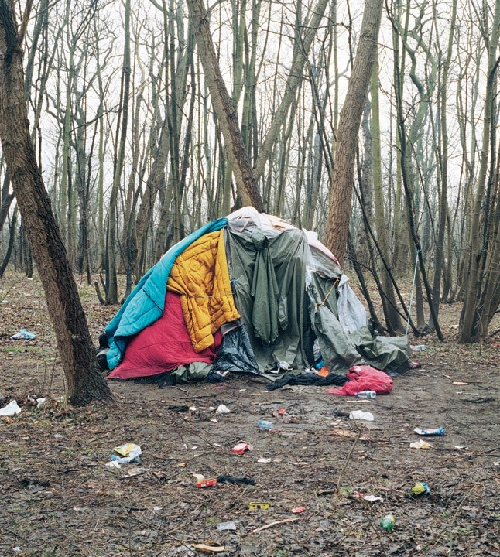
Photograph by Henk Wildschut, “Calais, France, Feb. 2006”
Fiction
Diary of an Interesting Year
By Helen Simpson
December 13, 2009
Published in The NewYorker
(abbreviated)

February 12, 2040. My thirtieth birthday. G. gave me this little spiral-bound notebook and a Biro.
It’s a good present, hardly any rust on the spiral and no water damage to the paper. Fm going to
start a diary. I’ll keep my handwriting tiny to make the paper go further.
February 15th. G. is really getting me down. He’s in his element. They should carve it on his
tombstone: “I Was Right.”
February 23rd. Glad we don’t live in London. The Hatchwells have got cousins staying with
them—they trekked up from Peckham (three days). Went round this afternoon and the cousins were
saying the thing that finally drove them out was the sewage system—when the drains backed up, it
overflowed everywhere. They said the smell was unbelievable. The pavements were swimming in
it, and of course the hospitals are down, so there’s nothing to be done about the cholera. Didn’t get
too close to them in case they were carrying it. They lost their two sons like that last year.
[...]
March 2nd. Can’t sleep. fm writing this instead of staring at the ceiling. There’s a mosquito in the
room, I can hear it whining close to my ear. Very humid, air like filthy soup, plus we’re supposed to
wear our face masks in bed, too, but I was running with sweat, so I ripped mine off just now. Got up
and looked at myself in the mirror on the landing—ribs like a fence, hair in greasy rats’ tails.
Yesterday the rats in the kitchen were busy gnawing away at the bread bin, they didn’t even look up
when I came in.
March 6th. Another quarrel with G. O.K., yes, he was right, but why crow about it? That’s what
you get when you marry your tutor from Uni—wall-to-wall pontificating from an older man. “I saw
it coming, any fool could see it coming, especially after the Big Melt,” he brags. “Thresholds
crossed, Cascade effect, hopelessly optimistic to assume we had till 2060, blahdy blahdy blah, the
plutonomy as lemming, democracy’s massive own goal.” No wonder we haven’t got any friends.
2
He cheered when rationing came in. He’s the one who volunteered first as car-share warden for our
road; one piddling little Peugeot for the entire road. He gets a real kick out of the camaraderie round
the standpipe.
—Fil swap my hig tin of chickpeas for your little tin of sardines.
—No, no, my sardines are protein.
—Chickpeas are protein, too, plus they fill you up more. Anyway, 1 thought you still had some
tuna.
—-No, I swapped that with Violet Huggins for a tin of tomato soup.
Really sick of bartering, but hard to know how to earn money since the Internet went down. “Also,
money’s no use unless you’ve got shedloads of it,” as I said to him in bed last night. “The top layer
hanging on inside their plastic bubbles of filtered air while the rest of us shuffle about with goiters
and tumors and bits of old sheet tied over our mouths. Plus, we’re soaking wet the whole time.
We’ve given up on umbrellas, we just go round permanently drenched.” [...]
April 8th. Boring morning washing out rags. No wood for hot water, so had to use ashes and lye
again. Hånds very sore, even though I put plastic bags over them. Did the face masks first, then the
rags from my period. Took forever. At least I haven’t got to do nappies, like Lexi or Esmé—that
would send me right over the edge.
April 27th. Just back from Maia’s. Seven months. She’s very frightened. I don’t blame her. She
tried to make me promise Td take care of the baby if anything happens to her. I havered (mostly at
the thought of coming between her and that throwback Martin—she had a new black eye, I didn’t
ask). I suppose there’s no harm in promising if it makes her feel better. Alter all, it wouldn’t exactly
be taking on a responsibility—I give a new baby three months max in these conditions. Diarrhea,
basically.
May 14th. Can’t sleep. Bites itching, trying not to scratch. Heavy thumps and squeaks just above, in
the ceiling. Think of something nice. Soap and hot water. Fresh air. Condoms! Sick of being
permanently on knife edge re pregnancy.
Start again. Wandering round a supermarket—warm, gorgeously lit—corridors of open fridges full
of tiger prawns and fillet steak. Gliding off down the fast låne in a sports car, stopping to fill up
with thirty litres of petrol. Online, booking tickets for “The Mousetrap,” click, ordering a crate of
3
5
wine, click, a vacation home, click, a pair of patent-leather boots, click, a gap year, click. I go to
iTunes and download “The Mandage of Figaro,” then I chat face to face in real time with G.’s
parents in Sydney. No, don’t think about what happened to them. Horrible. Go to sleep.
May 21st. Another row with G. He blew my second candle out, he said one was enough. It wasn’t,
though. I couldn’t see to read anymore. He drives me mad—it’s like living with a policeman. It
always was, even before the Collapse. “The earth has enough for eveiyone’s need, but not for
everyone’s greed” was his favorite. Nobody likes being labelled greedy. I called him Killjoy and he
didn’t like that. [...]
June 6th. Went round to the Lumleys’ for the news last night. Whole road there squashed into front
room, straining to listen to radio—batteries very low (no new ones in the last government delivery).
Big news, though: compulsory billeting imminent. [...]
When we got back, G. checked our stash of tins under the bedroom floorboards. A big rat shot out
and I screamed my head off. G. held me till I stopped crying, then we had sex. Woke in the night
and prayed not to be pregnant, though God knows who I was praying to.
June 12th. Visited Maia this afternoon. She was in bed, her legs have swollen up like balloons. On
at me again to promise about the baby, and this time I said yes. She said Violet Huggins was going
to help her when it started—Violet was a nurse once, apparently, not really the hands-on sort but
better than nothing. Nobody else on the road will have a clue what to do now that we can’t Google
it- [•••]
Jitly Ist. First billet arrived today by Army truck. We’ve got a Spanish group of eight, including one
old lady, her daughter, and twin toddler grandsons (all pretty feral), plus four unsmil i ng men of
fighting age. A bit much, since we have only two bedrooms. G. and I tried to show them round but
they ignored us. The grandmother bagged our bedroom straight off. We’re under the kitchen table
tonight. I might try to sleep on top of it because of the rats. We couldn’t think of anything to say—
the only Spanish we could remember was “Muchas gracias,” and, as G. snapped, we’re certainly
not saying that.
July 3rd. G. depressed. The four Spaniards are bigger than him, and he’s worried that the biggest
one, Miguel, has his eye on me (with reason, I have to say).
July 4th. G. depressed. The grandmother found our tins under the floorboards and all but danced a
flamenco. Miguel punched G. when he tried to reclaim a tin of sardines and since then his nose
won’t stop bleeding.
4
July 6th. Last night under the table G. came up with a plan. He thinks we should head north. Now
that this lot are in the flat and a new group from Tehran promised next week, we might as well cut
and run. Scotland’s heaving—everyone else has already had the same idea—so he thinks we should
get on one of the ferries to Stavanger, then aim for Russia.
5 “I don’t know,” I said. “Where would we stay?”
‘Tve got the pop-up tent packed in a rucksack behind the shed,” he said. “Plus our sleeping bags
and my windup radio.”
“Camping in the mud,” I said.
“Look on the bright side,” he said. “We have a huge mortgage and we’re just going to walk away
10 from it.”
“Oh, shut up,” I said.
July 17th. Maia died yesterday. It was horrible. The baby got stuck two weeks ago, it died inside
her. Violet Huggins was useless, she didn’t have a clue. Martin started waving his Swiss Army
knife around on the second day and yelling about a Cesarean—he had to be dragged off her. He’s
15 round at ours now drinking the last of our precious brandy with the Spaniards. That’s it. We’ve got
to go. Now, says G. Yes.
August Ist. Somewhere in Shropshire, or possibly Cheshire. We’re staying off the beaten track.
Heavy rain. This notebook’s pages have gone all wavy. At least Biro doesn’t run. Tm lying inside
the tent now. G. is out foraging. We got away in the middle of the night. G. siung our two rucksacks
20 across the bike. We took turns wheeling it, then on the fourth morning we woke up and looked
outside the tent flap and it was gone, even though we’d covered it with leaves the night before.
“Could be worse,” G. said. “We could have had our throats cut while we slept.”
“Oh, shut up,” I said.
August 3rd. Rivers and streams all toxic—fertilizers, typhoid, etc. So we’re following G.’s D.I.Y.
25 system. Dip billycan into stream or river. Add three drops of bleach. Boil up on camping stove with
T-shirt stretched over billycan. Only moisture squeezed from the T-shirt is safe to drink; nothing
else. “You’re joking,” I said, when G. first showed me how to do this. But no.
5
August 9th. Radio news in muddy sleeping bags—skeleton government obviously struggling, they
keep playing the “Enigma Variations.” Last night they announced the end of fuel for civilian use
and the compulsory disabling of all remaining civilian cars. From now on we must all stay at home,
they said, and not travel without permission. There’s talk of martial law. We’re going cross-country
5 as much as possible—less chance of being arrested or mugged—trying to cover ten miles a day, but
the weather slows us down. Torrential rain, often horizontal in gusting winds.
August 16th. Rare dry afternoon. Black lace clouds over yellow sky. Brown grass, frowsty gray
mold, fungal frills. Dead trees come crashing down without waming—one nearly got us today, it
made us jump. G. was hoping we’d find stuff growing in the fields, but all the farmland round here
10 is surrounded by razor wire and armed guards. He says he knows how to grow vegetables from his
gardening days, but so what. They take too long. We’re hungry now—we can’t wait till March for
some old carrots to get ripe.
[...]
Diary of an Interestine Year 1 The New Yorker

