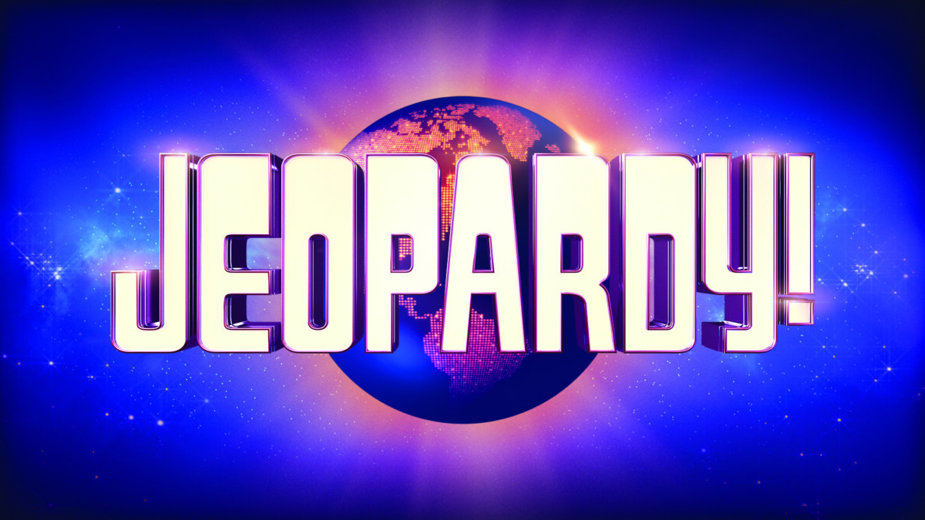

Revision of third year topics

Please create a jeopardy game with the following 5 obligatory categories

- Punching the Air
- So#6 Sustainability in the USA
- Disney’s princesses
- Christmas
- Music

The procedure is as follows:

- You get 40 minutes for the preparation of a jeopardy in your group. Please make sure that you make at least 4 questions for each category. This should be easy since you have already prepared your questions at home. It is recommendable to create your jeopardy game at https://jeopardylabs.com/. Remember the following when creating your questions: Write your question first ”What is the date of the signing of the Declaration of Independence”?
Then you write your answer. Remember your answer must be written as a question ”What is the 4 July 1776”?

- After the 40 minutes the person, whose name is written in bold, is supposed to remain seated – since he is the quiz master. The remaining members of the team are to split up and to visit the following groups: Group 1 visits the quiz master from group 2, Group 2 visits group 3, group 3 visits group 4, group 4 visits group 5, group 5 visits group 6.
- The quiz master is in charge of the game. He/ she will now divide you into two teams and will give you instructions in relation to the game.

Groups

Gruppe 1
- Cameron Bilde Stephens
- Alexander Deschampheleere Staugaard
- Mubarik Abdiqadir Isse
- Frederik Scharff
Gruppe 2
- Thomas Nicolaj Hänel
- Johan Frants Mathias Verhoog
- Amaan Ahmed Habib
- Rasmus Gadegaard Edske
Gruppe 3
- August Daugaard Weidlich
- Laura Voss Virklund
- Sarah Gry Nielsen-Hannerup
- Johannes Vraa Mortensen
Gruppe 4
- Savannah Mitzi Vithcetz
- Nicolai Dalsgaard Fredløv
- Alexzander Hesseldahl
- Alexander Gade Ringkow Jørgensen.
Gruppe 5
- Signe Rømer Brandt
- Jonathan Greulich Meinertz
- Jens Krogh Hermansen
- Tina Fatic Petrovic
Gruppe 6
- Alexander Dam Runesten-Petersen
- Sara Simonsen
- Sebastian Juul Falkenlund
- Marcus Jensen Bruun

