Disney – The company and its princesses
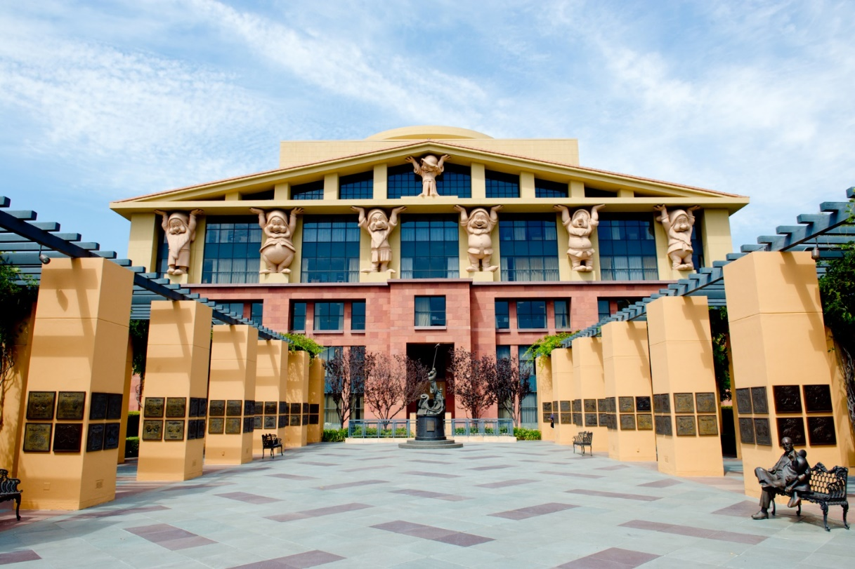

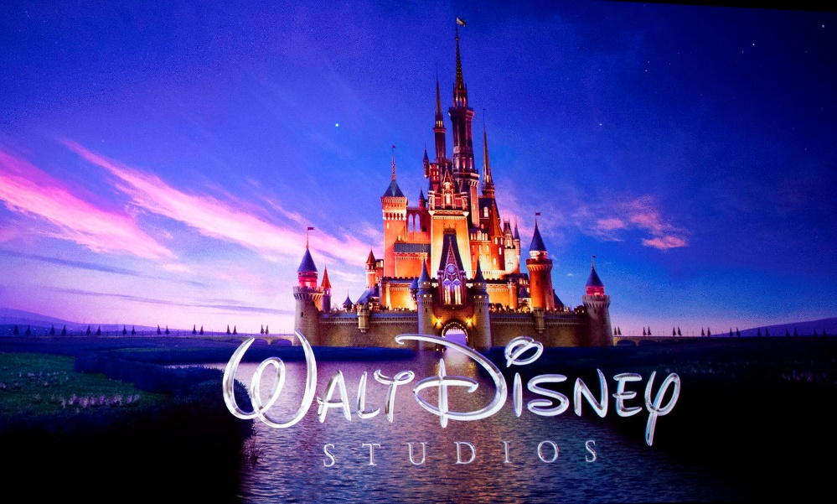
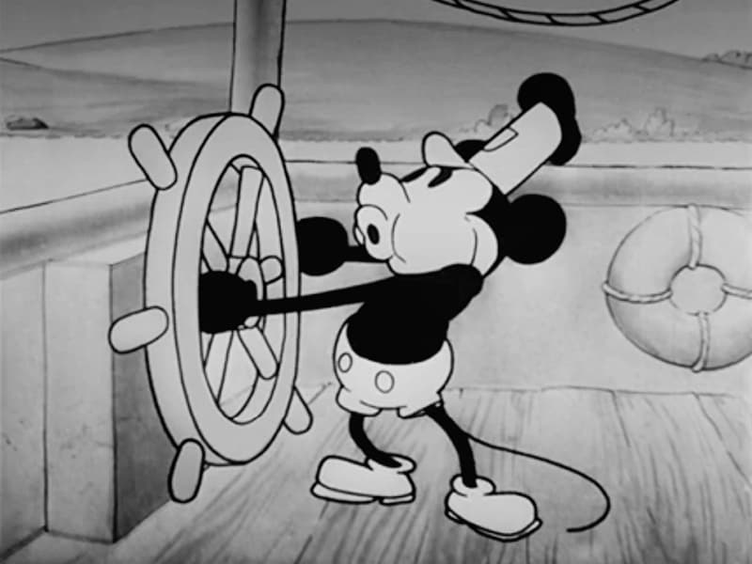
Table of Contents
What is Disney? 4
The Walt Disney Company Reports – Second Quarter and Six Months Earnings for Fiscal 2024 (Excerpt) 5
Tasks: Company Report 7
Understanding Disney 8
Tasks: Understanding Disney 13
The Companies that Disney Owns 14
CNBC: 14 years, 4 acquisitions, 1 Bob Iger: How Disney’s CEO revitalized an iconic American brand 15
Tasks: 14 years, 4 acquisitions, 1 Bob Iger… 24
Argumentative essay – A Black Princess 25
Walt Disney Studios: The Little Mermaid | Officuak Teaser Trailer 27
The Recount - Black Kids’ Heartwarming Reactions to ‘The Little Mermaid’ 28
Inside Edition: Disney’s ‘The Little Mermaid’ Trailer Sparks racist remarks 29
Spiked-online.com - Disney: a billion-dollar casualty of woke 30
Business Insider: Bob Iger says 'woke' Disney is over, but it may not silence his critics 33
Analyzing the World According to Disney 35
Tasks: the World According to Disney 38
Movie: Snow White and the seven dwarves 39
Find examples of classic Disney in the movie 39
Movie: Viana 41
Find examples of classic Disney in the movie 41
Manuscript for a speech – Disney and Its princesses. 43
From Snow White to Moana: The Evolution of Disney Princesses 44
Report: Disney still has a big princess problem 47
Why children need better role models than Disney princesses | Mia Fisher | TEDxCCHS Youth 49
Disney Princesses As Told By Bros | Let's Talk Disney by Oh My Disney 50

What is Disney?
What is Disney? We all have an idea, whenever we hear the word, but what is it actually? This task is all about conceptualizing the abstract notion which is Disney.
The rules are pretty clear:
- You are not allowed to use ChatGPT at all. Only Google searches.
- You may only use English texts.
- You must find enough information to conduct a 5 minutes presentation.
- NO POWERPOINT! Only cue cards.
So.. What are you going to do? Answer the question in title: What is Disney?
You have both lessons to prepare the presentation.
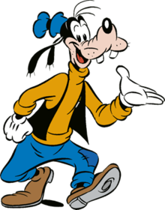

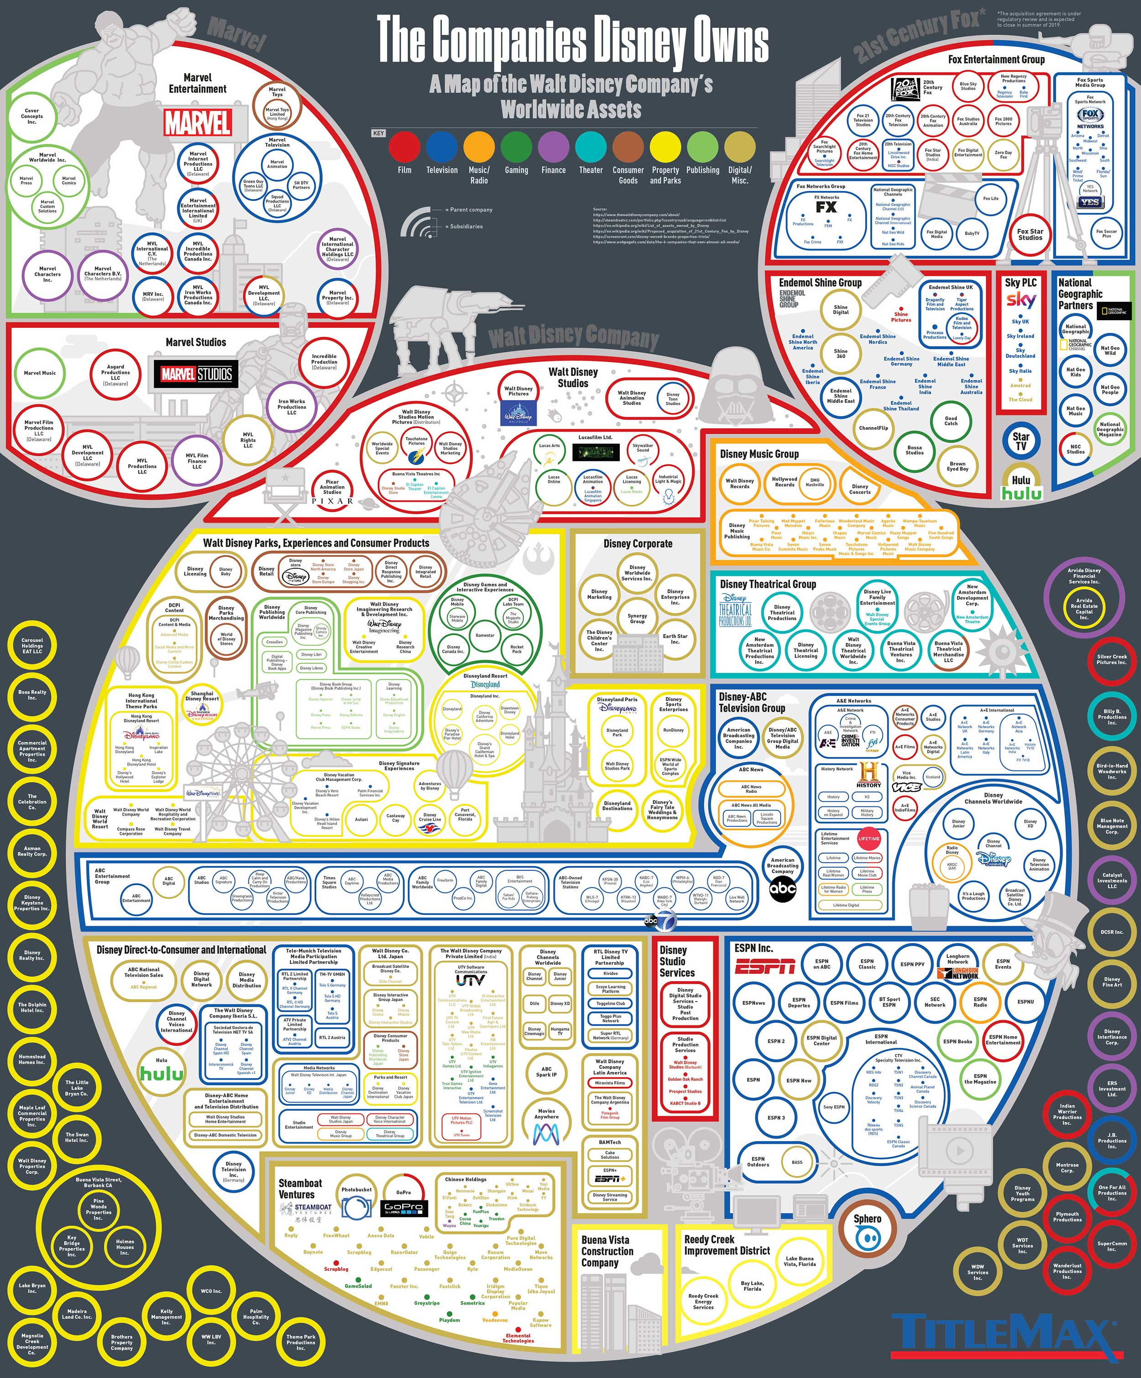
The Companies that Disney Owns

The Walt Disney Company Reports – Second Quarter and Six Months Earnings for Fiscal 2024 (Excerpt)
May 7, 2024
BURBANK, Calif. – The Walt Disney Company today reported earnings for its second quarter ended March 30, 2024.06.17
Financial Results for the Quarter:
- Revenues for the quarter increased to $22.1 billion from $21.8 billion in the prior-year quarter.
[…]
Key Points:
- In the second fiscal quarter of 2024, we achieved strong double digit percentage growth in adjusted EPS, and met or exceeded our financial guidance for the quarter.
- As a result of outperformance in the second quarter, our new full year adjusted EPS(1) growth target is now 25%.
- We remain on track to generate approximately $14 billion of cash provided by operations and over $8 billion of free cash flow(1) this fiscal year.
- We repurchased $1 billion worth of shares in the second quarter and look forward to continuing to return capital to shareholders.
[…]
- Disney+ Core subscribers increased by more than 6 million in the second quarter, and Disney+ Core ARPU increased sequentially by 44 cents.
- Sports operating income declined slightly versus the prior year, reflecting the timing impact of College Football Playoff games at ESPN, offset by improved results at Star India.
- The Experiences business was also a growth driver in the second quarter, with revenue growth of 10%, segment operating income growth of 12%, and margin expansion of 60 basis points versus the prior year. […]

Message from our CEO
“Our strong performance in Q2, with adjusted EPS up 30% compared to the prior year, demonstrates we are delivering on our strategic priorities and building for the future,” said Robert A. Iger, Chief Executive Officer, The Walt Disney Company. “Our results were driven in large part by our Experiences segment as well as our streaming business. Importantly, entertainment streaming was profitable for the quarter, and we remain on track to achieve profitability in our combined streaming businesses in Q4.
“Looking at our company as a whole, it’s clear that the turnaround and growth initiatives we set in motion last year have continued to yield positive results. We have a number of highly anticipated theatrical releases arriving over the next few months; our television shows are resonating with audiences and critics alike; ESPN continues to break ratings records as we further its evolution into the preeminent digital sports platform; and we are turbocharging growth in our Experiences business with a number of near- and long-term strategic investments.”

Tasks: Company Report
Based on what you have read: Is everything okay with Disney?
Write your answer here.

Understanding Disney

From: Janet Wasko: Understanding Disney: The Manufacture of Fantasy, 2020
Theatrical markets
After the 1984 management shuffle, the Disney company greatly diversified its repertoire of theatrical film releases, expanding into adult-oriented films via Touchstone, Hollywood, and Caravan labels, as well as independent labels such as Miramax and Merchant-Ivory.55 These moves provided opportunities to distribute films not associated with the family-oriented, PG-rated Disney' brand. The company also reinvigorated its animated film fare, as well as maintaining the Disney tradition of periodically reissuing classic Disney films. The new animated features, such as The Little Mermaid and The Lion King, added stories and characters to the Disney stable and became wildly successful as theatrical films, home videos, television series, merchandise, theme-park attractions, and Broadway productions.
Under Bob Iger’s leadership, the company added even more diversity with the previously discussed purchases of Pixar, Marvel, and Lucasfilm. The distribution of Marvel and Lucasfilm products were a bit complicated, with various rights remaining with other major studios. However, by 2016 Disney was shattering industry records and setting new benchmarks for annual box-office revenues with a good number of worldwide hits that year. During 2016, the company became the fastest studio to hit $2 billion domestically, $3 billion internationally... and, by the end of the year, the first studio ever to hit $7 billion globally. In 2016, Disney was responsible for six of the highest-grossing ten films of the year domestically, and five of the top ten internationally. And records continued to be shattered: in 2018, Avengers: Infinity War grossed more than $2 billion, while Black Panther pulled in more than $1.3 billion.
Obviously, the company's acquisition strategy was working. However, Disney owed its success to more than just a return to a galaxy far, far away. As Alan Horn, chairman of Walt Disney Studios, observed, “This historic achievement is possible because all of our film studios arc bringing their absolute best to the table, telling great stories of all kinds that resonate with audiences across borders, gender, and generations. These films work because each one has not only something for everyone, but everything for someone."
Home entertainment market
The company distributes entertainment products to home entertainment markets under each of its motion picture banners. During takeover discussions in the early 1980s, the value of the Disney film library was estimated to be approximately $400 million, but the same reports observed that, if exploited more aggressively, it would have been worth even more. Team Disney was aggressive, to say the least. Many of the classic (and even not-so-classic) Disney films were pulled from the vaults and released on video, resulting in quick cash for the new management team. Gomery noted that, in 1986 alone, video revenues raised more than S100 million of “pure profit” for the firm.
The company continued to exploit its film library; carefully releasing already amortized products in home video formats, as well as packaging and promoting them in various ways, thus maintaining the stable of classic Disney characters for exploitation throughout the company's various businesses. Home entertainment releases are sold after theatrical distribution in physical (DVD and Blu-ray) and electronic formats. Physical formats arc generally sold to retailers, such as Wal-Mart and Target, and electronic formats arc sold through Apple and Amazon, as well as direct-to-consumer streaming video businesses such as Netflix, Hulu, and Disney+ […]. Buena Vista Home Entertainment manages Disney’s home video business and interactive products around the world and, thanks to the video release of its popular animated features, has consistently been the top video company in the United States. Meanwhile, the list of top-selling titles for many years has been dominated by Disney. The company offers so man)' releases that video stores and Other retailers often set aside special sections for these products - a feature that is unique to the Disney brand. In addition, follow-up, direct-to-video versions of successful animated features have been produced by the company, although they became less common after 2016.
The extent of Disney ’s library' represents a valuable resource as content is available for release in current and future outlets and platforms. At the end of 2017, Disney reported approximately 1,400 active produced and acquired titles, including 1,000 live-action titles and 400 animated titles, in the domestic home entertainment market and approximately 1,900 active produced and acquired titles, including 1,300 liveaction titles and 600 animated titles, in international markets.
Consumer products
Disney’s merchandising activities are legendary in terms of their historical precedence, as well as ongoing and recent successes. As discussed in the previous chapter, merchandising started almost simultaneously with the success of Mickey Mouse’s Steamboat Willie, Recall that the company was offered $300 to put The Mouse on writing tablets in 1929. And although various histories claim that Walt Disney was not necessarily interested in licensing his characters, these activities still provided needed revenue to continue producing expensive animated films. During the 1930s, the company began to flood the market with Disney products: "Mickey’s likeness soon appeared on everything from soap to ice-cream cones to Cartier diamond bracelets for $1,250.”
At the height of the Depression, the Disney merchandising bonanza was said to have saved the Lionel Company with the sale of 253,000 Mickey Mouse handcars and the Ingersoll-Waterbury Company with the sale of 2.5 million Mickey Mouse watches. By 1934. annual profits on films and merchandise brought in more than $600,000 for the Disney company. It is claimed that Mickey has been the most popular licensed character in the World. As of 1998, he Was said to have appeared on more than 7,500 different items, not including publications. At the time of his eightieth-anniversary celebration in 2008, Time magazine declared Mickey Mouse one of the world’s most recognized characters, even when compared to Santa Claus, and that approximately 40 percent of Disney s revenues for consumer products were derived from Mickey Mouse merchandise, with revenues peaking in 1997.
Merchandising activities played a relatively minor role in Hollywood, except for Disney, until the 1970s, when film companies (as well as toy manufacturers) started to realize the value of movie-related merchandise, especially with the enormous success of Star Wars items. Television also joined the bandwagon, increasing merchandise and tie-ins evolving from children’s shows, as well as programs designed around preexisting toys. Media-related merchandise and tie-ins have grown dramatically since the 1980s, and, by 2016, retail sales of licensed merchandise reportedly reached $262.9 billion worldwide, with entertainment/characters representing 45 percent of that total.
Disney is often claimed to be the largest worldwide licensor of character-based merchandise and is listed as “the perennial No. 1 global licensor in a survey published annually by License! Global. Certainly, it is the foremost merchandising company in Hollywood. Consumer revenues have increased over the years, especially since the purchase of Pixar, Marvel, and Lucasfilm.
In June 2015, the Disney company merged its Consumer Product and Interactive divisions in response to changing consumer preferences in a marketplace increasingly influenced by technology… as technology and digital entertainment continue to evolve, a shared innovation strategy will enable this new segment to create unique and engaging products and experiences that exceed consumers' expectations As Iger explained: "Our Consumer Products team is also combining next-generation technology with Disney’s creativity to elevate storytelling for a new generation, transforming the merchandising, retail, and publishing industries in the process.” The combined Consumer Products and Interactive Media segment attracted $5.5 billion in revenue in 2016, but this had declined to ¢4.8 billion by 2017. While it is unclear what products are included in these revenue figures, it is probable that they do not include items that are manufactured and sold without the company’s authorization - in other words, pirated Disney merchandise. Consumer Products and interactive Media covered a wide range of businesses that will be discussed in following sections.
Retail
Disney merchandise is marketed in a multitude of ways, including directly through retail, online, and wholesale businesses. Disney-, Marvel- and Lucasfilm themed products are sold at retail stores, Disney Stores, and through internet sites, such as shopDisney.com and MarvelStore.com.
In 2018, Disney owned and operated a total of 365 Disney stores, mostly in the United States but also in Europe and Japan. The sites well represent the overriding Disney philosophy, as observed by an industry publication: “The core strategy behind The Walt Disney Co.’s retail endeavor, The Disney Store, is to be both entertainer and merchant.” The stores have been called the first example of “retail-tainment,” as they often include Disney characters in costume, videos, animation, and other attractions, carefully coordinated with racks of merchandise, as well as promotions for other Disney businesses. Computer kiosks often allow consumers to connect to the Disney Stare online tor items not available in the store. In 2017, the company began revamping the stores in various ways to make the stores “a hit more like Disney's theme parks? The stores have added large video screens, where live activities at the parks are featured.
Of course, Disney products are sold at a wide range of retail outlets around the world, sometimes in special “product comers" which feature only Disney merchandise. Very often, hew product lines are introduced with special contests and events. In fact, the wide range of products means that it is often difficult to avoid Disney merchandise. A survey of one typical American shopping mall found that more than 90 percent of the retail outlets offered at least one Disney-themed product. And this was a shopping mall that included an official Disney Store.
The Disney company also sells its products through its own outlets, beyond the Disney Stores. The theme parks are jam-packed with gift shops and merchandise kiosks, and Disney’s online sites vigorously promote sales of the merchandise. For many years, millions of copies of The Disney Catalog were mailed monthly, but the company suspended this direct mail process in 2014 and now emphasizes online and social media outlets. As the Disney annual report boasts:
Every day, The Walt Disney Company connects with millions of people around the world through its more than 1,000 social media accounts. In addition to the accounts listed in this online directory, a variety of TV personalities and talent at Disney, ABC, ESPN and Marvel engage with fans through soda! media. The Walt Disney Company is committed to providing our fans and social communities with exciting new content and experiences, allowing them to connect with their favorite brands, characters and stories anywhere, at any time, on every platform.
Online business
Disney OnLine was started in 1995 to “develop The Walt Disney Company's presence in the online world,” including creating and distributing content for online services, interactive software, interactive television, and internet websites. The site www.disney.com was launched in February 1996, followed in 1997 by the creation of a web portal called the Go Network (or Go.com), with access to “every form of information and entertainment that Disney offers.” However, rather quickly, Go.com became a Disney “landing page” as search engines became the common route to access the internet. As Wikipedia reports: “Go.com proved to be an expensive failure for its parent company, as web users preferred to use search engines to access content directly, rather than start at a top-level corporate portal. In 2013, the site was transitioned from a portal to a simple landing page.”
Disney Daily Blast was initiated in April 1997 as an “ad-supported Internet subscription service for kids” on the Microsoft Network. Jake Winebaum, president of Disney Online, explained: “We will be extra sensitive in our ad efforts, since the consumers we’re talking about here arc kids.” The site included interactive comic strips with sound, online coloring books, games, and ‘digital toys” to download, all featuring Disney characters, plus news and sports provided by ABC and ESPN. After being blasted by the press, not only for charging a fee for the service but for not immediately making the site compatible with Apple computers, the service became known as a “dub,” and was described this way in the D23 A to Z reference guide: “Disney’s Blast Online was introduced in 1997 as Disney’s Daily Blast. This dub by Disney Online offered interactive and educational games for kids and families. In 2007, it became Disney Game Kingdom Online; its memberships ended on August 25, 2011.
As suggested by these examples, the saga of Disney's online development since the 1990s has been complex and expensive, involving a number of blind alleys, small company takeovers, and start-ups that folded. But the company has moved along in the general direction of online businesses, developing a digital machine for promoting their properties and marketing their merchandise.
Disney’s website was redesigned in 2007, including a service that allowed users to communicate with each other, as well as various Disney entertainment features and a shopping area. The site gradually changed to represent the expanded Disney Multiverse, with features and products connected to various franchises and brands, and specific films and characters, as well as demographic designations. Meanwhile, other website features include “Oh My Disney,” which offers a combination of news for fans, quizzes, Disney-themed recipes, surrounded by links to shopping sites, and “Disney LOL," featuring games, videos, and other activities. Thus, the redesign also expanded the demographic appeal of the site, with special attention given to adult shoppers […]

Tasks: Understanding Disney
Expand your vocabulary: Find at least 10 words you want in your vocabulary
Word | What does it mean? | Use the word in a sentence
What are the main points from the following sections of the text? Find at least 3 from each section.
Theatrical markets:

Home Entertainment:

Consumer products:

Retail:

Online Business:

CNBC: 14 years, 4 acquisitions, 1 Bob Iger: How Disney’s CEO revitalized an iconic American brand


KEY POINTS
- Disney has earned more than $8 billion from sales of movie tickets this year, the most any studio has ever made.
- The company’s net income has increased 404% under Bob Iger, who is still set to depart the position of CEO in 2021.
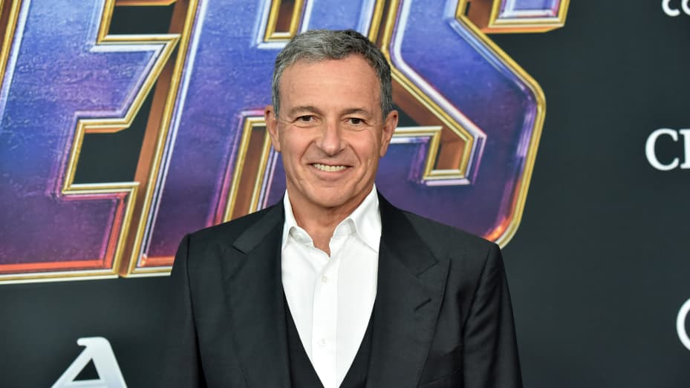
- The entertainment giant reported earnings after the close on Tuesday.
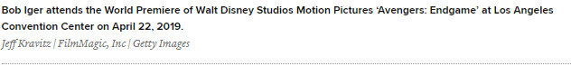

Disney’s domination of the global box office in 2019 has been nearly 20 years in the making, under the direction of Bob Iger.
In 2005, Disney was coming off a successful decade of hit animated films — “Lion King,” “Aladdin” and “Pocahontas,” among others — but competition from other studios was getting stronger and the House of Mouse was starting to slip.
While releases like “Lilo and Stitch,” “Pirates of the Caribbean” and “National Treasure” performed well for the company in the early ’00s, it also released less memorable features like “The Country Bears,” “Snow Dogs” and “Home on the Range.”
Enter: Iger.
In 2005, Disney promoted its chief operating officer to the helm of the company. In the last 14 years, Iger has facilitated one of the most remarkable revitalizations of any iconic American brand.

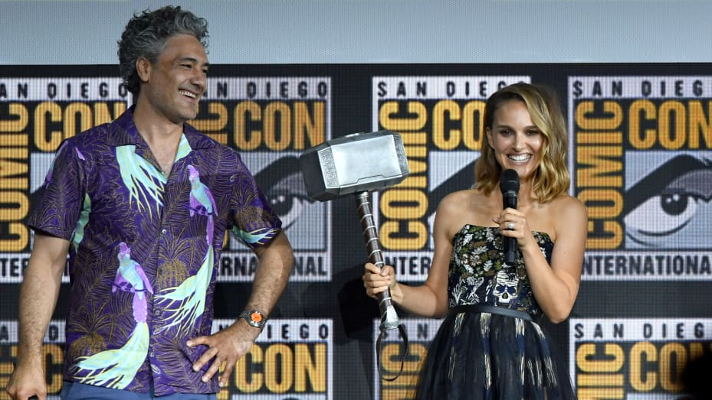
Iger has led the charge on acquiring Pixar, Marvel, Lucasfilm and, most recently, 20th Century Fox. The first three acquisitions alone have earned Disney more than $33.8 billion at the global box office, not including production and marketing costs or the benefit of merchandise and theme park extensions.

As of Sunday, the company has earned more than $8 billion from sales of movie tickets, the highest any studio has made in a year, and there’s still five months left to go. A large portion of that gross is from “Avengers: Endgame” which has become the highest-grossing film of all time, surpassing “Avatar.”
In the U.S., Disney has made $2.6 billion from its films. It’s closest competitor, Comcast’s Universal, has made $987 million so far this year.
Disney’s 38% of the total U.S. box office this year marks the high point of a Hollywood strategy now a decade-and-a-half in the making, and that began at a time when the company’s films captured about 10% of the market.
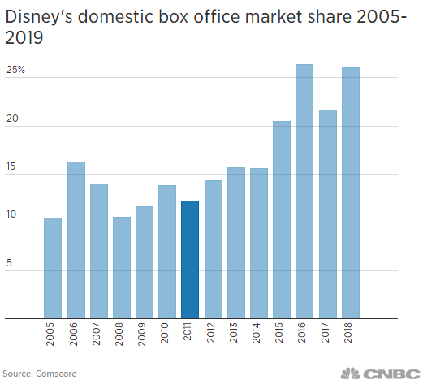
“Iger is going to be viewed historically as a major mogul,” said Jason Squire, professor at the USC School of Cinematic Arts and editor of “The Movie Business Book.”
In the year that Iger was named CEO, Disney made $2.5 billion in net income. Last year, the company’s net income was $12.6 billion, a 404% increase. Similarly, Disney stock has risen exponentially. Shares of Disney are up 450% from $25 per share in 2005 to nearly $140 in August 2019.
“Disney is totally different than what it used to be 10 or 12 years ago,” said Doug Stone, president of Box Office Analyst. “Iger came in and was laser-focused on increasing profitability.”
To infinity and beyond
In his first earnings call as CEO, Iger was quick to address how he planned to put his mark on the company.
“We intend to be disciplined in our approach to our current cost structure and our investments,” he said. “This investment approach extends not only to our internal development, but also to how we approach acquisitions. As we have stated in the past, we do not feel the need to acquire assets just to get bigger or simply to wade into new space. We are prepared to move wisely and quickly in order to respond to rapid changes in the marketplace.”
Within two months of that call, Iger announced that Disney would acquire Pixar Animation Studios for $7.4 billion.
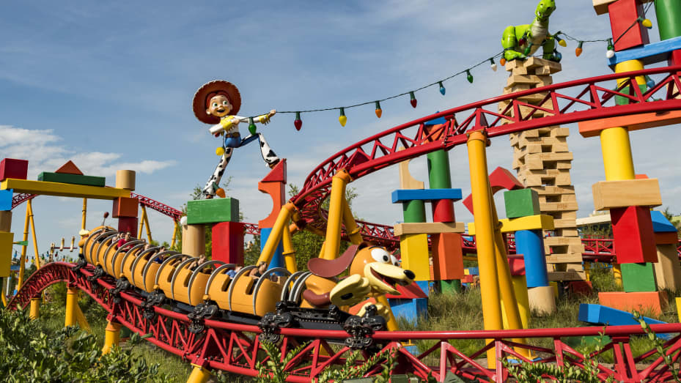
Since Pixar’s first film “Toy Story” debuted in 1995, it has earned more than $14 billion at the global box office. Around $11 billion of that has come after Disney’s acquisition.
But when Disney first announced this acquisition, analysts were skeptical. Some even felt that Disney had paid too much for the animation studio.
“Seems that all those choices, in retrospect, were great choices,” Squire said.
Pixar was already a well-established and prestigious brand. In the years before Disney acquired the company, Pixar had earned two Academy Awards for best animated feature for “Finding Nemo” and “The Incredibles.”
Since 2007, Pixar has earned another seven — for “Ratatouille,” “WALL-E,” “Up,” “Toy Story 3,” “Brave,” “Inside Out” and “Coco.”
Simply buying a brand like Pixar didn’t ensure Disney’s success. The company still had to continue to produce good content. Disney kept John Lasseter in command at Pixar, and when Lasseter left in 2018 after a sexual harassment scandal, it hired Pete Docter and Jennifer Lee to helm the studio.
Docter had been with the company for decades and directed “Monsters, Inc.,” “Up,” “Inside Out” and the upcoming “Soul.” Lee joined Disney Animation Studios, a separate animation house at Disney, in 2011 and co-wrote “Wreck-It Ralph.” She also co-directed “Frozen,” which went on to win an Academy Award.
“You have to give Disney credit, not just for the acquisition but for the execution,” said Paul Dergarabedian, senior media analyst at Comscore. “Had other companies bought these brands, the market share might would have been split up, but we don’t know what other studios would have done with these brands.”
Assembling Earth's mightiest heroes
That same sentiment goes for Disney’s acquisition of Marvel.
Marvel Studios had taken a big risk in green lighting “Iron Man.” At the time, Marvel had just entered into a massive financing contract with Merrill Lynch to fund a slate of films and a lot was hanging on whether the film would resonate with audiences.
They had tapped Robert Downey Jr., an actor who was fixing for a comeback after years of drug abuse and a brief stint in prison, as well as Jon Favreau, a director, who at the time was best known for his work on the Christmas comedy “Elf.”
In its opening weekend in 2008, “Iron Man” snared nearly $100 million at the box office, before going on to garner just under $600 million worldwide.
From the beginning, Disney’s philosophy has been “cradle to grave,” Squire said. The company catered to children with its animated features, the Disney theme park was a family destination, and its cruise line, while also family-friendly, could also be a place for older generation Disney fans to enjoy.
What Disney was missing was the teenage and young adult demographics.
In 2009, Disney made its move. While Marvel had already contracted several films with Paramount and Universal as part of its Marvel Cinematic Universe, Iger closed on a deal to purchase the comic book company for around $4 billion.
The company kept Kevin Feige, president of production for Marvel Studios, on board. He continues to run the studio today.
“This is perfect from a strategic perspective,” Iger said at the time. “This treasure trove of over 5,000 characters offers Disney the ability to do what we do best.”
It seems he was right.
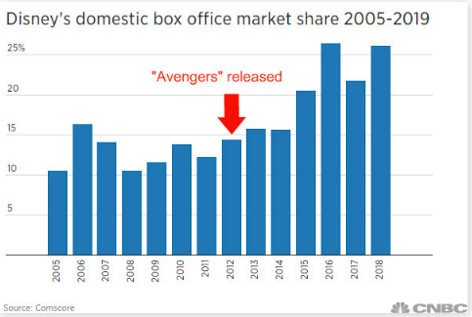
Since releasing its first Disney-produced Marvel movie in 2012, the company has earned more than $18.2 billion at the global box office. And it’s on its way to making billions more.
At San Diego Comic-Con last month, Marvel announced its upcoming slate of films and TV shows that expand on the 23 movies already in the MCU.
“Marvel ensured the future of the company,” Dergarabedian said.

One with the Force
In the same year that Disney released its first produced Marvel feature, it also snatched up another lucrative brand. In October 2012, Iger announced that Disney had purchased Lucasfilm for $4.05 billion.
After three years of production, the company released “Star Wars: The Force Awakens” in 2015. It was a continuation of the original “Star Wars” trilogy from the late ’70s and early ’80s, taking place 30 years after the fall of the Empire.

It made more than $2 billion globally.
Since 2015, Disney has released four “Star Wars” films and garnered nearly $5 billion at the global box office. The final film in the Skywalker saga is set to be released in December.
Of course, these receipts don’t account for the estimated $200 million to $300 million Disney shelled out per film in production costs or the money spent on its robust marketing campaigns to promote each release.
However, Disney has also made money from DVD, BluRay and digital sales, not to mention licensing agreements for the brand and sales of its own Star Wars apparel, toys and novelizations.
Ahead of the release of “The Force Awakens” in 2015, Disney’s earnings got a boost from sales of Star Wars merchandise on Force Friday, a September event designed to excite fans of the franchise to purchase newly released goods.
Not to mention, Disney has two Star Wars Lands theme park lands, one open in California and one in Florida due to open at the end of August.
Meet the Simpsons
In March, Disney closed on its biggest acquisition yet: a $71 billion deal for 20th Century Fox.
Buying the studios behind “The Simpsons” and X-Men allows Disney to better compete with companies such as Amazon and Netflix for viewership and dollars as the streaming competition intensifies.
Disney is set to release its own streaming service, Disney+, in November. Along with its own library of content, Disney now has all of Fox’s entertainment assets.
The company has already said all episodes of “The Simpsons” will appear on the services on day one. Other 20th Century Fox titles on Disney+ will include “The Sound of Music,” “The Princess Bride” and “Malcolm in the Middle.”
“The coin of the realm is IP,” Squire said.
Little is known about how Disney plans on using Fox properties in the future. It has added films that were already in production or set for release to its box office slate, but hasn’t announced any Disney-made Fox films or TV shows as of yet.
However, Disney has revealed that it will produced all four “Avatar” sequels which were green lit by Fox several years ago.
Outside of the film space, Disney has faced headwinds in recent years, including at cash cow ESPN. Viewership has been on the decline, relationships between cable operators and networks are tense, and the situation remains unstable as more people ditch cable for streaming services.
Disney has created ESPN+, a streaming version of its TV network. The company has said that it will bundle ESPN+ with the upcoming Disney+ and Hulu, but the company is being forced to invest heavily in streaming without an immediate path to profits. It has seen fast growth in the ESPN+ service since launching last year, adding more than two million subscribers.
Disney shares fell when it reported earnings after the close on Tuesday. While revenue was up from the year-ago quarter in Studio Entertainment (+33%), Media Networks (+21%), and Parks (+7%), the direct-to-consumer segment saw revenue of $3.86 billion but operating losses increased to $553 million from $168 million. Disney cited Hulu and increased investments in ESPN+ and Disney+ streaming services, and Iger said on a call with analysts that the bundle will cost $12.99 and launch in November. Even the movie studio’s impressive performance took a hit on the disappointing box office results for “Dark Phoenix.”

What's next for Iger?
Iger has said that he is definitely stepping down from his post at the company in 2021.
“I’m expecting my contract to expire at the end of 2021,” Iger said during Disney’s investor day in April. “And I was going to say ‘and this time I mean it,’ but I’ve said it before. I’ve been CEO since October of 2005 and as I’ve said many times, there’s a time for everything and 2021 will be the time for me to finally step down.”
Iger has extended his contract with Disney twice during his tenure. Once in 2018 and then through 2021, but it was contingent on the Fox deal closing. Since that merger has wrapped up, Iger will remain with the company as the head executive for the next two years.
“This success was not overnight,” Dergarabedian said. “Disney has had to go through many permutations, but it’s now got an unbeatable combination of brands.”
This story has been updated to include Disney’s earnings results reported after the close on Tuesday.
Disclosure: Comcast is the parent company of NBCUniversal and CNBC.

Tasks: 14 years, 4 acquisitions, 1 Bob Iger…
Comprehension:
- What is the text about. No more than 30 words.

Analysis:
- Make an analysis in which you analyse two different semantic fields.

Write your notes here.

Argumentative essay – A Black Princess
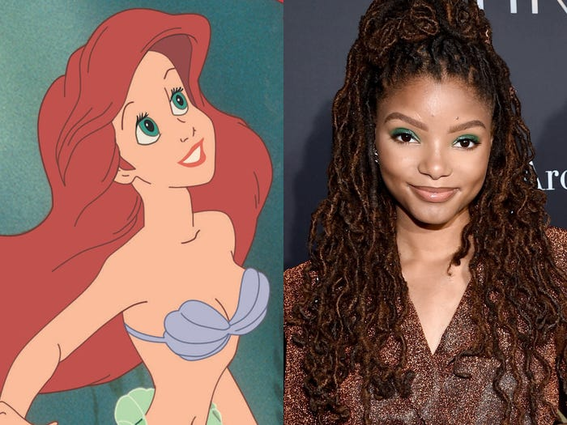
Write an argumentative essay in which you discuss the debate about the little mermaid being black.
Write the essay in English.
Give your essay a title that reflects your thesis statement.
Word count: 800-1200 words.
State your word count at the end of your essay.
Your essay must include references to the source material. All sources must be documented.

Use the following sources:
- Walt Disney Studios: The Little Mermaid | Officuak Teaser Trailer [0,4 ns]
- Inside Edition: Disney’s ‘The Little Mermaid’ Trailer Sparks racist remarks [0,6 ns]
- Spiked-online.com - Disney: a billion-dollar casualty of woke [2,6 ns]
- Business Insider: Bob Iger says 'woke' Disney is over, but it may not silence his critics [1,1 ns]
- The Recount - Black Kids’ Heartwarming Reactions to ‘The Little Mermaid’ [1,2 ns]

Walt Disney Studios: The Little Mermaid | Officuak Teaser Trailer
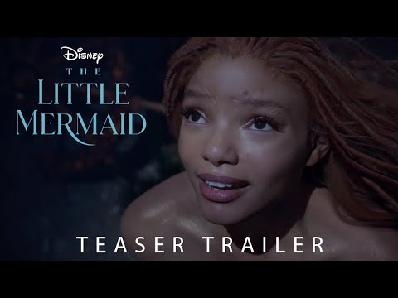

The Recount - Black Kids’ Heartwarming Reactions to ‘The Little Mermaid’


Inside Edition: Disney’s ‘The Little Mermaid’ Trailer Sparks racist remarks
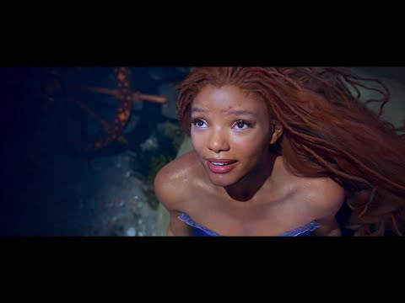

Spiked-online.com - Disney: a billion-dollar casualty of woke

The entertainment giant is paying a heavy price for trying to shove identity politics down our throats.
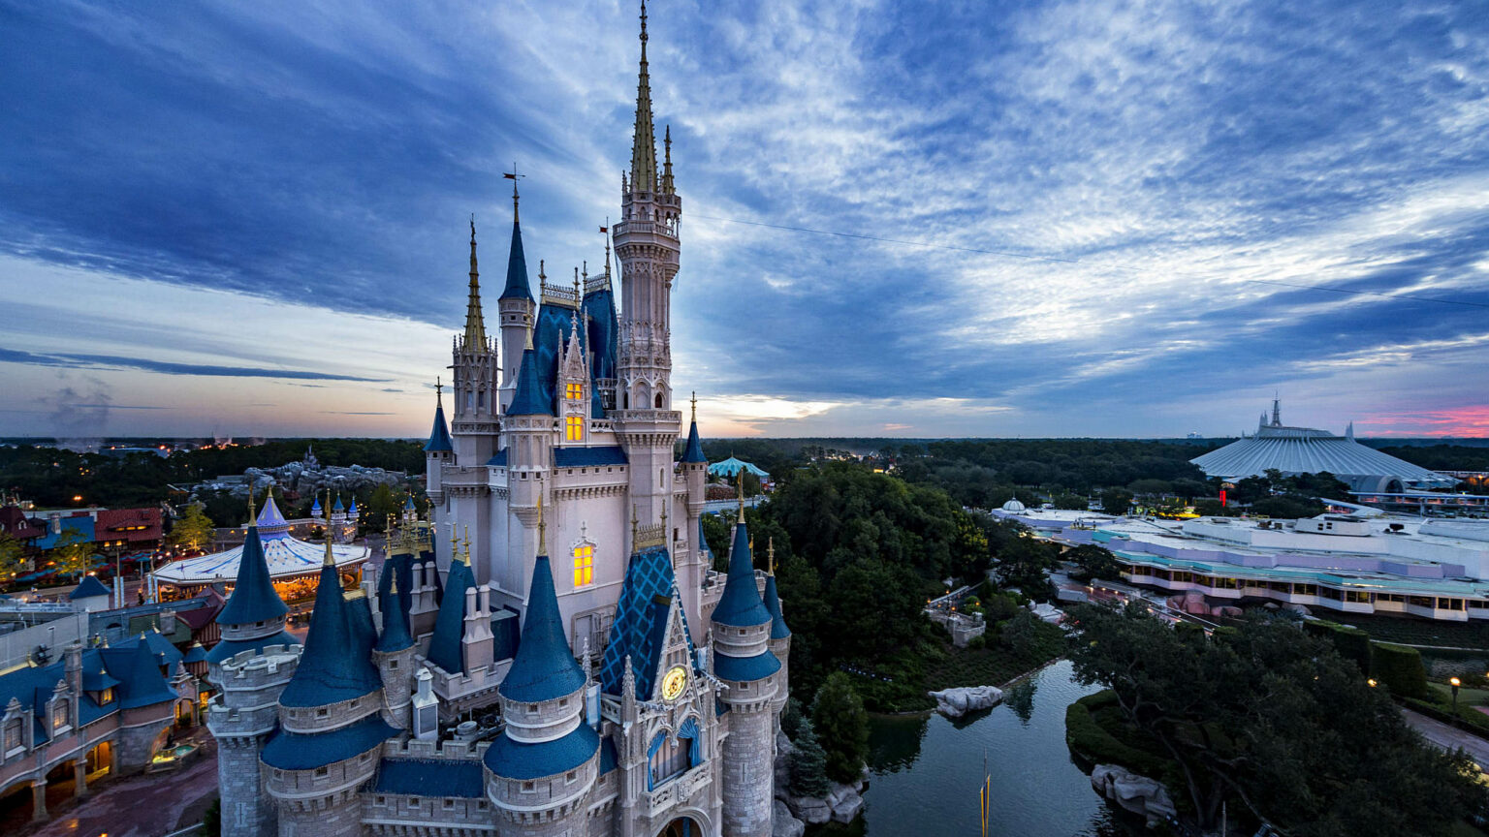
The Walt Disney Company is in deep trouble. Its last four high-profile releases bombed at the box office, losing over $1 billion between them. Once Hollywood’s most successful film studio, Disney was dethroned last year by Universal Pictures.
The reason for Disney’s decline? It has gone woke, to an almost comical degree. Last year, the company admitted to investors that there was a growing ‘misalignment’ between Disney’s output and ‘public and consumer tastes and preferences for entertainment’. ‘Consumers’ perceptions of our position on matters of public interest’, it said, are risking the company’s reputation and profits.
Viewing figures and box-office sales spell this out clearly. Audiences are growing sick of the woke slop that Disney has been serving them. They are tired with scripts that are weighed down by clunky political messaging. They are fed up with storylines being mangled to fit ‘progressive’ narratives. They are irked by Disney’s desire to lecture them instead of entertain them.
Even Disney franchises that were once guaranteed money-makers have struggled to excite audiences of late. Marvel Studios, which is owned by Disney, used to regularly break box-office records with its billion-dollar superhero films. As recently as 2019, Avengers: Endgame became the second-highest grossing movie of all time. But last year, Marvel registered its worst-ever year at the box office.
[…]
Practically all new Disney films place a huge emphasis on this kind of diversity casting. Karey Burke, president of Disney’s General Entertainment Content division, said in a leaked video in 2022 that she wants 50 per cent of all Disney characters to be either LGBT or from an ethnic-minority background. Disney Television Animation executive producer Latoya Raveneau has similarly said she is ‘adding queerness’ wherever she can to the shows she oversees.
No one is against diverse characters. Like any other character, they just need to be compelling and have depth. But all too often, their inclusion in Disney productions feels more like a tick-box exercise to meet Karey Burke’s quota. Meanwhile, they often come at the cost of other more familiar faces. It’s as if these ‘diverse’ characters are only on screen to send a message – to remind the public that ‘diversity is our strength’ – rather than drive the plot forward or engage the audience.
[…]
Disney’s preoccupation with diversity can often feel like an attempt to distract from its otherwise pedestrian output. Its 2023 live-action remake of The Little Mermaid, in which black actress Halle Bailey was cast as Ariel, is another case in point. Although some might have seen this blockbuster remake as a sad day for redhead representation, most members of the public were distinctly unbothered by the prospect of a black Ariel. Once again, few people are opposed to ‘diverse’ casting in and of itself.
Predictably, there were some tedious woke additions to the remake – including new lyrics in ‘Kiss the Girl’, emphasising the importance of consent. But the film’s main problem was that it was boring and uninspired. Although Disney was hailed in the media for its ‘inspirational’ choice of casting, The Little Mermaid performed worse than expected when it hit screens in 2023, barely breaking even. No amount of diversity hype can make up for a dull film.
Snow White is next up for a woke reboot. It’s slated for release next year. And already, its prospects aren’t looking good. Ever since her casting was announced in 2023, star Rachel Zegler has used every opportunity to trash the source material as sexist and outdated. She has called the film’s love story ‘weird’ and accused Prince Charming of having ‘literally stalked’ Snow White. Zegler claims that this new, updated version will focus less on romance and ‘true love’, and more on ‘women being in roles of power’.
This might sound thrilling to a women’s studies graduate, but what about the young girls the film is supposed to appeal to? And what about the adults who feel nostalgic for the original? Zegler has essentially branded their tastes as bigoted and backward. Listening to her interviews, you get the distinct impression that Disney now loathes its canon and its audience.
Time and again, Disney has gone out of its way to alienate and insult the core fanbases of its franchises. After Disney acquired Lucasfilm studios in 2012, Star Wars fans feared the franchise was about to be given a feminist, progressive makeover. Disney executive Kathleen Kennedy was even pictured wearing a t-shirt saying ‘The Force is Female’. Whatever that means.
[…]
Disney has even taken to making political interventions out in the real world. Since 2022, in the US state of Florida, home to Disney’s biggest theme park and resort, the Walt Disney Company has been locked in a fierce battle with governor Ron DeSantis over something entirely unrelated to Disney’s business interests – namely, the place of transgender ideology in schools.
DeSantis’s Parental Rights in Education Act bans ‘classroom instruction’ on issues of ‘sexual orientation or gender identity’ for schoolkids under the age of 10. Disney, apparently outraged by the prospect of preteens being denied an indoctrination into gender-identity ideology, pledged to donate $5million to organisations opposing the law. In retaliation, DeSantis revoked the special tax status that the Walt Disney World Resort has enjoyed since the 1960s.
Not only did this spat cost Disney its tax breaks – it also damaged its image as a family friendly company. Most parents agreed with DeSantis that gender ideology is an inappropriate subject for under-10s and were baffled that Disney would say otherwise. After the skirmish with DeSantis, Disney’s approval rating among Americans tumbled by more than 25 percentage points.
The woes facing Disney illustrate the powerful hold wokeness now has on big corporations. It’s as if Disney’s leaders felt compelled to toe the line on the identitarian agenda. They were prepared to trash the company’s reputation and alienate its fans, seemingly just to signal their allegiance to this new elite ideology.
Perhaps those billion-dollar losses will finally break the spell.
By Lauren Smith. She is a staff writer at spiked.
Spiked is considered to be a conservative magazine.

Business Insider: Bob Iger says 'woke' Disney is over, but it may not silence his critics


[…]
Disney CEO Bob Iger emphasized that the company would focus on entertaining over advancing "any kind of agenda," […]
Asked during Disney's annual shareholder meeting Q&A on April 3 if the company would just provide entertainment and stay out of politics, Iger said Disney's job was to "entertain, first and foremost."
"I've always believed that we have a responsibility to do good in the world, but we know our job is not to advance any kind of agenda," he said on the live-streamed meeting. "For as long as I'm in the job, I'm going to continue to be guided by a sense of decency and respect, and we'll always trust our instincts."
It's a message Iger has been keen to send since his return as CEO in November 2022.
During an April 2023 analyst call, he was asked a similar question about "promoting the woke agenda."
"I'm sensitive to that," he answered. "Our primary mission needs to be to entertain and then through our entertainment to continue to have a positive impact on the world. And I'm very serious about that. It should not be agenda-driven."
[…]
"I've used 'Black Panther' as a great example of that just in terms of fostering acceptance, or the movie 'Coco,' which Pixar did about the Day of the Dead," he added. "I like being able to do that, entertain and if you can infuse it with positive messages, have a good impact on the world, fantastic. But that should not be the objective."
Iger was even willing to put a pin in the long-running feud between Florida Gov. Ron DeSantis and Disney over the state's so-called "Don't Say Gay" law. In a surprising move, Disney and Florida settled their legal dispute in March.
Over the last several years, Disney has become a target of conservative politicians like DeSantis and social media voices — including, most recently, Elon Musk. Some criticize the company for including LGBTQ+ characters and elements in stories — like a same-sex kiss in "Lightyear" and nonbinary character in "Elemental" — while others took issue with a Black Ariel in the recent "Little Mermaid."
[…]
No matter how much Iger insists that the company's focus is entertainment, Disney will likely still produce content that reflects the world around it and introduces new characters — Iger has made clear that those movies can still be perfectly entertaining.
But even that will continue to agitate social conservatives. Just take the vicious online reactions to its new "Star Wars: The Acolyte" series on Disney+, made by a female showrunner.
With a company as embedded in the culture as Disney is, it doesn't take much for it to upset longtime fans, much less culture warriors. And with Iger promising the company will lean more on its beloved franchises, Disney is likely to continue being a magnet for criticism from social conservatives.

Analyzing the World According to Disney
From: Janet Wasko: Understanding Disney. 2001.
Snow White and the Seven Dwarfs
Zipes and other critics cite Snow White as the film that established the model for Disney’s reinterpretation of children’s literature. The film has attracted a good deal of critical attention from different perspectives, but, most importantly, it represents a prime example of Classic Disney.
Snow White and the Seven Dwarfs premiered in December 1937 and was Disney’s first animated feature. It is claimed as the first American animated feature and the first Technicolor feature and received special Academy Awards in 1939. Before its release, however, it was also known as “Disney’s Folly,” as many in the film industry were not convinced that audiences would sit through a feature-length cartoon. Nevertheless, by some accounts, Disney persevered primarily because he was convinced that the introduction of the double bill would eventually squeeze out short cartoons, and that the only profitable future for animation was in features that would attract more revenues.
Snow White was started in 1934 and took more than three years to complete. By the time it was finished, the cost was reported to be $1.5 million, although Schickel claims it was $1.7 million. The film earned $8 million on its first release and had been reissued six times by 1983, with revenues increasing to $47 million. With its fiftieth anniversary release in 1987, the film attracted $40 million in less than eight weeks.
Even though the story had already been produced as an animated film (Betty Boop was featured as Snow White by Max Fleischer in 1933), Disney considered Snow White to be the perfect narrative, replete with humor, romance, and pathos. According to Zipes, “it was in Snow White and the Seven Dwarfs that Disney fully appropriated the literary fairy tale and made his signature into a trademark for the most acceptable type of fairy tale in the twentieth century . . . Snow White became the first definitive animated fairytale film — definitive in the sense that it was to define the way other animated films in the genre of the fairy tale were to be made.”

Most analysts agree that Disney adapted the story of Snow White to suit an American audience, incorporating numerous changes from the printed Grimm brothers’ tale. The following is a summary of these changes, following Zipes:
 | Grimms’ Version |  | Disney’s Version
Mother dies and father is alive |  |  | No parents
Snow White does not work |  |  | Snow white works as a maid, cleans the castle
Prince: “negligible role” |  |  | Prince featured at beginning of film
Queen: “negligible role” |  |  | Queen: Jealous of Snow White
Animals: ““negligible role” |  |  | Animals: Snow White’s friends/protectors
Dwarfs: Anonymous, play humble roles |  |  | Dwarfs: Have names, personalities, starring roles
Queen visits three times |  |  | Queen visits only once
Queen is punished by dancing in hot iron shoes at Snow White’s wedding |  |  | Queen is killed while trying to kill the dwarfs
Snow white returns to life when dwarf stumbles while carrying the coffin |  |  | Snow white returns to life when kissed by the prince

While some analysts have found these changes problematic, Stone reminds us that the Grimms’ version was also a revision of the original oral versions of the Snow White tale, which were altered and adapted according to who was telling the story. Stone notes that textual and contextual sacrifices are inevitable when shifting from oral to printed to filmic forms. but concludes that the film version represents the most rigid and manipulative interpretation of the story. The Disney film “isolates creators and' receivers, and offers them even less possibility of interaction since it furnishes sights, sounds, and motivations. The filmed text thus provides the narrowest bridge of all, with the most closed text and context. There is only one Snow White and the Seven Dwarfs.
While it is clear that the Grimms’ and Disney versions share similar approaches to the domestication of women, Zipes argues that Disney went much further in making the tale the “triumph of the banished and the underdogs” and again relates the film to Disney’s own life. The Prince is ultimately the champion of the film, just as Disney is the one who controlled the production process. In other words, for Zipes, the overriding sign is “the signature of Disney’s self-glorification in the name of justice," as well as (once again) the quest for control:
Disney wants the world cleaned up, and the pastel colors with their sharply drawn ink lines create images of cleanliness, just as each sequence reflects a clearly conceived and preordained destiny for all the characters in die film. For Disney, the Grimms’ tale is not a vehicle to explore the deeper implications of the narrative and its history. Rather it is a vehicle to display what he can do as an animator with the latest technological and artistic developments in the industry. The story is secondary... The manner in which he copied the musical plays and films of his rime, and his close adaptation of fairy tales with patriarchal codes, indicate that all the technical experiments would not be used to foster social change in America but to keep power in the hands of individuals like himself, who felt empowered to design and create new worlds. Disney always wanted to do something new and unique just as long as he had absolute control.
There have been many other discussions of Disney’s version of Snow White, focusing on how Disney used romantic elements to emulate love, sentiment, and romance and examining themes of beauty. However, we turn now to how Snow White combined these various elements, and exemplified Classic Disney, as outlined above.
Classic Disney and Snow White. The Disney version presented an Americanized Snow White and might be said to have fully established the Classic Disney formula. Above all, the film was entertaining, with emphasis on the dwarfs and their comic escapades. One technical reason for this change had to do with the limitations of animation at the time, since humans didn’t animate especially well. The more cartoonish dwarfs thus provided comic relief by way of gags, mostly physical and slapstick, and thus actually dominated much of the film.
The film also features music throughout, a characteristic shared by most Classic Disney films. The characters are revealed and developed through the music; themes are set up and developed by it. Again, Disney adds anthropomorphized animal characters, although the animals do not play as large a role as in other Disney productions. Childlike behavior is featured, as cute characters abound, including Snow White herself, the animals, and the dwarfs.
The work ethic is emphasized in the Disney version of the story, as the dwarfs sing and whistle as they dutifully go off to work ( Whistle while you work” and “Heigh ho, heigh ho, it’s off to work we go”). Snow White is industrious and hard-working, as evidenced in the first scene in which she is seen cleaning at the palace, as well as cleaning sequences at the dwarfs’ cottage.
Snow White’s theme song (“I’m Wishing”) sets the stage for the theme of escape and fantasy. Other scenes include the magic wishing apple (dreams will come true) and especially Snow White praying for her dreams to come true.
Innocence is represented overtly through Snow White’s name, but also by her character. She trusts the dwarfs, but also trusts the witch. There is an emphasis on cleanliness. Snow White seems always to be cleaning, and the dwarfs’ washing song also stresses cleanliness and purity.
Classic Disney is emphatic in its depiction of good triumphing over evil. The Queen/witch is obviously evil and therefore is punished eventually with death. Snow White is innocent and good and is therefore rewarded. Ultimately, she finds fulfillment through a romantic relationship with a prince. Optimism and happiness prevail, “With a smile and a song.” The essence of the story is romance, and, as usual, it’s love at first sight.
Someday my prince will come.” And he does. And there is the happy ending — in this case, a very quick ending, as the Prince appears and they exit to the castle. Snow White’s dream comes true, so we must assume that happiness followed. Anyway, we are told so: “They lived happily ever after.”

Tasks: the World According to Disney
- Snow White became one of Disney’s greatest successes, but what was it known as before its release?
- What was Disney’s motivation for making Snow White into a feature length film?
- Using the numbers in the text, how much has Disney earned on Snow White?
- What has the lasting effect of Snow White been?
- Using Zipes’ list of changes, explain why the changes to the story have been made
- What is your opinion on the changes that Disney has made to the Snow White story?
    - What is good about the Disney approach?
    - What is lost from the original
- Think back to our topic “American Values”. Do we see any of them in the text?

Grammar in context!
Analyze the following sentences by finding:
Subject (x)
Verb (o)
Object (/\)
Indirect object ([ ])
Adverbial phrases (~~~)
1: Classic Disney is emphatic in its depiction of good triumphing over evil
2: The Disney version presented an Americanized Snow White
3: While it is clear that the Grimms’ and Disney versions share similar approaches to the domestication of women, Zipes argues that Disney went much further

Movie: Snow White and the seven dwarves
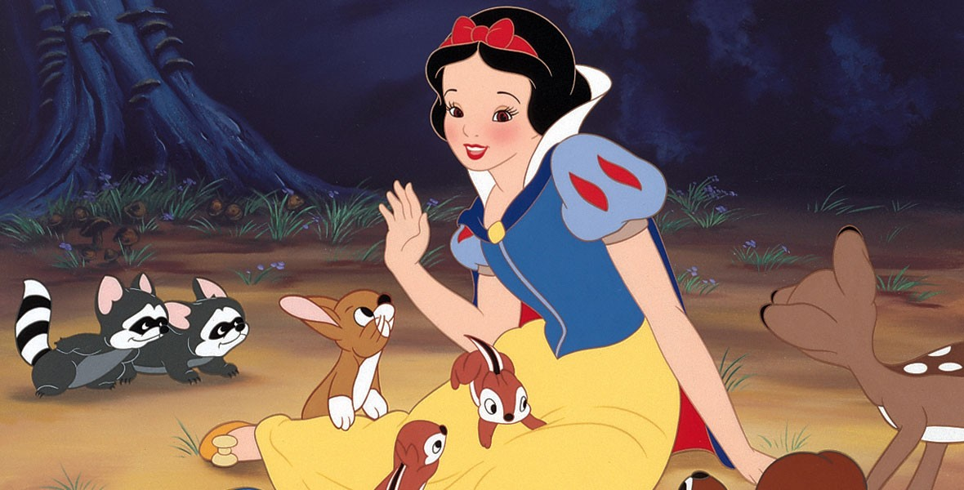

Find examples of classic Disney in the movie
Entertaining

Music which ‘helps’ developing the story

Animal Characters

Childlike behavior and cute characters

Work ethic - central

Cleanliness and purity

The theme of escaping and fantasy

Good triumphing over evil – the happy ending

Optimism and happiness prevail

Romance

Movie: VIana
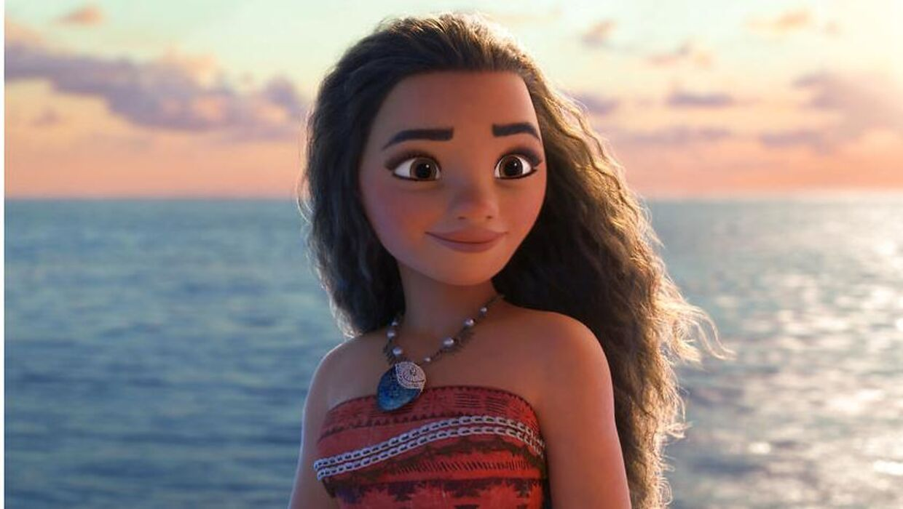

Find examples of classic Disney in the movie
Entertaining

Music which ‘helps’ developing the story

Animal Characters

Childlike behavior and cute characters

Work ethic - central

Cleanliness and purity

The theme of escaping and fantasy

Good triumphing over evil – the happy ending

Optimism and happiness prevail

Romance

Manuscript for a speech – Disney and Its princesses.
Scenario: You are students at Harvard University, and you are going to conduct a speech at a student debate forum. Your task is to make a manuscript for that speech.
Topic: In your manuscript, you must comment on whether Disney has a problem with their princesses or not, and you must include both the negative and positive aspects of Disney princesses.
Remember to include at least three rhetorical devices – highlight then with yellow.
You must use the following sources:
- From Snow White to Moana: The Evolution of Disney Princesses [2,8 ns]
- CBS News: Report: Disney still has a big princess problem [1,25]
- Why children need better role models than Disney princesses | Mia Fisher | TEDxCCHS Youth [2,3 ns]
- Disney Princesses As Told By Bros | Let's Talk Disney by Oh My Disney

- All sources must be documented, and all your references must be cited!
- Word count: 800-1200 words.

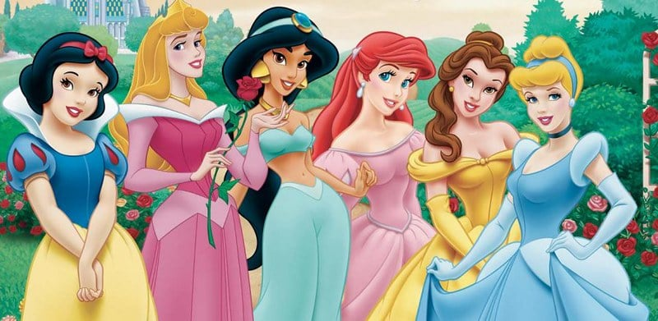
From Snow White to Moana: The Evolution of Disney Princesses
Most of us remember watching Disney princess movies growing up — it is safe to assume that almost everyone has seen at least one of them. Generations grew up with these fancy, beautiful princesses, sometimes even serving as role models with their kindness and loving personas. The impact of these princess movies, however, is far from benign. Many of them taught kids the stifling bonds of gender roles and emphasized the importance of looks and beauty standards. In recent years, though, Disney has attempted to redefine what it means to be a Disney princess. This move gives hope for young generations, especially girls, to be powerful on their own.
There are two types of Disney Princesses: traditional ones and new ones; and there are three eras: the Classics Era, the Renaissance Era and the New-Age Era.
Classics Era (1937-1959)
The Classics-Era princesses — Snow White, Cinderella and Sleeping Beauty — were primarily passive and temperate. They were waiting for someone to come rescue them. These princesses also fit squarely into conventional beauty standards.
Snow White is the typical, beautiful, gentle and innocent princess. The only thing she does in the movie is clean the house for seven guys and get saved by another one. Cinderella is more developed but still struggles to progress beyond the limits of needing someone to save her; she is curious about the world, but ends up with the strong Prince Charming that saves the day. In “Sleeping Beauty,” the fairies give Aurora the gift of beauty — not intelligence or personality — when she is a newborn. As the story continues, we don’t even get a chance to see Aurora’s depth of character —only her beauty and grace. In the Classics Era, these kinds of gender stereotypes and the objectification of submissive female characters were at their peak.
Renaissance Era (1989-1999)
The Renaissance Era of Disney princesses, also called the “rebel children era,” appears to have been in response to a wake-up call for a needed transition from being conventional to being a reformer. While the Renaissance Era improved on the Classics Era by making princesses curious about the world rather than doing the housework for others, Disney still stuck to the motif of princesses needing someone. This era includes Ariel, Belle, Jasmine, Pocahontas and Mulan.
With Ariel, Disney finally succeeded in creating a complex character. Out of all her sisters, Ariel can sing the best, yet she wonders about life on land. After seeing Prince Eric, she decides to exchange her singing voice for the opportunity to become a human. She develops into a self-sustained princess without reliance on another’s help, even at the cost of going against her family and community.
Another great example of Disney’s development is Belle from “The Beauty and the Beast.” In Belle, we see a woman whose key characteristic is not her beauty, but rather her intelligence and love of books. She doesn’t fit in society, and even sings a whole song about how she wants to break away from it. As the story continues, we see that she is not preoccupied with beauty but instead falls for the “ugly, terrifying” Beast’s kind personality and big heart. Like Belle, Jasmine continues to follow in her footsteps and resists society’s expectations for her to marry someone of political import. There are even a few times that Aladdin points out Jasmine’s intelligence and ambition, a rarity for Disney. Jasmine is also the first Disney princess of color, a revolutionary move at the time.
[…]
Pocahontas is Disney’s first attempt at basing a princess on a real person rather than a fairy tale; I still feel that it failed, though: they twisted the facts about her story, focusing on her romance with John Smith instead of her leadership abilities and brave soul. […] Mulan is one of the bravest and strongest princesses of all, as she is the best fighter in an all-male army. She fights for her country and her roots, showing that women can do anything they want, even if it defies tradition. Also, for the first time, a princess’s love interest remains in the background, a relief after many years of male dominance in a princess movie.
New-Age Era (2009-present)
The latest era of Disney princesses, the New-Age Era, also known as the “independent woman era,” is the most recent and most equal era of Disney. It includes Tiana, Rapunzel, Merida, Elsa, Anna and more. Tiana definitely embodies the new definition of a princess. She works hard to achieve her dreams and keep her promise to her father, and she doesn’t turn to shortcuts or a man to help her get there. She is straightforward in every situation, even if it’s hard, a virtue making her the best role model out of all the Disney princesses.
Another Disney princess wanted to see life outside of her tower, where she was locked up and spent all of her childhood and young adult life. Rapunzel is free-spirited, artistic and stubborn. Even though Mother Gothel told her that the outside world is full of evil and that she wouldn’t be able to handle it, Rapunzel followed her instincts and pursued her dream. Rapunzel represents a strong, determined personality, defying the stereotype of women as innocent, weak and inadequate by themselves.
[…]
In the story of Elsa, a powerful girl is afraid of those powers and is seen as evil. She isolates herself because of her “evil” power, but as the story continues she embraces it with the help of her sister. Instead of romance, Frozen focuses on the undying bond between two sisters, Anna and Elsa. Even though Elsa hurt Anna with her powers unintentionally, Anna forgives Elsa and wants to be there for her, in bad and better times. Anna even rejects her love interest, Kristoff, to help Elsa, who she loves the most and would do anything for her. They represent the importance of independence, women’s unity and doing just fine without a man by their side.
One of Disney’s newest princesses, Moana, continues to carry on the theme of the independent, brave women. She doesn’t have any love interest, and she is determined to save her people no matter how dangerous the journey. She is another inspiration for girls who do not need a man to accomplish their goals.
Disney has come a long way after many years, and is still continuing to make progress over time. I remember not liking iconic Disney princesses when I was a kid because they needed a man or magic to realize their goals. I have since noticed many changes in the meaning of being a princess over the years, and I’m glad that Disney decided to change their stories and let female characters define themselves without a need for someone else.
[…] I hope that Disney continues to progress, because we still live in a male-dominated society, and in many facets of life women still aren’t allowed to be what they want. I believe with open-minded and egalitarian princess movies, a new generation will rise to solve these problems for a better society.
Aslıhan Alp is a high schooler writing as part of The Daily’s Summer Journalism Workshop. Contact them at workshop 'at' stanforddaily.com.

Report: Disney still has a big princess problem
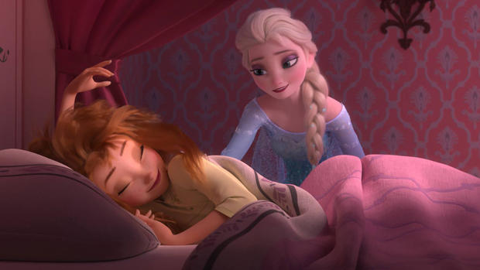
In the Disney universe, gone are the days when men are necessary to save the damsel in distress. No prince's kiss is needed to wake the girl. The prince's hand in marriage is not the ultimate goal anymore.
Today's Disney princesses have saved China, saved each other, fought bears, and generally taken on kick-butt personas.
Still, there's a problem, according to new research that was first reported on by the Washington Post.
Simply put, the women in modern Disney movies just aren't allowed to open their mouths and talk as much as the men, according to research by linguists Carmen Fought and Karen Eisenhauer, who have been working on a project to analyze all the dialogue from the Disney princess franchise.
They told the Post that because so many girls around the world watch Disney princess movies, often on repeat, it was important to understand better what they were teaching.
"We don't believe that little girls naturally play a certain way or speak a certain way," Fought, a professor of linguistics at Pitzer College, told the Post. "They're not born liking a pink dress. At some point we teach them. So a big question is where girls get their ideas about being girls."
A paradoxical discovery in their research found that in the classic Disney princess films - "Snow White," "Sleeping Beauty," and "Cinderella" - women give a majority of the dialogue in the movies, 72 percent, despite taking on roles that are traditionally subservient to men.
In modern Disney princess films, despite being more independent, women talk less.
The Post report: "Men speak 68 percent of the time in 'The Little Mermaid'; 71 percent of the time in 'Beauty and the Beast'; 90 percent of the time in 'Aladdin'; 76 percent of the time in 'Pocahontas; and 77 percent of the time in 'Mulan.'"
Even in the modern blockbuster, "Frozen," where two princess sisters are the centerpiece and heroes of the film, men speak 59 percent of the time.
The researchers found two modern exception: "Tangled," the retelling of the Rapunzel story, in which women have 52 percent of the lines; and "Brave," about a fraught mother-daughter relationship, women speak 74 percent of the time.
There has been one important and positive shift, however, researchers found. In the old Disney princess classics, an overwhelming majority of the time female characters were complimented on their looks. In modern princess films, their abilities and accomplishments were given most of the compliments.
As for the dialogue problem, the linguists chalked it up largely to an oversight, as well as the likelihood for the quirky sidekick character and most other supporting characters to almost always being male.
"My best guess is that it's carelessness, because we're so trained to think that male is the norm," said Eisenhauer, a graduate student at North Carolina State. "So when you want to add a shopkeeper, that shopkeeper is a man. Or you add a guard, that guard is a man. I think that's just really ingrained in our culture."

Why children need better role models than Disney princesses | Mia Fisher | TEDxCCHS Youth
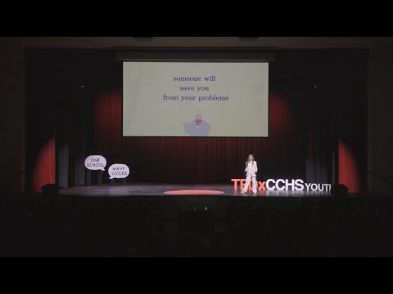
A happy ever after is the necessity for every princess fairytale but what comes next? Reality. In this talk, Mia Fisher addresses the impact of Disney Princess media on both children's self-image and societal beliefs. Mia Fisher is a sophomore at Cathedral. She is a member of the CCHS cheer team and finds joy through photography and painting. Mia is president of her National Charity League class, and has completed a total of 235 philanthropy hours through this organization. Her talk was inspired by her childhood love of Disney animated films and her realization of their impact on young children. This talk was given at a TEDx event using the TED conference format but independently organized by a local community.

Disney Princesses As Told By Bros | Let's Talk Disney by Oh My Disney
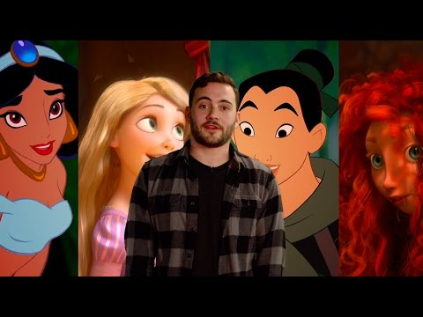

Earnings per share

