Indian Independence and Partition, Comprehension questions
Sources:
Narrating India pp.16-22
Why was India split into two countries? Ted-ed, 21 June 2021.
https://www.youtube.com/watch?v=DrcCTgwbsjc

- Initial exercise:
Pair work
Partner A is the interviewer and partner B is the interviewee.
Partner A will now interview partner B about the following questions regarding the partition of India including questions such as what, when and why.

- Comprehension questions (pair work)

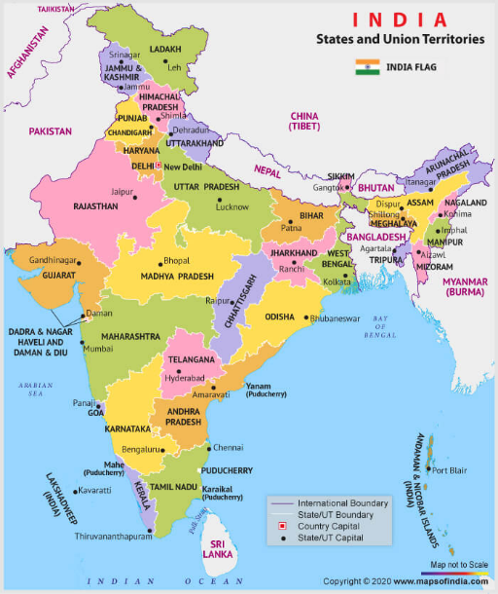  This map illustrates India after partition | 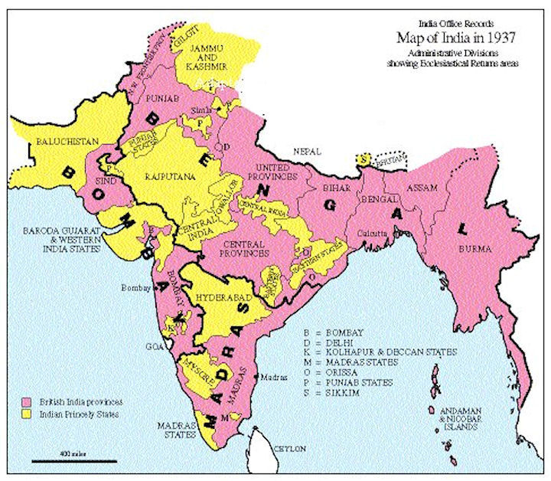  This map illustrates India before partition
- Why did Britain not wish to continue to rule India after the Second World War? | Write your answers to the questions in this column.
- What were the different aspirations for the country?

- What were Mohammad Ali Jinnah’s arguments for wanting two countries?

- Who was Mohandas Gandhi?
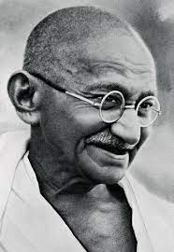
- Which were the three major religious groups in India?

- Who did the Sikhs side with and why?

- Find more information about the Mughal Empire

- Where is Shimla located?

- What happened after the negotiations at the Shimla Conference in 1946?

- Who was Louis Mountbatten, who arrived in March 1947 and what does it mean to be ‘Viceroy’?

- Why were Punjab and Bengal divided between India and Pakistan?

- Who was Sir Cyril Radcliffe, and under what circumstances did he draw up the borders?

- How were the borders decided and what happened when the new borders were announced?

- What happened to the Princely States?

- What is a Princely State?

- What is the relationship between India and Pakistan today? Give examples from current news stories.
If time: https://www.youtube.com/watch?v=bTfR7D1NkkE&t=1s

C Foretag en syntaktisk analyse af nedenstående sætning:
In August 1947, India gained independence after 200 years of British rule.

Vær opmærksom på, at ikke alle sætningsled forekommer.

Verballed
O
Subjekt
X
Subjektsprædikat
⊗
Direkte objekt
Δ
Indirekte objekt
□
Adverbialled

Konjunktional

