**THE CHESS SCENE - THE WIRE**

Rewatch [The Wire - Chess Scene](https://www.youtube.com/watch?v=ztc7o0NzFrE&ab_channel=chesshaha)

Pause and takes notes every time you hear examples of African American English (transcript on the last page).

Organize your notes into examples of:

* grammar
* words/phrases
* pronunciation

*The grammatical introduction from the PowerPoint can be found on the next page!*

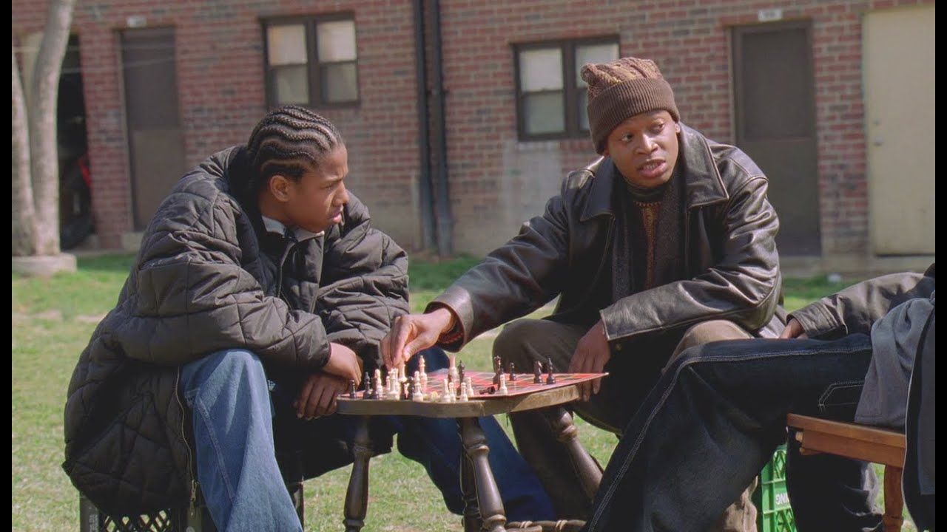

**AFRICAN AMERICAN ENGLISH GRAMMAR**

**Grammatical Tense**

| **Past** | *I been bought it* |
| --- | --- |
| *I done buy it* |
| *I did buy it* |
| *I do buy it* |
| **Present** | *I be buying it* |
| **Future** | *I’mma buy it* |
| *I gonna buy it* |

**Grammatical Aspect**

| **AAE aspect** | **MAE meaning** |
| --- | --- |
| *He be working Tuesdays* | *He works on Tuesdays* |
| *He stay working* | *He is always working* |
| *He steady working* | *He keeps on working* |
| *He been working* | *He has been working* |
| *He fixing to go to work* | *He is about to go to work* |

**Deletion of verbal copula**

In some contexts, the word "is/are" can be left out.

Example:

*He workin'.*

**Negative concord**

This means that negation has to all "match” (double negation). The negative is frequently expressed with *ain’t.* And *ain’t* is a common contraction used by AAE speakers.

Example:

*He ain't never without a job!*

*Can't nobody say he don't work.*

**Chess scene from ‘The Wire’**

**‘The Buys’ (2002)**

**D’Angelo Barksdale:** Yo, what was that?

**Wallace:** Hm?

**D’Angelo Barksdale:** Castle can’t move like that. Yo, castle move up and down and sideways like.

**Preston ‘Bodie’ Broadus:** Nah, we ain’t playing that.

**Wallace:** Yeah, look at the board. We playing checkers.

**D’Angelo Barksdale:** Checkers?

**Wallace:** Yeah, checkers.

**D’Angelo Barksdale**: Yo, why you playing checkers on a chess set?

**Preston ‘Bodie’ Broadus:** Yo, why you give a shit?

**D’Angelo Barksdale:** Now look, check it, it’s simple, it’s simple. See this? This the kingpin, a’ight? And he the man. You get the other dude’s king, you got the game. But he trying to get your king too, so you gotta protect it. Now, the king, he move one space any direction he damn choose, ’cause he’s the king. Like this, this, this, a’ight? But he ain’t got no hustle. But the rest of these motherfuckers on the team, they got his back. And they run so deep, he really ain’t gotta do shit.

**Preston ‘Bodie’ Broadus**: Like your uncle.

**D’Angelo Barksdale:** Yeah, like my uncle. You see this? This the queen. She smart, she fast. She move any way she want, as far as she want. And she is the go-get-shit-done piece.

**Wallace:** Remind me of Stringer.

**D’Angelo Barksdale:** And this over here is the castle. Like the stash. It can move like this, and like this.

**Wallace**: Dog, stash don’t move, man.

**D’Angelo Barksdale:** C’mon, yo, think. How many time we move the stash house this week? Right? And every time we move the stash, we gotta move a little muscle with it, right? To protect it.

**Preston ‘Bodie’ Broadus:** True, true, you right. All right, what about them little baldheaded bitches right there?

**D’Angelo Barksdale:** These right here, these are the pawns. They like the soldiers. They move like this, one space forward only. Except when they fight, then it’s like this. And they like the front lines, they be out in the field.

**Wallace:** So how do you get to be the king?

**D’Angelo Barksdale:** It ain’t like that. See, the king stay the king, a’ight? Everything stay who he is. Except for the pawns. Now, if the pawn make it all the way down to the other dude’s side, he get to be queen. And like I said, the queen ain’t no bitch. She got all the moves.

**Preston ‘Bodie’ Broadus:** A’ight, so if I make it to the other end, I win.

**D’Angelo Barksdale:** If you catch the other dude’s king and trap it, then you win.

**Preston ‘Bodie’ Broadus**: A’ight, but if I make it to the end, I’m top dog.

**D’Angelo Barksdale:** Nah, yo, it ain’t like that. Look, the pawns, man, in the game, they get capped quick. They be out the game early.

**Preston ‘Bodie’ Broadus**: Unless they some smart-ass pawns.