[DONATE](https://www.npr.org/donations/support)

[](https://www.npr.org/series/pop-culture-happy-hour)

# The Term 'Graphic Novel' Has Had A Good Run. We Don't Need It Anymore

NOVEMBER 17, 2016 · 3:49 PM ET

[](https://www.npr.org/people/137817249/glen-weldon) [Glen Weldon](https://www.npr.org/people/137817249/glen-weldon)

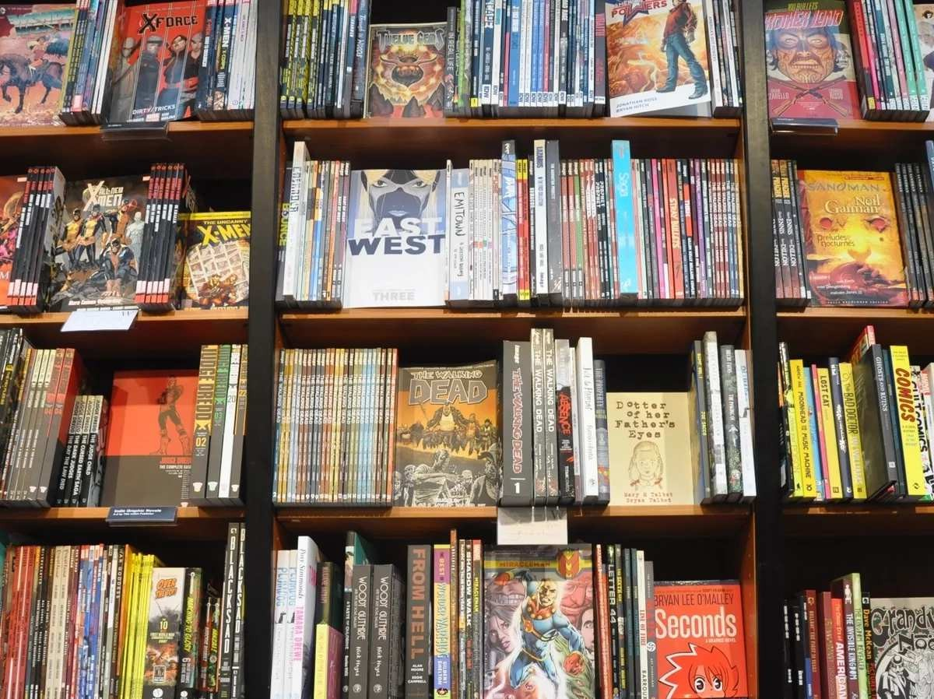

[*morebyless via Flickr*](https://creativecommons.org/licenses/by/2.0/)

## Hey Glen, did you hear? Last night, *March: Book Three* by Rep. John Lewis, Andrew Aydin and Nate Powell — the final book in their graphic novel trilogy about young Lewis' experiences in the civil rights movement — won the National Book Award for young people's literature!

I heard! It's fantastic! Both the fact that it won, and the comic itself, which is a *deeply* moving, eye-level, feet-on-the-ground account of the era that shows just how much hard, punishing work it took to change America. Lewis and co-writer Aydin take time to dig into the kind of small, human moments of pain, anguish, doubt and fear that history books tend to breeze past. And Artist Nate Powell makes sure you *feel* all those emotions — as well as moments of joy and soaring triumph.

It ends up offering far more than a how-to on civil disobedience — ultimately, it's a *why*-to: a searingly hopeful testament to the power of protest, and a celebration of the young people who sacrificed their safety to make the country a more just place to live.

## Yeah, I figured you'd be happy. I know you're a graphic novel guy, so.

... It's not a graphic novel.

## What?

That's the second time you called it a graphic novel. Stop calling it a graphic novel. It's not a graphic novel. For one thing, it's non-fiction.

## ... Oh. Right. Sorry. Graphic *memoir*, then.

See now, "graphic memoir" is even worse. Makes it sound smutty. It's not *The Diary of Anais Nin*, buddy.

## ... "Sequential art?"

Spare me. I mean, good on you [for reading up](http://scottmccloud.com/2-print/1-uc/), but you're not defending your thesis here. You're not defending anything, so you don't need a term like "sequential art," which sounds so wounded and defensive, like you're desperately trying to justify the medium itself. You don't need that nebbishy Poindexter of a term; put it away. Try this: *comics*.

## Comics?

*Comics*. Just call them comics.

**But wait. I thought you nerds *wanted* us to call them graphic novels. At least the ones like *Maus* and *Persepolis* and *Jimmy Corrigan* and, well, *March*.**

Go on.

**You know ... the *serious* ones. The *important* ones.**

Ah. *There* it is. Knew that was coming.

## I just mean ... it's useful, isn't it? To, you know, distinguish them from, uh ...

No, go ahead, you can say it. It's OK.

**... (whispers) *Superheroes*.**

Uh-huh.

## And all the other, sillier, less meaningful stuff. Science fiction, or whatever.

Oy. OK. Lots to unpack here, and, to be fair, at lot of it's our fault. Comics readers and creators, that is.

By the time the great cartoonist Will Eisner slapped the term "graphic novel" on his 1978 book, *A Contract With God and Other Tenement Stories*, the term had been percolating around comics fandom for years. Eisner, however, was a tireless advocate, and wanted people to appreciated that comics are a medium, not a genre. A medium dominated, then as now, by superheroes, but nevertheless a storytelling medium that could be used to tell an infinite number of stories in vastly different ways.

Which is why--

## Um, OK. It looks like you're ramping up. I'm gonna ... I'm just gonna grab a seat then.

Fine, go ahead.

The reason Eisner latched onto the term "graphic novel" and ran with it is because

... well, it was 1978. He *needed* to. Comics were considered, if they were considered at all, junk culture. Kid stuff that was beneath serious notice, if not beneath contempt.

And in that environment, he was putting out a book containing a series of interwoven comics stories about a Lower East Side tenement building and its hapless inhabitants. He wanted to draw a clear line between what he was doing and mainstream superhero smash-em-ups — as well as the head-shop alt-comics scene of R. Crumb and others.

"Graphic novel" was a serviceable term for what he was up to, but even then, at the very beginning, it wasn't a perfect fit. *A Contract With God* isn't truly a novel, after all, it's a story collection. But he sought legitimacy, or at least serious consideration, so he adopted the terms of art of the literary community.

Later still, in 1985, he published *Comics and Sequential Art*, a treatise in which he nailed his theses to the church door of the art world, right from the jump:

*This work is intended to consider and examine the unique aesthetics of Sequential Art as a means of creative expression, a distinct discipline, an art and literary form that deals with the arrangement of pictures or images and words to narrate a story or dramatize an idea*. *For reasons having to do with usage and subject matter Sequential Art has been generally ignored as a form worthy of scholarly discussion.*

In other words: *it's not just about Little Orphan Friggin' Annie, jerks*.

He makes a good case, and if the prose is a bit dry and academic (and it really, really is), that served his purpose.

In the meantime, the alt-comics scene was blowing up, fueled by anthologies like *RAW,* and in the 1990s many titles broke through to mainstream acceptance — and acclaim.

***Oh, right. The usual suspects. Maus* and *Jimmy Corrigan* and *Black Hole***

**and *Ghost World* and...**

Right. *Maus* became the first comic to win a Pulitizer, in 1992. And although *March* is now the first comic to win a National Book Award, several others have been finalists in the young people's literature category:

2006: *American Born Chinese* by Gene Luen Yang

2009: *Stitches* by David Small

2013: *Boxers and Saints* by Gene Luen Yang

 2015: *Nimona* by Noelle Stevenson

In addition, Roz Chast's *Can't We Talk About Something More Pleasant?* was an NBA finalist in the fiction category last year.

## So what's your point?

No matter what metric you use, it's clear that the world Will Eisner envisioned, in which a wider audience comes to appreciate that artists can use the comics medium to tell any story they want, has arrived.

Comics aren't visual art, and they're not prose. They're a medium that exists in the *tension* between images and text. Talented creators can play with that tension in ways that are utterly unique to comics.

So with *March*'s win, it's a perfect time to retire terms like "graphic novel" and "sequential art," which piggyback on the language of other, wholly separate mediums. What's more, both terms have their roots in the need to dissemble and justify, thus both exude a sense of desperation, a gnawing hunger to be accepted.

Forget *that*.

Comics. Say it.

## ... "Comics."

Just call them comics. And by doing so, you'll be joining the ranks of creators like Neil Gaiman, who have always been amused by the pernicious desire on the part of book marketers and awards panels to dress comics up in pretentious language.

*I always loved, most of all with doing comics, the fact that I knew I was in the gutter. I kind of miss that, even these days, whenever people come up and inform me, oh, you do graphic novels. No. I wrote comic books, for heaven's sake. They're creepy and I was down in the gutter and you despised me. "No, no, we love you! We want to give you awards! You write graphic novels!"*

*We like it here in the gutter.*