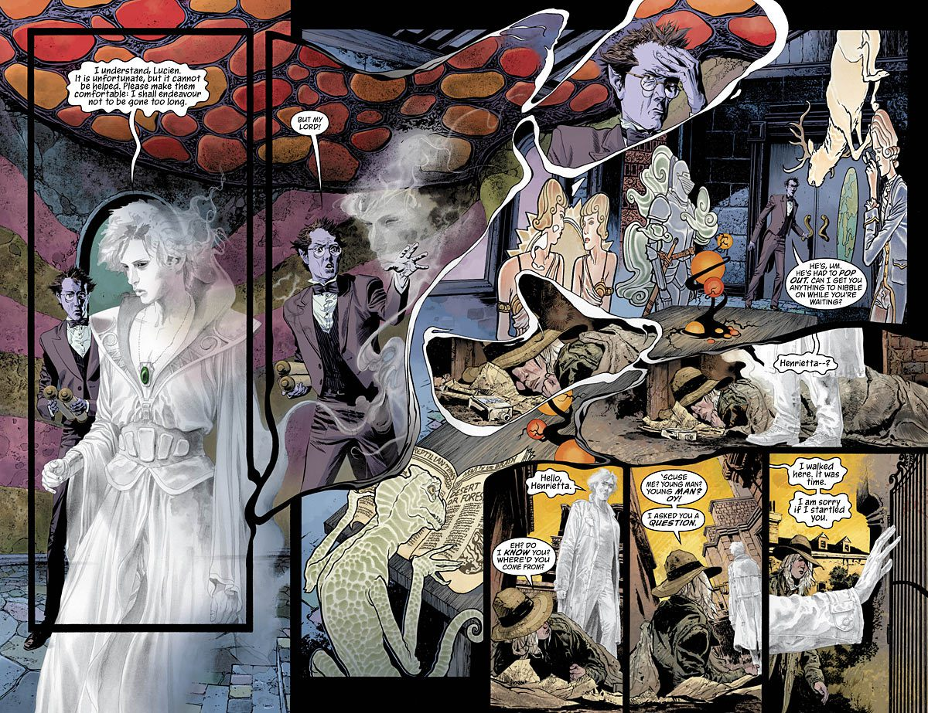

## Group project: write a graphic novel about being different

As an epic conclusion to the very last theme of the year, you are going to write your own graphic novel!  
You’ve already started the creative process of creating a main character as well as researching plot, setting, etc.  
And now it’s time to put those creative ideas to good use!

**The common MESSAGE of your graphic novels is: *It’s okay to be different!***

Requirements:

1. Your group must create at least one protagonist/main character: what do they look like? What is their personality? What is their background story?
2. Create a plot: HOW do you want to convey the message: *It’s okay to be different*?
3. Your graphic novel must contain both visual and textual narratives: consider which of the 7 Word and Picture-combinations you want to use)
4. Choose one of the following genres to tell your story:
   1. Horror
   2. Thriller
   3. Romance
   4. Comedy
   5. Sci-Fi
5. Length: 2-3 pages with a minimum og 6 panels per page.
6. You can either create the graphic novel digitally or by hand.
7. All groups must have finished their project by 12:35 on Wednesday, 22 May.
8. Everyone will present their graphic novels during our very last lesson of the year (12:40 on Wednesday, 22 May).