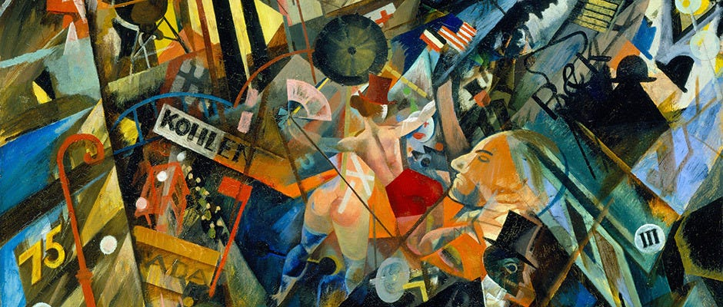

Mini-presentations: Modernism and Inter-modernism in literature
GROUP A | GROUP B | GROUP C | GROUP D | GROUP E | GROUP F
Modernism | Inter-modernism | Modernism | Inter-modernism | Modernism | Inter-modernism

Group A, C, and E: about Modernism in Animal Farm on Systime.
Group B, D, and F: read the paragraph about Intermodernism in Animal Farm on Systime.
- Research your assigned literary tradition. Find at least 3 different sources (including the paragraph in Animal Farm).
- Make a mini-presentation, where you present the main characteristics about your literary tradition, including:
  - Historical context (relevant people, timeline, etc.)
  - Themes
  - Writing style
- Create a Powerpoint containing keywords and illustrations relevant to your literary tradition.
- Duration: 2,5-3 minutes.
- Everyone must participate in the presentation.

