# SOURCE 2 (Text):

# **Why this artificial intelligence expert says Elon Musk is 'selling fear'**

[Ruth Umoh](https://www.cnbc.com/ruth-umoh/) | [@ruthumohnews](https://twitter.com/ruthumohnews)

1:05 PM ET Wed, 6 Sept 2017

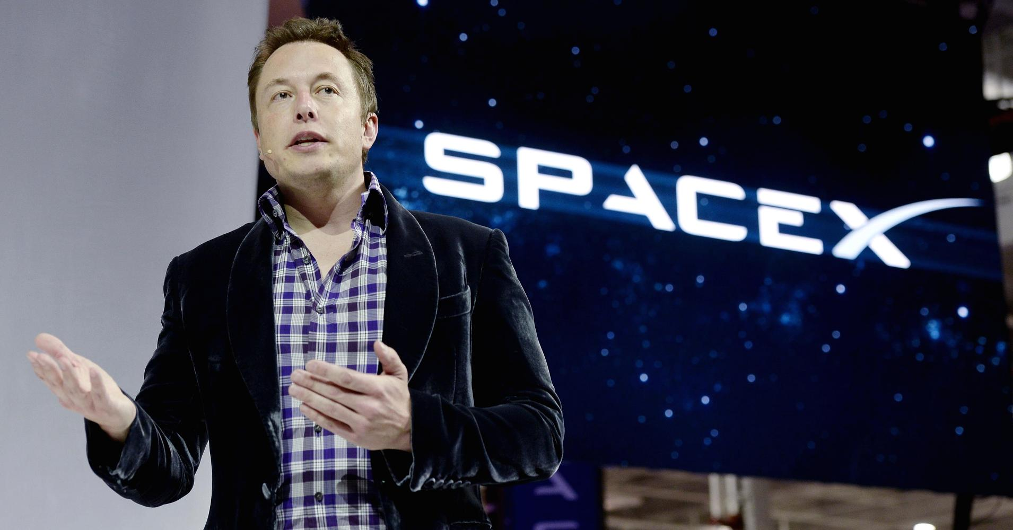Elon Musk, founder and CEO of SpaceX  
Getty Images | Robyn Beck

Elon Musk came out with another artificial intelligence warning on Monday. The SpaceX and Tesla CEO suggested that AI could be the cause of a [third world war.](https://www.cnbc.com/2017/09/04/elon-musk-says-global-race-for-ai-will-be-most-likely-cause-of-ww3.html) But Musk couldn't be more wrong, says artificial intelligence expert Max Versace, CEO of robotics and computing company [Neurala](https://www.neurala.com/) and founding director of the [Boston University Neuromorphics Lab](http://nl.bu.edu/), which studies biological intelligence in computers and robots.

Versace tells [CNBC Make It](https://www.cnbc.com/make-it/) that Musk and others like him who warn against artificial intelligence are misguided. "They are selling fear and it's working," he says.

In July, Musk warned that [artificial intelligence should be regulated](https://www.cnbc.com/2017/07/16/musk-says-a-i-is-a-fundamental-risk-to-the-existence-of-human-civilization.html) because it's a "fundamental risk to the existence of human civilization."

Versace disagrees. In fact, he says that it's much too early to begin regulating AI because it would slow down innovation. He points to other technological innovations like drones, which he says were not regulated until after they'd been mass produced.

"It's not appropriate to regulate AI until you know what you're working on," says Versace. "AI will not kill us. That's science fiction."

The robotics expert says that the biggest issue with these AI predictions is that non-experts warn against its use. "People who aren't competent are discussing AI, which they have no clue about," he says. "AI is hard to understand and is very complex."

Versace again points to Musk who said in April that he [created Neuralink](https://www.cnbc.com/2017/04/24/elon-musk-neuralink-ai-human-machine-terminator-skynet.html), a company that links the human brain with a machine interface, to avoid artificial intelligence becoming like Skynet. Notably, Skynet is a fictional self-aware AI system in the "Terminator" movies that saw humans as a threat and sought to wipe them out.

Versace, whose company also deals with using software to mimic how the brain works, says that although artificial intelligence is being used more day-to-day, scientists still have a long way to go in perfecting its use.

Artificial intelligence, he says, has not reached a level where it will become so powerful that it will take over everything.

"Unlike grilling burgers, AI is a complicated technology, and it would be best if an expert in AI were the one giving opinions about AI," Versace says. "I have been in the field for 25 years, and not even once have these 'grim future' concerns been discussed with my colleagues."

He adds, "The likelihood of an AI scientist building Skynet is the same as someone accidentally building the space station from Legos."

However, says Versace, artificial intelligence has been used to assist humans in a variety of ways. He says that artificial intelligence helps us filter out spam in our email and is behind speech recognition in phone apps and for those with disabilities.

"Not much is being spoken about its benefits," says Versace. "[Artificial intelligence] helps you so you don't get mad or waste your time."

Versace does note that regulation will likely be needed in the future as more is understood about artificial intelligence and how we want to use it to better assist us each day. For example, he says that regulators may forbid companies from running AI on algorithms, which businesses like [Facebook](https://www.cnbc.com/quotes/?symbol=.FOQ), [Amazon](https://www.cnbc.com/quotes/?symbol=AMZN) and [Google](https://www.cnbc.com/quotes/?symbol=GOOGL) use extensively.

Job disruption will also be another factor that regulators will have to consider, says Versace. Musk has repeatedly discussed the effects of artificial intelligence on the workforce.

"What's going to happen is robots will be able to do everything better than us. ... I mean all of us," Musk told the [National Governors Association](https://www.c-span.org/video/?431119-6/elon-musk-address-nga&start=5049) in June.

However, Versace says that this sentiment may be blown out of proportion. Although he admits that there will be some job loss, the positions will likely be remedial jobs like assembly line work or cleaning bathrooms.

Versace believes that this will actually push humans to seek out "jobs that are more elevated" and that require more brain power. "Humans are resourceful and history has shown we can change to various economic conditions," he says.

Versace notes that like any other technological advancement, artificial intelligence can be used for good or bad. Therefore, Musk's warnings can be considered "misleading."

The AI expert suggests that people get "acquainted with artificial intelligence at its most basic level" instead of being afraid because we don't understand the science behind it.

"The use of artificial intelligence is going to be very gradual," says Versace, "so this doomsday scenario is just creating fear."