A. Brrr… That is one Cold War right there!
Animal Farm was published at the beginning of the Cold War and, as you discovered in the last chapter, draws references to e.g. Communism.
- 15 minutes research.
- Half of the table group does internet research about the Cold War.
- The other half about the two primary ideologies of the Cold War.
- Use at least 2 different sources.
- Write down key words.
- Present your research to each other in the table groups. (2 minutes for each half of the group)

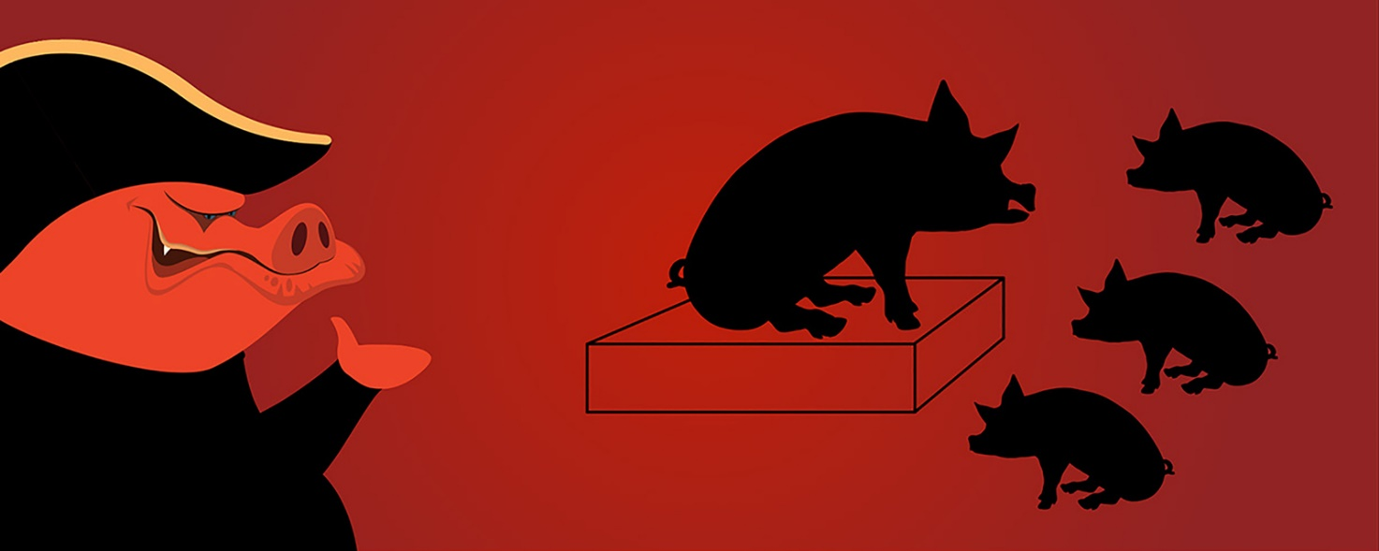

B. An Interview with a pig
Study group work
Napoleon is invited on national TV to talk about Animal Farm.
Study Groups A
- Prepare an interview with Napoleon where he has to answer for the idea/ideology behind Animal Farm.
- Remember to ask critical questions as rumour has it that things are not quite what they seem.
- Come up with 5 questions to be answered. One of the questions must contain information about ideological beliefs from your pre-reading exercise.
- All the questions must be OPEN questions (i.e. demands elaborate answers from Napoleon).
Study Groups B
- Prepare to be interviewed as Napoleon.
- Look at your word documents for characterization to put yourself in the role of Napoleon.
- You will be answering questions about the idea/ideology behind creating Animal Farm.
- Remember to act like Napoleon during the interview - that means using some of the tactics used by both him and Squealer as to fake news, propaganda and rhetorics.
- Select one person from study group A and B and conduct the interview.

