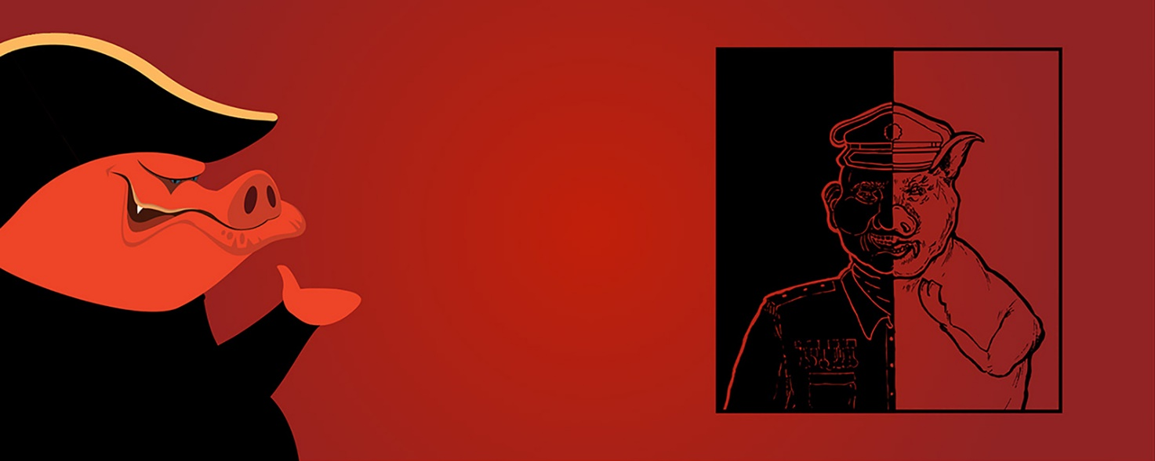

09B Comparing Endings – individual work
- Make a summary of 125 words of the ending. Use your highlights from the while-reading task.
- Compare the ending with your own ending from the pre-reading exercise.
  - What are the major differences?
  - Have you chosen an open or closed ending and what about the novel?
  - What is the effect of your ending and the ending of the novel?
- Place YOUR ending and your summary in the same document and upload it in the folder “Comparing Endings” under Lectio Opgaver.

Discuss with a partner
After finishing reading Animal Farm, why do you think Orwell chose to write it as an allegory?
You may want to consider the audience, time period and the message.

