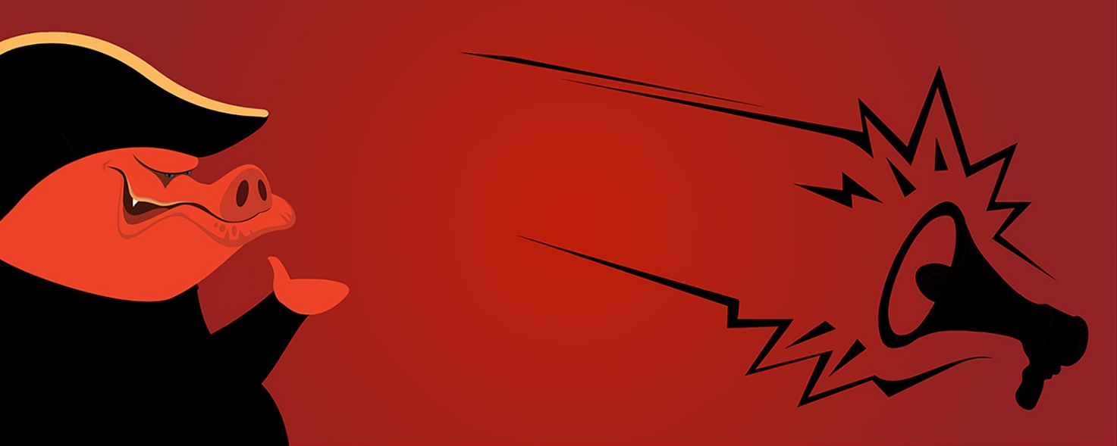

09C Structure and Composition
Animal Farm follows a simple structure and can be divided into three sections: The Dream, The Rebellion and Napoleon's regime. Try to divide the chapters into these three sections.
- Work in your table groups.
- Determine the type of composition in Animal Farm. See "How to analyse a novel" if you are in doubt about what it is. Come up with examples from the novel to substantiate your choice of composition.
- Animal Farm has a circular narrative. Put differently, the novel bites "its own tail" meaning that when you have read the ending, it is possible to start over once again. Come up with examples from your analysis of the novel which shows a circular narrative.
- Write your answers on the back of this paper

