**In the American Society – Peer Feedback of 1st draft**

Peer feedback: 20 min

Open the link to ‘***Skriftlig eksamen i engelsk’*** <https://skriftligeksameniengelskhhx.systime.dk/?id=140> – if you are in doubt, then look at the examples here.

Use *Gennemse/Ny kommentar* in Word to insert your comments in the essay you are checking.

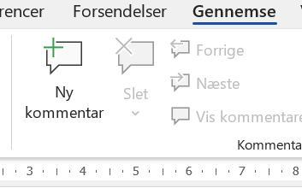

Check whether the essay includes/lives up to the following aspects:

Does the essay have the right **structure** with Introduction – Body (divided into at least 3 paragraphs) – Conclusion?

Is there an **Introduction** with

* A general introduction (2-3 lines about the subject of the short story)
* The author’s name
* The title of the short story (written in italics and with inverted commas)
* 1-2 lines about what the short story is about
* The focus points of the essay

Is there a **Body** with

* Characterisation (Antagonist /Protagonist – Inner/Outer – Flat/Complex)
* Setting (Physical/Social/Time/Historical Context)
* Theme
* Message

Also check the **documentation** of the body – does each paragraph here use the P-E-E structure? Are all examples written in italics and with inverted commas? Are there page and line numbers in brackets after all of them? Do all Examples have Points and Explanations?

Is there a **Conclusion** with

* A very short summary of the analysis
* A comment on the general introduction

Return the essay with your written comments/feedback to the group who wrote it. Then spend the rest of the lesson working with the comments you have received.