**Nike – Mini Company Profile 2023**

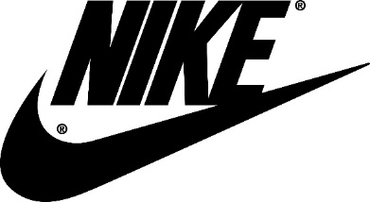

**In Class: 30 min.**

**In groups, you make a mini company profile of Nike.**

In your profile, you must incorporate information about the following points:

1. **Corporate history**
2. **Number of stores, employees, and revenue**
3. **Market share**
4. **Competitors**

You may use the following websites:

<https://www.businessinsider.com/nike-history-timeline-2015-10?r=US&IR=T>

<https://www.companieshistory.com/nike/>

<https://www.statista.com/statistics/250287/total-number-of-nike-retail-stores-worldwide/>

<https://www.statista.com/statistics/243199/number-of-employees-of-nike-worldwide/>

<https://www.statista.com/statistics/241683/nikes-sales-worldwide-since-2004/>

<https://www.statista.com/statistics/216821/forecast-for-nikes-global-market-share-in-athletic-footwear-until-2017/>

<https://seekingalpha.com/article/4500051-nike-solid-foothold-over-market>

You may also search the Internet for further information.

**WRITE DOWN KEYWORDS ONLY. Make a PP-show with your keywords.**

**Get ready to present your profile to another group. No reading aloud. Make the presentation based on your keywords. You only have 30 min. to find the requested information, so divide the tasks between you in your group☺.**

**Afterwards, you present your company profile to another group.**

**Take turns. All group members must participate. Remember to show your PP when presenting. Listen up for/notice information you may not have noticed yourselves.**