**Topic: How do consumers impact Nikes sustainability policies and priorities?**

**Task 1 – Analysis / pair work**

* Use the rhetorical pentagon and analyse the article *Nike’s ambitious environmental goals are being thwarted by sneakerheads and the Jordans, Air Force 1s, and Dunks they love (Business Insider)* using the six terms.

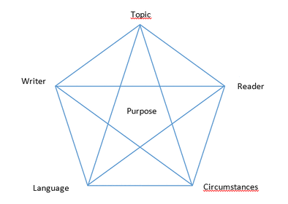

If you are in doubt, you can read more about the rhetorical pentagon here:

<https://app.minlaering.dk/bog/42/kapitel/66538/sektion/66540>

**Task 2 – Discussion / pair work**

Discuss the two following statements from the text:

*‘What’s more important, financial goals or carbon footprint goals?’* (p. 2 ll. 41)

*‘The footwear industry is at the point where the automotive industry was a few years ago.*’ (p. 5 ll. 141)

**Task 3 – Grammatik / pair work**

Find i nedenstående tekststykke:

* 2 eksempler på forskellig brug af genitiv (vær klar til at forklare forskellen på de 2 typer).
* 2 præpositioner.
* 2 adjektiver.

*Nike's corporate headquarters features numerous sustainable building practices, including extensive solar panels.*

*The popularity of the shoes pushed up Nike's leather use by 35% last year, and put the company behind a goal to use more sustainable materials.*

**Task 4 – Grammar / pair work**

Angiv ordklasserne for hvert af nedenstående ord. Brug de latinske betegnelser.

|  |  |  |  |  |  |  |  |  |  |
| --- | --- | --- | --- | --- | --- | --- | --- | --- | --- |
| Among | the | biggest | materials | accomplishments | has | been | getting | the | greenhouse |
|  |  |  |  |  |  |  |  |  |  |

|  |  |  |  |  |  |  |
| --- | --- | --- | --- | --- | --- | --- |
| gases | out | of | Nike’s | popular | Air | technology |
|  |  |  |  |  |  |  |

**Task 5 – Grammar / pair work**

Foretag en syntaktisk analyse af nedenstående sætning:

*Nike is considered a sustainability leader in the global fashion and sportswear industry.*

|  |  |
| --- | --- |
| Verballed |  |
| Subjekt |  |
| Subjektsprædikat |  |
| Direkte objekt |  |
| Indirekte objekt |  |
| Adverbialled |  |