Don’t You Hate Having Two Heads? Worksheet

Gruppe 1
- Nana Gammelgaard Jakobsen
- Signe Aunsbjerg-Rudén
- Magnus Høgsted
- Ida Eden
Gruppe 3
- Anton Klindt Thomassen
- Fekrat Ahmad Abdu
- Madeline Nørgaard Skøtt
- Mads Boye Høgstrup
Gruppe 4
- Tinke Staugaard Simonsen
- Augusta Larsen-Boldsen
- Marius Johannes Holgersen Goos
Gruppe 5
- Rosa Gerdes-Nielsen
- Stephanie Marie Estilles Sørensen
- Maja Zofia Rogalska
- Ramona-Florina Muster
Gruppe 7
- Anna Elisabeth Bisgaard
- Esben Yde Nordholt
- Zirva Abdo
- Naveen Manivannan
Gruppe 9
- Nikolaj Trankjær Andersen
- Silje Puggaard Ørsted Jakobsen
- Toke Peter Kull
- Kamille Lysemose Korsgaard
Gruppe 10
- Thea Frost Weinreich
- Sarah Hejslet Jørgensen
- Mikkel Bek Lauridsen
- Malthe Højbjerg Bonde

Questions:

- Where does the story take place?

- When does the story take place?

- Characterise Jessica using at least three adjectives and use an example from the text. Why is she referred to as ‘the girl’ in the beginning? (How does it impact the plot? Think about the plot elements)

- Analyze the interaction between Jessica and Richard:
  - Why does he slip off the wedding ring? What effect does it create? (p. 1, l. 32)
  - Comment on „He felt a little thrill of excitement and apprehension“ – What does this reveal about Richard as a character? (p. 2, l. 5)
  - Why doesn't he tell her his real name, and what does it reveal about Richard? (p. 3, ll.29/30)
  - Comment on: „This was just an experiment“ – What is the effect? (p. 5, l. 4).
- Explain what happens in the last paragraph on p. 5 (Jessica was … concern); also p. 6, ll. 12/13.
  - What happens to Richard after he has had this vision? Explain his reactions. What is the function of the vision? (Think about plot elements)

- What type of crime fiction is this short story and how can you tell (use examples from the text)?

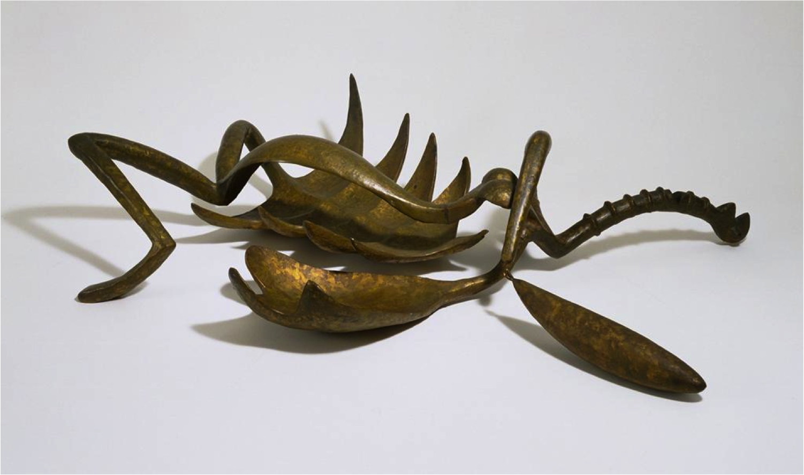
Woman With her Throat Cut

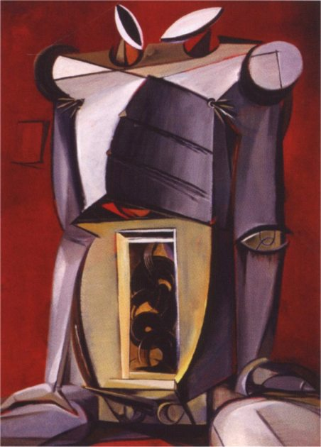
Don’t you hate having two heads?

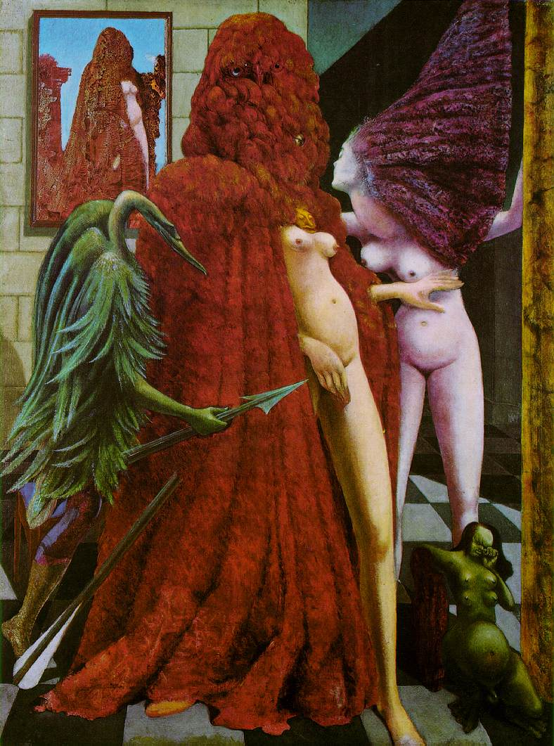
The Robbing of the Bride

