Sponsored

**Statue of Liberty: 50 fascinating facts**

**The Statue of Liberty reopens today. Here are 50 fascinating facts about the New York landmark.**

|  |  |  |  |  |  |
| --- | --- | --- | --- | --- | --- |
|  |  |  |  |  |  |

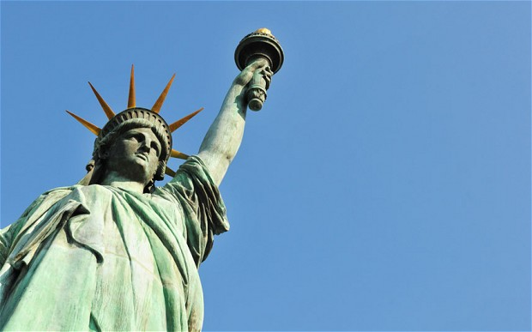

1. The statue’s full name is Liberty Enlightening the World.

2. It was a gift from France, given to America in 1886.

3. The head of the statue was displayed at the World's Fair in Paris in 1878.

4. The robed female figure represents Libertas, the Roman goddess of freedom.

5. She holds a torch and tablet upon which is inscribed the date of American Declaration of Independence (July 4, 1776).

6. From the ground to the top of the torch the statue measures 93 metres, and weighs 204 metric tonnes.

7. Lady Liberty wears a size 879 shoe.

8. She has a 35-foot waistline

9. Visitors have to climb 354 stairs to reach the statue’s crown.

10. There are 25 windows in the crown.

11. Approximately 4m people visit the statue each year. In comparison, over 6m people visit The Eiffel Tower, and 3.5m visit The London Eye.

12. The seven spikes on the crown represent the seven oceans and the seven continents of the world, indicating the universal concept of liberty.

13. The statue has an iron infrastructure and copper exterior which has turned green due to oxidation. Although it’s a sign of damage, the patina (green coating) also acts as a form of protection from further deterioration.

14. Edouard de Laboulaye provided the idea for the statue, while Frederic-Auguste Bartholdi designed it.

15. Laboulaye proposed that a great monument should be given as a gift from France to the United States as a celebration of both the union’s victory in the American Revolution, and the abolition of slavery.

16. Laboulaye also hoped the gift of the statue would inspire French people to fight for their own democracy in the face of a repressive monarchy under Napolean III.

17. Gustave Eiffel, the man who designed the Eiffel Tower was also behind the design for Liberty’s ‘spine’; four iron columns supporting a metal framework that holds the copper skin which is a mere 3/32ths of an inch thick.

18. 300 different types of hammers were used to create the copper structure.

19. The statue's face was said to be modelled on the sculptor's mother, Charlotte.

20. The statue’s original torch was replaced in 1984 by a new copper torch covered in 24k gold leaf.

21. Although you cannot see Lady Liberty’s feet clearly she is in fact standing among a broken shackle and chains, with her right foot raised, depicting her moving forward away from oppression and slavery.

22. Despite the positive meaning of the statue - American independence and the abolition of slavery - it African Americans saw the statue as an ironic image of America; professing to be a country of freedom and justice for everyone regardless of race, despite racism and discrimination continuing to exist.

23. The Statue of Liberty became the symbol of immigration during the second half of the 19th century, as over 9m immigrants came to the United States, with the statue often being the first thing they saw when arriving by boat.

24. The statue’s most famous cinematic appearance was in the 1968 film “Planet of the Apes” where it is seen half buried in sand.

25. It is also destroyed in the films "Independence Day" and "The Day After Tomorrow".

26. The cost of the statue was funded by contributions from both the French and the Americans. In 1885, a New York newspaper entitled “World” announced that $102,000 had been raised from donors, and that 80 per cent of this total had been received in sums of less than one dollar.

27. Groups in Boston and Philadelphia offered to pay the full cost of the construction of the statue, in return for its relocation.

28. When the statue was first erected in 1886 it was the tallest iron structure ever built.

29. In 1984, the statue was listed as a UNESCO World Heritage Site.

30. In high winds of 50mph Lady Liberty can sway by up to 3 inches, while her torch can move 5 inches.

31. Lady Liberty is thought to have been hit by around 600 bolts of lightning every year since she was built. A photographer captured this for the first time in 2010.

32. Two people have committed suicide by jumping off the statue, one in 1929 and the other in 1932, while many others have jumped and survived.

33. American poet Emma Lazarus wrote about the Statue of Liberty in a sonnet called “The New Colossus” (1883). In 1903 the poem was engraved on a bronze plaque and placed inside the lower level of the pedestal on the statue.

34. The island in which it stands was previously called Bedloe Island, but its name was changed in 1956 to Liberty Island.

35. There are various replicas of the statue, including a smaller version in Paris, and one on the Las Vegas Strip in Nevada.

36. In 1944 the lights in the crown flashed “dot-dot-dot-dash” which in the Morse code means V, for Victory in Europe.

37. Andy Warhol painted “Statue of Liberty” as part of his Pop Art series in the 1960s. It is estimated to be worth in excess of $35m.

38. The statue functioned as a lighthouse for 16 years (1886-1902), lighting a distance of up to 24 miles away.

39. The statue will be celebrating its 127th birthday in October 2013.

40. Miss America, the comic book character, was granted her powers by the statue.

41. After the terrorist attacks of September 11, the statue was closed for security reasons, with the pedestal reopening in 2004, and the statue in 2009, but only a limited number of visitors are able to go up to the crown.

42. The statue was again closed in 2012 due to the effects of Hurricane Sandy, with the island off limits to the public. The statue is reopening to visitors on Independence Day, July 4, 2013.

43. The statue sustained minor damage in 1916 when German saboteurs set off an explosion during World War One. The torch-bearing arm suffered the most damage, with repair works costing $100,000. The stairs in the torch were then closed to the public for safety reasons, and have remained closed ever since.

44. No-one has been able to visit the torch since.

45. Private boats are not allowed to dock at Liberty and Ellis islands. Therefore the only way on is via the ferry system.

46. The statue's 300 copper pieces were transported to America in 214 crates on the French ship *Isere*, which almost sank in stormy seas.

47. Liberty Island is federal property within the territory of the State of New York, even though it is closer to New Jersey.

48. In 1982, it was discovered that the head had been installed two feet off centre.

49. Two images of the statue appear on a $10 bill.

50. The cost of building the statue and pedestal amounted to over $500,000, over $10m in today’s money.

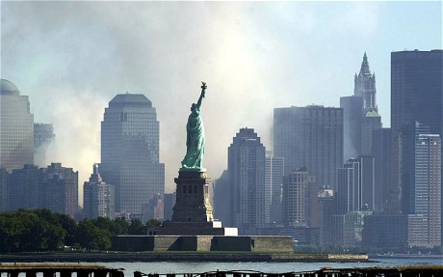http://www.telegraph.co.uk/travel/destinations/northamerica/usa/newyork/10157989/Statue-of-Liberty-50-fascinating-facts.html