Crime and Punishment – introduction

Activity 1:
In pairs, consider the vocabulary you need to discuss the theme of crime and punishment. Look up words and phrases you expect will be useful, and make notes.

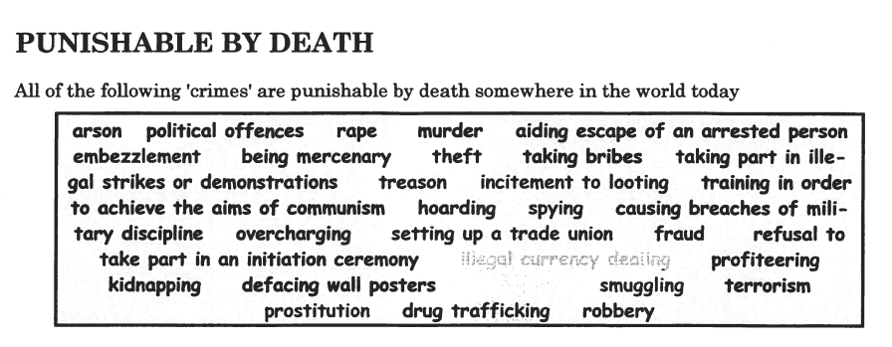

Activity 2:
- Look up any words in the box above that you do not understand.
- In pairs, discuss which crimes are worse than others.
- Write a list of the “Five Worst Crimes”.
- Do you believe that the death penalty should exist for any of these crimes? If do which one(s)? Be prepared to explain why.
- Which of these crimes are against the government?
- Which crimes are against the individual?
- Do you think these two crimes should have the same punishment? Why/why not?

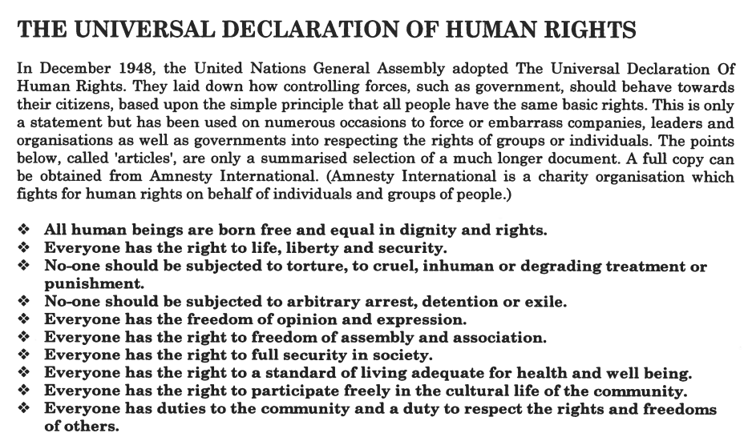

Activity 3:
Look back on the on box with the list of crimes around the world for which death penalty is the punishment. How many of these are in direct contravention of the articles in The Declaration of Human Rights? What do you think about this?
Activity 4:
INSTRUCTIONS FROM JANNIE

