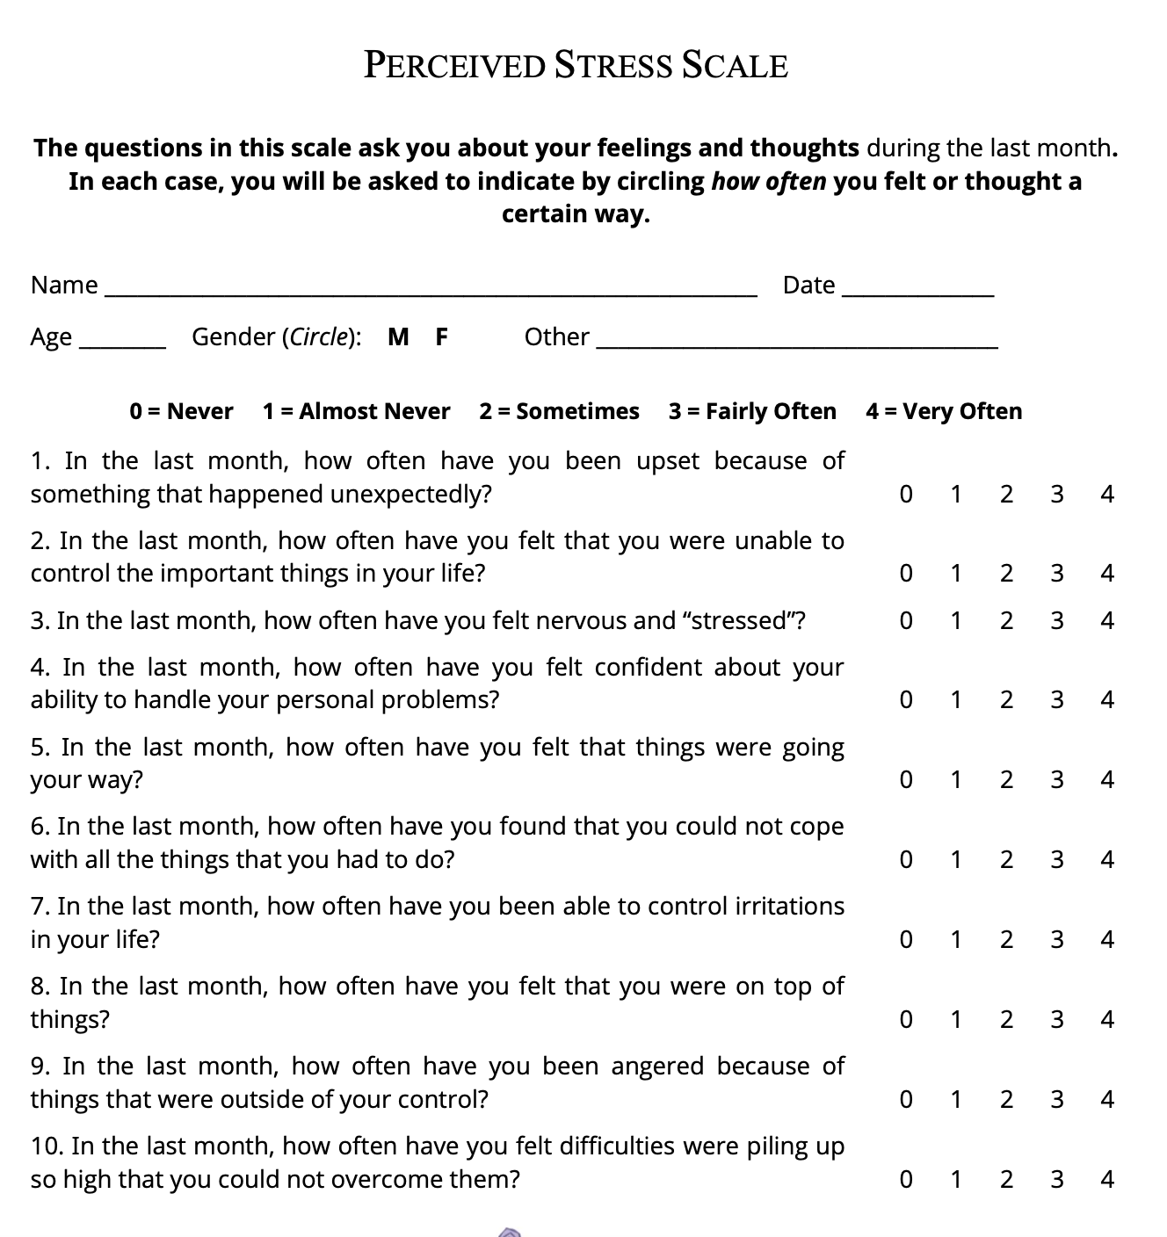

Individual scores on the PSS (perceived stress scale) can range from 0 to 40 with higher scores indicating higher perceived • stress. ► Scores ranging from 0-13 would be considered low stress. ► Scores ranging from 14-26 would be considered moderate stress. ► Scores ranging from 27-40 would be considered high perceived stress.

Obs.: Ved spørgsmål 4,5,7,8 skal skalaen vendes om, når man tæller scoren sammen. Dvs. svaret ”4” (very often) giver 0 point, og ”3” (fairly often) giver 1 point.

