Positive Psychology In Dystopian Fiction
by Roland Majla | November, 2024 | Roland Majla | 0 comments
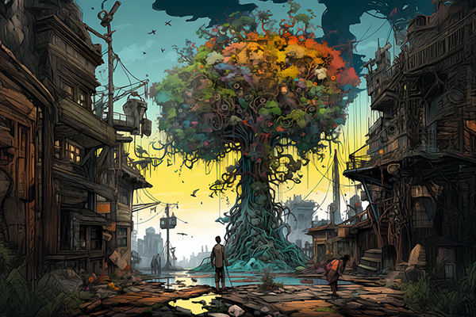

Dystopian fiction, with its bleak landscapes and oppressive regimes, might seem an unlikely place to find inspiration and hope. Yet, within these dark tales, we often encounter characters who exhibit remarkable resilience and positive psychology. By analyzing the elements of positive psychology present in dystopian stories, we can gain a deeper understanding of how these narratives offer hope and inspiration, even in the most challenging circumstances.

Positive Psychology in Dystopian Fiction
At first glance, dystopian fiction may appear to be the antithesis of positive psychology. However, many dystopian stories explore the human capacity for hope, resilience, and the pursuit of meaning, even in the face of adversity. You just have to look at it from a positive perspective, as everything has it’s positive side. Here are some examples of how elements of positive psychology can be found in dystopian fiction:
Character Strengths
- Katniss Everdeen (The Hunger Games): Katniss displays immense courage as she volunteers to take her sister’s place in the deadly Hunger Games. Her resilience is evident in her ability to survive harsh conditions, overcome challenges, and protect those she loves.
- Winston Smith (1984): Despite the constant surveillance and threat of punishment, Winston maintains a rebellious spirit and a desire for truth and freedom. His unwavering belief in the importance of individual thought and expression demonstrates his courage and moral fortitude. Aren’t we a bit like him sometimes?
- Tris Prior (Divergent): Tris exhibits exceptional courage and resilience as she navigates a dangerous world and defies societal expectations. Her ability to adapt to challenging situations and overcome her fears showcases her strength of character.
Positive Emotions
- Hope in The Handmaid’s Tale: Despite the oppressive regime and the dehumanizing treatment of women, characters like Offred cling to hope. They find solace in small acts of defiance, such as reading forbidden books or forming clandestine relationships.
- Gratitude in The Book Thief: Liesel, the protagonist, finds joy in simple pleasures, such as reading books, spending time with her foster family, and helping others. Her gratitude for these small moments of happiness helps her endure the hardships of war and loss.
- Love in The Giver: Jonas and Fiona’s deep bond of love and friendship provides a sense of comfort and meaning in a colorless and emotionless world. Their love for each other gives them strength and hope, even as they face the challenges of their society.
Positive Relationships
- Community in The Hunger Games: The districts in Panem form a sense of community, supporting each other and sharing resources. This collective strength helps them to resist the oppressive regime and fight for their survival.
- Mentorship in Divergent: Mr. Holmes serves as a mentor to Tris, guiding her through the challenges of her Divergent identity and teaching her valuable life lessons. His support and wisdom help Tris to develop her strengths and become a resilient individual.
- Friendship in 1984: Winston and Julia’s forbidden love affair provides them with a sense of connection and purpose. Their friendship and mutual support help them to endure the harsh realities of their dystopian world.

Meaning and Purpose
- Rebellion in 1984: Winston’s rebellion against the totalitarian regime gives his life meaning and purpose. His desire to challenge the Party’s control and to expose the truth fuels his actions and drives him to risk his life.
- Preservation of Knowledge in The Giver: Jonas’s role as the Receiver of Memory gives him a sense of purpose and responsibility. He strives to preserve the memories of the past and to understand the true nature of human experience.
- Human Connection in The Handmaid’s Tale: Offred finds meaning in her relationships with other women, such as Ofglen and Janine. These connections provide her with a sense of belonging and hope, even as she is stripped of her identity and autonomy.

The Power of Positive Psychology in Dystopian Fiction
By exploring the elements of positive psychology present in dystopian fiction, we can gain a deeper appreciation for the human spirit’s capacity to endure and overcome adversity. These stories remind us that even in the darkest of times, there is always hope, resilience, and the potential for positive change. By identifying and cultivating our own character strengths, practicing gratitude, nurturing positive relationships, and seeking meaning and purpose, we can enhance our own well-being and contribute to a more positive future.

The Power of Positivity in Real Life Experiences
The rate at which information is fed to us far exceeds our ability to process the experience. But this doesn’t create crisis, I think it creates indifference rather. It paralyses one’s ability to react. Normal person is horrified by things that causes horrifying things, rejoices at things that causes happiness, laughs at funny things, or gets sad at sad things. There is no time to live in the moment, therefore there’s no time to process the experience which will lead to indifference. But there is a way out of this. And it’s called Positive Thinking. Or rather Positive Reframing.
Positive thinking allows you to perceive challenges as opportunities for growth and development. Instead of viewing rapid changes as disruptive and negative, you can see them as a catalyst for positive transformation. This reframing of perspective can significantly impact your emotional response and your approach to problem-solving.

Let me give you a couple of examples of how I usually think when challenges arise:
- Shifting Perspective:
  - Negative Perspective: “This change is causing so much stress and uncertainty. I don’t know how to cope.”
  - Positive Perspective: “This change is a chance to learn new skills, adapt to new circumstances, and emerge stronger.”

- Embracing Growth:
  - Negative Mindset: “I’m not good at handling change. This is going to be difficult.”
  - Positive Mindset: “This change is an opportunity to step outside my comfort zone and develop new strengths.”

- Focusing on Solutions:
  - Negative Focus: “This is a problem. I don’t know how to fix it.”
  - Positive Focus: “This is a challenge, and challenges can be overcome. Let’s brainstorm potential solutions.”

Mind you, I confess that most of the times negative thinking patterns are the ones that pops up to my mind when challenges arise, and they are not nice. The feeling that comes with it is sometimes dragging me down. However, I metaphorically ‘kick myself in the but’ and reverse my thinking pattern and then just go with the flow of positivity.
Next time you are watching a dystopian film, you can try it for yourself and see if you are able to shift your perspective. If you can do it with films, then you can do it with your life as well. Consider your life as a movie.

Source:
https://www.thepositivepsychologypeople.com/positive-psychology-in-dystopian-fiction/#:~:text=Dystopian%20fiction%20can%20also%20feature%20characters%20who,in%20small%20acts%20of%20defiance%20*%20**Gratitude**

