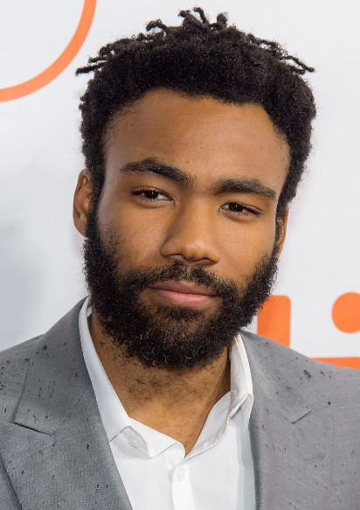“This Is America”

[Donald Glover](https://www.google.com/search?rlz=1C1GCEV_en&sxsrf=ACYBGNSFSPRKh8Xy-yIGA3WgTS4e-Cx6Zw:1580460566926&q=Donald+Glover&stick=H4sIAAAAAAAAAONgVuLSz9U3MDI3tyjPXcTK65Kfl5iTouCek1-WWgQAp66Qrx4AAAA&sa=X&ved=2ahUKEwi8-rC1uq3nAhW5zMQBHYtKDcoQMTAAegQIDRAF) (**Donald McKinley Glover Jr.)**

**Stage name: ”Childish Gambino” or ”mcDJ”**

**Youtube:** <https://www.youtube.com/watch?v=VYOjWnS4cMY>

**Genious:** <https://genius.com/14510122>

Yeah, yeah, yeah, yeah, yeah  
Yeah, yeah, yeah, go, go away  
Yeah, yeah, yeah, yeah, yeah  
Yeah, yeah, yeah, go, go away  
Yeah, yeah, yeah, yeah, yeah  
Yeah, yeah, yeah, go, go away  
Yeah, yeah, yeah, yeah, yeah  
Yeah, yeah, yeah, go, go away

We just wanna party  
Party just for you  
We just want the money  
Money just for you  
I know you wanna party (yeah)  
Party just for free  
Girl, you got me dancin' (girl, you got me dancin')  
Dance and shake the frame  
We just wanna party (yeah)  
Party just for you (yeah)  
We just want the money (yeah)  
Money just for you (ooh)  
I know you wanna party (yeah)  
Party just for free (yeah)  
Girl, you got me dancin' (girl, you got me dancin')  
Dance and shake the frame (ooh)

This is America  
Don't catch you slippin' now  
Don't catch you slippin' now  
Look what I'm whippin' now  
This is America (woo)  
Don't catch you slippin' now  
Don't catch you slippin' now  
Look what I'm whippin' now

This is America (skrrt, skrrt, woo)  
Don't catch you slippin' now (ayy)  
Look at how I'm livin' now  
Police be trippin' now (woo)  
Yeah, this is America (woo, ayy)  
Guns in my area (word, my area)  
I got the strap (ayy, ayy)  
I gotta carry 'em  
Yeah, yeah, I'ma go into this (ugh)  
Yeah, yeah, this is guerilla, woo  
Yeah, yeah, I'ma go get the bag  
Yeah, yeah, or I'ma get the pad  
Yeah, yeah, I'm so cold like yeah (yeah)  
I'm so dope like yeah (woo)  
We gon' blow like yeah (straight up, uh)

Ooh-ooh-ooh-ooh-ooh, tell somebody  
You go tell somebody  
Grandma told me  
Get your money, black man (get your money)  
Get your money, black man (get your money)  
Get your money, black man (get your, black man)  
Get your money, black man (get your, black man)  
Black man

This is America (woo, ayy)  
Don't catch you slippin' now (woo, woo, don't catch you slippin', now)  
Don't catch you slippin' now (ayy, woah)  
Look what I'm whippin' now (Slime!)  
This is America (yeah, yeah)  
Don't catch you slippin' now (woah, ayy)  
Don't catch you slippin' now (ayy, woo)  
Look what I'm whippin' now (ayy)

Look how I'm geekin' out (hey)  
I'm so fitted (I'm so fitted, woo)  
I'm on Gucci (I'm on Gucci)  
I'm so pretty (yeah, yeah)  
I'm gon' get it (ayy, I'm gon' get it)  
Watch me move (blaow)  
This a celly (ha)  
That's a tool (yeah)  
On my Kodak (woo, Black)  
Ooh, know that (yeah, know that, hold on)  
Get it (get it, get it)  
Ooh, work it (21)  
Hunnid bands, hunnid bands, hunnid bands (hunnid bands)  
Contraband, contraband, contraband (contraband)  
I got the plug on Oaxaca (woah)  
They gonna find you like blocka (blaow)

Ooh-ooh-ooh-ooh-ooh, tell somebody  
(America, I just checked my following list and)  
You go tell somebody  
(You mothafuckas owe me)  
Grandma told me  
Get your money, black man (black man)  
Get your money, black man (black man)  
Get your money, black man (black man)  
Get your money, black man (black man)  
Black man (one, two, three, get down)

Ooh-ooh-ooh-ooh-ooh, tell somebody  
You go tell somebody  
Grandma told me, "Get your money, " black man  
Get your money, black man (black man)  
Get your money, black man (black man)  
Get your money, black man (black man)  
Black man

You just a black man in this world  
You just a barcode, ayy  
You just a black man in this world  
Drivin' expensive foreigns, ayy  
You just a big dawg, yeah  
I kenneled him in the backyard  
No proper life to a dog  
For a big dog

Source: [LyricFind](https://www.lyricfind.com/)

Songwriters: Donald Glover / Ludwig Goransson

This Is America lyrics © Kobalt Music Publishing Ltd., Warner Chappell Music, Inc, Universal Music Publishing Group, Reservoir Media Management Inc