Edgar Allen Poe: “The Fall of the House of Usher”, 1839

[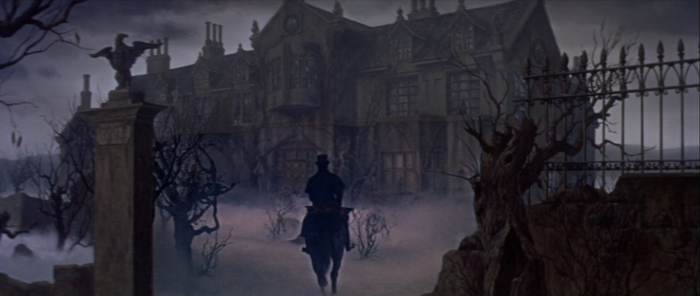](http://www.google.dk/url?sa=i&rct=j&q=&esrc=s&frm=1&source=images&cd=&cad=rja&docid=90JcIwgk4KBC5M&tbnid=wyTKCtHKBdzcOM:&ved=0CAUQjRw&url=http://breakfastintheruins.blogspot.com/2012/12/gothic-originals-fall-of-house-of-usher.html&ei=uh1JUoq4OqWq4ATThYHQBA&bvm=bv.53217764,d.bGE&psig=AFQjCNEHZsq98L8Mzg5IGje787sNDAAJ5w&ust=1380609774883788)

# Plot: The story begins with the unnamed [narrator](http://en.wikipedia.org/wiki/Narrator) arriving at the house of his friend, Roderick Usher, having received a letter from him in a distant part of the country complaining of an illness and asking for his help. Although Poe wrote this short story before the invention of modern psychological science, Roderick's condition can be described according to its terminology. It includes a form of [sensory overload](http://en.wikipedia.org/wiki/Sensory_overload) known as [hyperesthesia](http://en.wikipedia.org/wiki/Hyperesthesia) (hypersensitivity to light, sounds, smells, and tastes), [hypochondria](http://en.wikipedia.org/wiki/Hypochondria) (an excessive preoccupation or worry about having a serious illness), and acute [anxiety](http://en.wikipedia.org/wiki/Anxiety). It is revealed that Roderick's twin sister, Madeline, is also ill and falls into [cataleptic](http://en.wikipedia.org/wiki/Catalepsy)[1], deathlike trances. The narrator is impressed with Roderick's paintings, and attempts to cheer him by reading with him and listening to his improvised musical compositions on the [guitar](http://en.wikipedia.org/wiki/Guitar). Roderick sings "[The Haunted Palace](http://en.wikipedia.org/wiki/The_Haunted_Palace_(poem))", then tells the narrator that he believes the house he lives in to be alive, and that this sentience[2] arises from the arrangement of the masonry and vegetation surrounding it.

Roderick later informs the narrator that his sister has died and insists that she be entombed[3] for two weeks in a vault (family tomb) in the house before being permanently buried. The narrator helps Roderick put the body in the tomb, and he notes that Madeline has rosy cheeks, as some do after death. They inter[4] her, but over the next week both Roderick and the narrator find themselves becoming increasingly agitated for no apparent reason. A storm begins. Roderick comes to the narrator's bedroom, which is situated directly above the vault, and throws open his window to the storm. He notices that the [tarn](http://en.wikipedia.org/wiki/Tarn_(lake))[5] surrounding the house seems to [glow in the dark](http://en.wikipedia.org/wiki/Luminescence), as it glowed in Roderick Usher's paintings, although there is no lightning.

The narrator attempts to calm Roderick by reading aloud *The Mad Tryst*, a novel involving a [knight](http://en.wikipedia.org/wiki/Knight) named Ethelred who breaks into a [hermit](http://en.wikipedia.org/wiki/Hermit)'s[6] dwelling in an attempt to escape an approaching storm, only to find a [palace](http://en.wikipedia.org/wiki/Palace) of gold guarded by a [dragon](http://en.wikipedia.org/wiki/Dragon). He also finds hanging on the wall a [shield](http://en.wikipedia.org/wiki/Shield) of shining [brass](http://en.wikipedia.org/wiki/Brass) on which is written a legend: that the one who slays the dragon wins the shield. With a stroke of his [mace](http://en.wikipedia.org/wiki/Mace_(club))[7], Ethelred kills the dragon, who dies with a piercing shriek, and proceeds to take the shield, which falls to the floor with an unnerving clatter.

As the narrator reads of the knight's forcible entry into the dwelling, cracking and ripping sounds are heard somewhere in the house. When the dragon is described as shrieking as it dies, a shriek is heard, again within the house. As he relates the shield falling from off the wall, a [reverberation](http://en.wikipedia.org/wiki/Reverberation), metallic and hollow, can be heard. Roderick becomes increasingly hysterical, and eventually exclaims that these sounds are being made by his sister, who was in fact alive when she was entombed and that Roderick Usher knew that she was alive. The bedroom door is then blown open to reveal Madeline standing there. She falls on her brother, and both land on the floor as corpses. The narrator then flees the house, and, as he does so, notices a flash of light causing him to look back upon the House of Usher, in time to watch it break in two, the fragments sinking into the tarn.

# Excerpt from “The Fall of the House of Usher”:

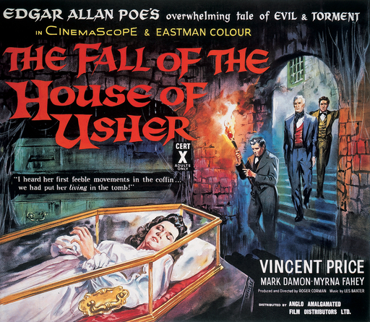DURING the whole of a dull, dark, and soundless day in the autumn of the year, when the clouds hung oppressively low in the heavens, I had been passing alone, on horseback, through a singularly dreary tract of country ; and at length found myself, as the shades of the evening drew on, within view of the melancholy House of Usher. I know not how it was - but, with the first glimpse of the building, a sense of insufferable gloom pervaded my spirit. I say insufferable ; for the feeling was unrelieved by any of that half-pleasurable, because poetic, sentiment, with which the mind usually receives even the sternest natural images of the desolate or terrible. I looked upon the scene before me - upon the mere house, and the simple landscape features of the domain - upon the bleak walls - upon the vacant eye-like windows - upon a few rank sedges - and upon a few white trunks of decayed trees - with an utter depression of soul which I can compare to no earthly sensation more properly than to the after-dream of the reveller[8] upon opium - the bitter lapse into everyday life - the hideous dropping off of the veil. There was an iciness, a sinking, a sickening of the heart - an unredeemed dreariness of thought which no goading of the imagination could torture into aught[9] of the sublime. What was it - I paused to think - what was it that so unnerved me in the contemplation of the House of Usher ? It was a mystery all insoluble ; nor could I grapple with the shadowy fancies that crowded upon me as I pondered. I was forced to fall back upon the unsatisfactory conclusion, that while, beyond doubt, there are combinations of very simple natural objects which have the power of thus affecting us, still the analysis of this power lies among considerations beyond our depth. It was possible, I reflected, that a mere different arrangement of the particulars of the scene, of the details of the picture, would be sufficient to modify, or perhaps to annihilate its capacity for sorrowful impression ; and, acting upon this idea, I reined my horse to the precipitous[10] brink of a black and lurid tarn that lay in unruffled lustre[11] by the dwelling, and gazed down - but with a shudder even more thrilling than before - upon the remodelled and inverted images of the gray sedge[12], and the ghastly tree-stems, and the vacant and eye-like windows.

(From: “The Fall of the House of Usher, 1839)

1. Faststivnen af legemet
2. Feeling
3. Buried
4. Bury
5. Small lake
6. Eneboer
7. Stridskølle/morgenstjerne
8. Svirebror
9. Hvad som helst
10. Stejl
11. Glans
12. Græslignende plante