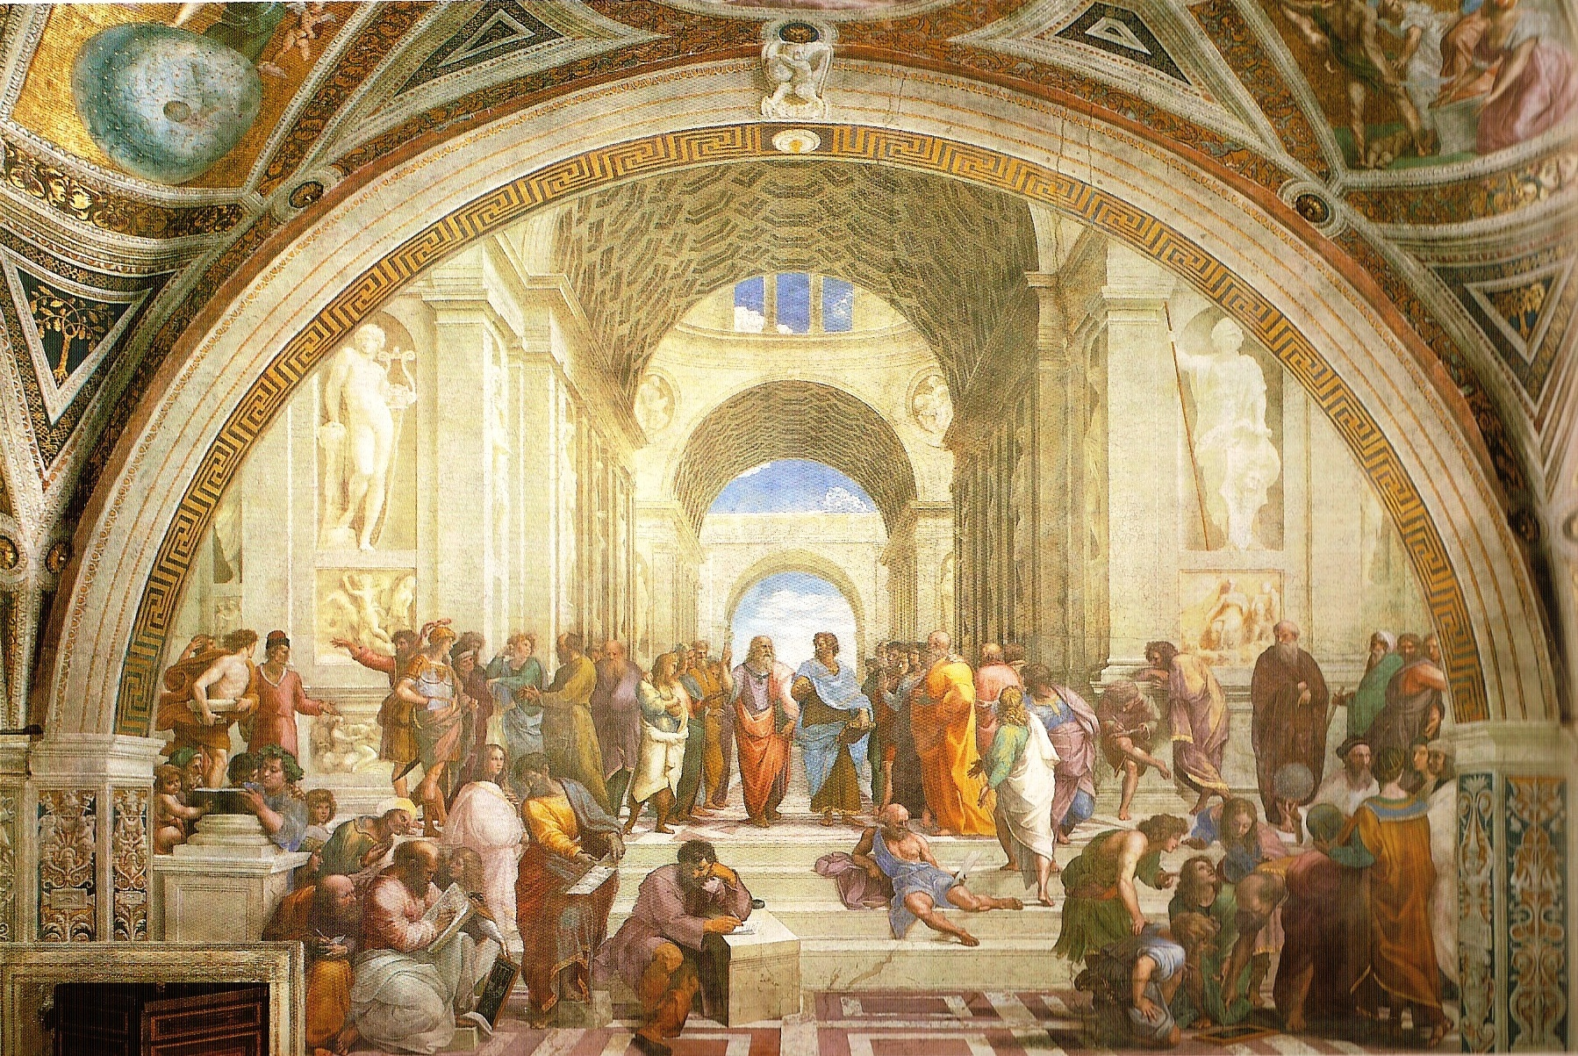

Rafael: Skolen i Athen, 1509-10

