**Film analysis**

When one analyses a film, it is very much the same as analysing a novel or a short story. This means that the same elements are analysed such as [setting](https://theenglishhandbook.systime.dk/index.php?id=148#c791), [point of view](https://theenglishhandbook.systime.dk/index.php?id=148#c803), [characters](https://theenglishhandbook.systime.dk/index.php?id=148#c814) and [theme](https://theenglishhandbook.systime.dk/index.php?id=148#c822). However, in a film there is the extra dimension of cinematic techniques which influence the analysis of the above mentioned elements. Cinematic techniques include the way the film is shot, the way the film is edited, lighting and colours and finally, the use of sound. The following sections describe some of the most important cinematic techniques which can be used to supplement the narrative analysis. Please note that this is not an exhaustive list.

**Shot analysis**

**Framing:**Framing is the way a shot is composed and how characters and objects are *framed* within the image.

**Long shot:** Focus is placed on setting. This frame shows the whole setting and characters may appear small.

**Medium shot:** Focus is on more than one character. This frame is often used for dialogues.

**Close-up:** Here the characters are framed very closely. Surroundings are not relevant. It is the characters' emotions or maybe a particular, important object which is in focus.

* 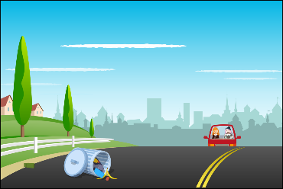

long shot

* 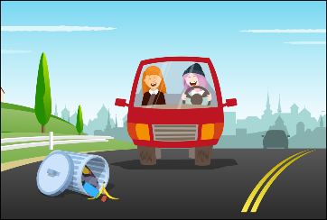

medium shot

* 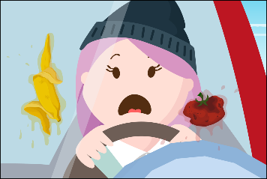

close up

**Angles:**Angles are used to make characters appear differently in the shot. Angles and framing will often give important information about the characters.

**Low angle:** When a shot is filmed in low angle, the character in question seems powerful and big.

**High angle:** When a shot is filmed in high angle, the character in question seems small and maybe weak

**Eye level:** When a shot is filmed in eye level, it makes the audience feel that they are at the same level as the character. It can make it easier to relate to the character.

* 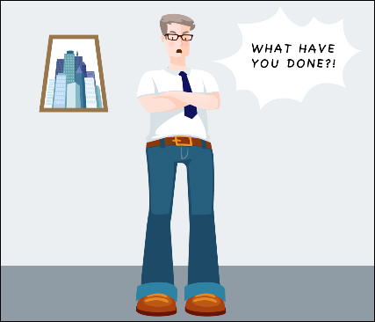

low angle

* 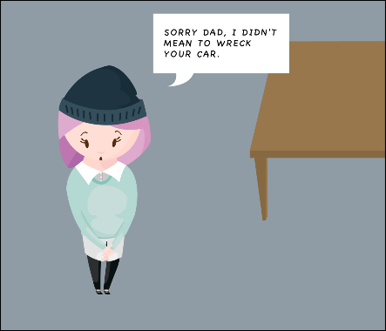

high angle

* Et billede, der indeholder tekst

  Automatisk genereret beskrivelse

eye level

**Composition:**   
Composition looks at how the shot is composed concerning what is placed in the foreground, the middle ground and the background of the shot. The relation between the three levels is important because it gives information about e.g. the characters' relation to each other.

* Et billede, der indeholder tekst

  Automatisk genereret beskrivelse

composition

**Sound**

**Diegetic sound** refers to sound which is part of the film such as dialogue, music the characters can hear and real sounds in the film.

**Non-diegetic sound**refers to sounds which are not part of the film such as voice over, music or sound effects the characters cannot hear. These sounds may add to the atmosphere of the film.

**Contrapuntal sound**refers to sounds being in direct opposition to the images of a film. An example of the use of contrapuntal sound can be found in the film *Goodmorning Vietnam* where the song *What a wonderful world* by Louis Armstrong is played while people are getting killed and bombed.

**Lighting and colour**

**Low key lighting** plays an important role in genres such as horror films, science fiction and gangster films. The low key lighting of e.g. streets in darkness and shadows adds to the mystery and horror. Low key lighting can also be used when a filmmaker wants to create a romantic atmosphere by e.g. using only candle light or the last sun beams of a sunset.

**High key lighting** is used in genres such as musicals and romantic comedies where bright and lively colours are in focus and where the filmmaker wants the audience to see every feature.

**Colour symbols**can be used if the filmmaker wants colours to symbolise different emotions and atmosphere.

**Overview of cinematic techniques**

| **Cinematic technique** | **Characteristics** |
| --- | --- |
| **Framing** | **Close-up:**The character(s) are framed very closely.  **Long shot:** Focus is placed on setting.  **Medium shot:** Focus is on more than one character. |
| **Angles** | **Low angle:**The character in question seems powerful and big.  **High angle**: The character in question seems small and maybe weak.  **Eye level:** Audience at the same level as characters. |
| **Composition** | **Foreground.**  **Middle-ground.**  **Background.** |
| **Sound** | **Diegetic sound:** Sound which is part of the film.  **Non-diegetic sound:**Sound which is not part of the film.  **Contrapuntal sound:** Sound being in direct opposition to the images of the film. |
| **Lighting** | **Low key:** Difficult to see everything in the image.  **High key:** Able to see everything in the image. |
| **Colour** | Each colour has both a positive and negative symbolism. |

**Shot by shot analysis**

It is impossible to analyse a full-length film by using cinematic techniques because they look at each shot of the film. Therefore, it is better to do a shot by shot analysis of a scene which is of great importance e.g. concerning characterization. A shot by shot analysis is done by pausing the film shot by shot or when it is relevant. Each shot is then analysed through the use of cinematic techniques and why these particular techniques have been used. Here, still images are also relevant e.g., for analyzing composition.

**Analysis of the narrative and the three-act structure**

This narrative analysis can be developed to include the three act structure which separates the film into three acts and adds plot points to the analysis.

**Three-act structure** 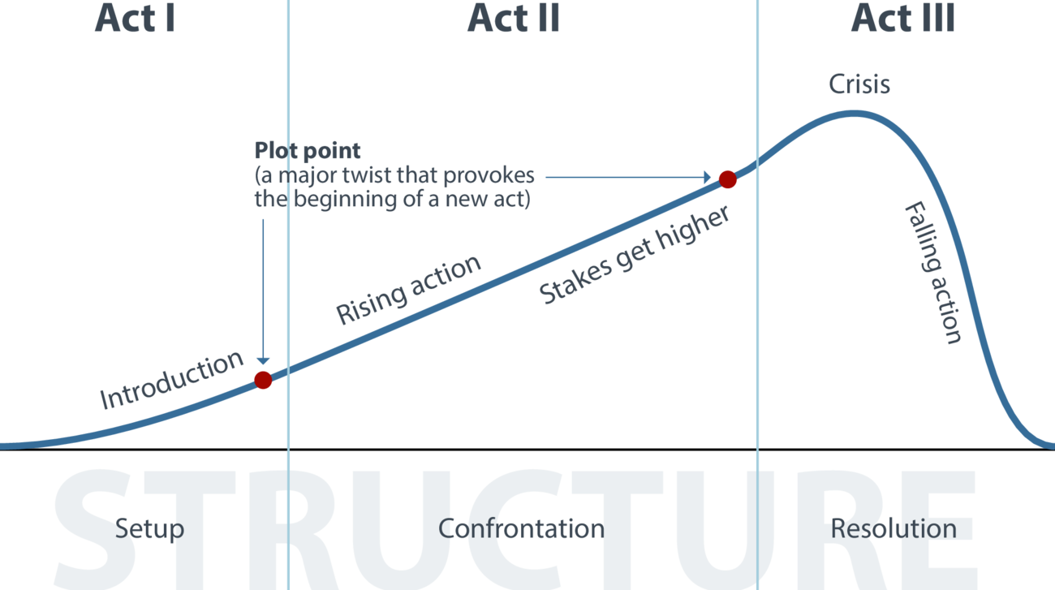

**Guide to film analysis**

1. Determine [the type of film](https://theenglishhandbook.systime.dk/index.php?id=152#c716). Who is director? Which year was the film released?
2. Analyse the composition of the film e.g. by using the [three-act structure model](https://theenglishhandbook.systime.dk/index.php?id=175#c883).
3. Analyse [setting](https://theenglishhandbook.systime.dk/index.php?id=148#c791), [characters](https://theenglishhandbook.systime.dk/index.php?id=148#c814), [narrator](https://theenglishhandbook.systime.dk/index.php?id=148#c803) and [theme](https://theenglishhandbook.systime.dk/index.php?id=148#c822).
4. Use a shot by shot analysis of a scene to supplement your analysis e.g. your character analysis. This is where you use [cinematic techniques](https://theenglishhandbook.systime.dk/index.php?id=175#c880) such as framing, angle, composition. What is the effect?

4b) Determine[the type of sound](https://theenglishhandbook.systime.dk/index.php?id=175#c877) used in the film. When does the filmmaker make use of diegetic, non-diegetic or contrapuntal sound and which effect does it have?

4c) Determine [the type of lighting and colour](https://theenglishhandbook.systime.dk/index.php?id=175#c878) used. When does the filmmaker make use of the different types of lighting and colours and why?

TIP: Other models e.g. the actantial model (below) can be used to analyze the characters and their relations. Find information e.g. about the characters on imdb.com.

