Tale af Joseph Goebbels marts 1933

German women! German men! “

It is a happy accident that my first speech since taking charge of the Ministry of Public Enlightenment and Propaganda is to German women. Although I agree with Treitschke that men make history, I do not forget that women raise boys to manhood.

…

We do not see the woman as inferior, but as having a different mission, a different value, than that of the man. Therefore we believed the German woman, who more than any other in the world is a woman in the best sense of the word, should use her strength and abilities in other areas than the man.

…

The first, best, and most suitable place for the women is in the family, and her most glorious duty is to give children to her people and nation, children who can continue the line of generations and who guarantee the immortality of the nation. The woman is the teacher of the youth, and therefore the builder of the foundation of the future. If the family is the nation’s source of strength, the woman is its core and centre.

The best place for the woman to serve her people is in her marriage, in the family, in motherhood. This is her highest mission. That does not mean that those women who are employed or who have no children have no role in the motherhood of the German people. They use their strength, their abilities, their sense of responsibility for the nation, in other ways. We are convinced, however, that the first task of a socially reformed nation must be to again give the woman the possibility to fulfil her real task, her mission in the family and as a mother.

…

A characteristic of the modern era is a rapidly declining birthrate in our big cities. In 1900, two million babies were born in Germany. Now the number has fallen to one million. This drastic decline is most evident in the nation’s capital. In the last 14 years, Berlin’s birthrate has become the lowest of any European city. By 1955, without emigration, it will have only about three million inhabitants. The government is determined to halt this decline of the family and the resulting impoverishment of our blood. There must be a fundamental change. The liberal attitude toward the family and the child is responsible for Germany’s rapid decline.

…

Plakat fra midten af 1930’erne ”Støt hjælpeprogrammet mor og barn”

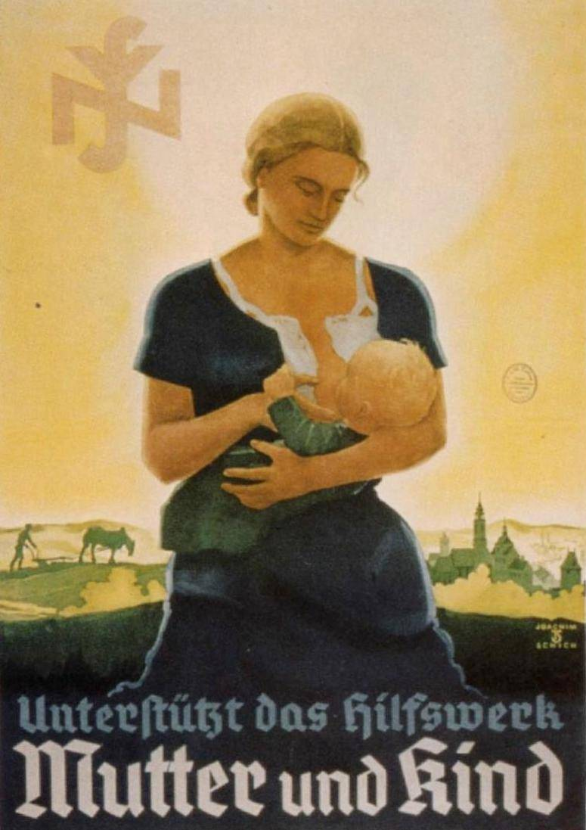

Plakat fra 1934 ”Mødre, kæmp for jeres børn!”

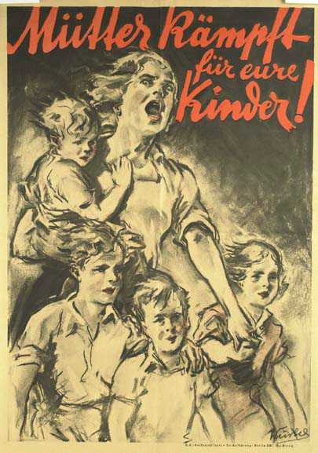

Plakat fra 1941 ”Hjælp du også med!”

