# Immigration & Multicultural Britain

# Discuss in pairs:

What does "multicultural" mean?

Which word class is it?

Does it hold positive and/or negative connotations?

Advantages/disadvantages of a multicultural society?

Is Denmark a multicultural society? Explain.

# Multicultural Britain – introduction

Our new topic is “Multicultural Britain”. The **purpose** of teaching that particular topic is to give you insight into how and why England has developed into a multicultural society and to give you information about the advantages and disadvantages of a multicultural society.

England **is** a multicultural society. This is largely due to the British Empire, which was founded at the end of the 16th century.

## The British Empire at its height:

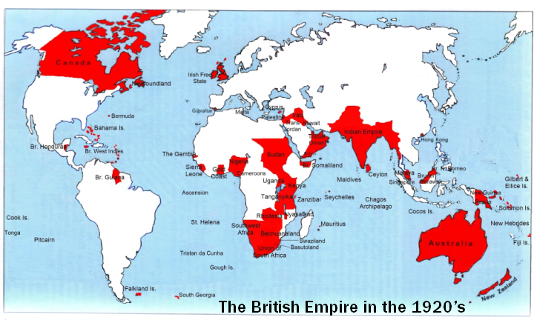

Today the British Empire looks like this:

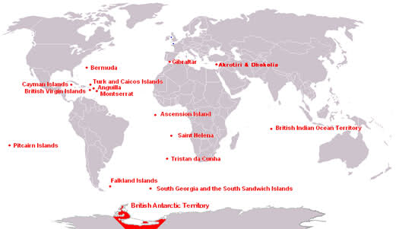

## Terms:

**The Jewel in the Crown** was a metaphor for India, which was regarded as the most important colony, giving Britain easy access to spices, cheap labour, textiles and a place to sell British goods.

**The scramble for Africa** took place between 1881-1914. It was basically when Europe divided Africa up between them.

**The dismantling of the British Empire** took place after 1945 (The Second World War) when the colonies gradually got their independence.

**The Commonwealth of Nations** is an organisation which originated around that time. It is an apolitical organisation consisting of most of the former colonies, and the purpose of it is to maintain a good relationship with other nations with whom they have a shared history, culture and language. The member states are free and equal, but the British monarch is the Head of the organisation. Today, some members want to establish a Commonwealth Union (like the EU) with free trade, visa-free travel area, common foreign policy etc.

Still, the reason why Britain is a multicultural society originates in the Empire. **The British Nationality Act** of 1948 established that all subjects of the British Empire could come to Britain to work without having a visa, thus solving the problem of labour shortage. In 1962, **the Commonwealth Immigration Act** acted as a response to the people who were becoming less tolerant and who thought Britain was being run over by immigrants. The new Act required migrants to have a job before they arrived, to possess special skills or who would meet the "labour needs" of the national economy.

Consequently, today Britain is a multicultural society, and a lot of young people feel they have a **double identity**: The identity of the country their parents came from and a more modern, Western identity. As a result of this, many of them experience a **clash of cultures** and identities. We shall explore that issue in the cause of this topic. A lot of “ethnic Britons” also have a tremendous national pride originating in the former greatness of the Empire.

We do, however, also sometimes talk about **Britain as a disunited kingdom**, meaning that it is still very much a society based on class; they do not have a welfare system similar to the Danish one; Scotland, Wales and Northern Ireland have their own regional parliaments, meaning that the idea of a particular British identity is falling apart in the sense that people have more “local” identities, and people largely live in ghettoes according ethnic origin or income. Nigel Farage and Ukip (The United Kingdom Independence Party) flourish because of this.

First, we shall analyse Rudyard Kipling’s ”White Man’s Burden” (questions are in the handouts). It shows you how most Britons regarded coloured people around that time. Later we shall look at the culture clash young people descending from immigrants experience today, and the way immigrants have contributed to forming British national identity today.