**Kildesæt i amerikansk identitetshistorie**

**Opstil og besvar 2-3 problemstillinger, på baggrund af det udtrukne materialesæt og relevant materiale fra undervisningen**

**Materiale 1. Declaration of the Immediate Causes which Induce and Justify the Secession of South Carolina**

**Materiale 2. Oversigt over hvor mange monumenter, skoler og andre afbildninger der er etableret årligt med et konføderalt præg**

**Materiale 3. Postkort der afbilder afsløringen af statuen af Sydstatsgeneralen Robert E. Lee i Charlottesville i 1924**

**Materiale 4. Behind the decision to remove a statue of Robert E. Lee**

**Materiale 5. Spørgeskemaundersøgelse om fjernelsen af statuer og mindesmærker for konføderale ledere**

# Materiale 1. Declaration of the Immediate Causes which Induce and Justify the Secession of South Carolina.

24. december 1860

The people of the State of South Carolina, in Convention assembled, on the 26th day of April, A.D. 1852, declared that the frequent violations of the Constitution of the United States, by the Federal Government, and its encroachments[1] upon the reserved rights of the States, fully justified this State in then withdrawing from the Federal Union; but in deference to the opinions and wishes of the other slaveholding States, she forbore[2] at that time to exercise this right…

…an increasing hostility on the part of the non-slaveholding States to the institution of slavery, has led to a disregard of their obligations, and the laws of the General Government have ceased to effect the objects of the Constitution.

…

We affirm[3] that these ends for which this Government was instituted have been defeated, and the Government itself has been made destructive of them by the action of the non-slaveholding States. Those States have assume the right of deciding upon the propriety of our domestic institutions; and have denied the rights of property established in fifteen of the States and recognized by the Constitution; they have denounced[4] as sinful the institution of slavery; they have permitted open establishment among them of societies, whose avowed[5] object is to disturb the peace and to eloign[6] the property of the citizens of other States. They have encouraged and assisted thousands of our slaves to leave their homes; and those who remain, have been incited by emissaries[7], books and pictures to servile insurrection.

…

A geographical line has been drawn across the Union, and all the States north of that line have united in the election of a man to the high office of President of the United States, whose opinions and purposes are hostile to slavery. He is to be entrusted with the administration of the common Government, because he has declared that that "Government cannot endure permanently half slave, half free," and that the public mind must rest in the belief that slavery is in the course of ultimate extinction.

…

On the 4th day of March next, this party will take possession of the Government. It has announced that the South shall be excluded from the common territory, that the judicial tribunals shall be made sectional, and that a war must be waged against slavery until it shall cease throughout the United States.

The guaranties of the Constitution will then no longer exist; the equal rights of the States will be lost. The slaveholding States will no longer have the power of self-government, or self-protection, and the Federal Government will have become their enemy.

…

We, therefore, the People of South Carolina, by our delegates in Convention assembled, appealing to the Supreme Judge of the world for the rectitude of our intentions, have solemnly declared that the Union heretofore existing between this State and the other States of North America, is dissolved, and that the State of South Carolina has resumed her position among the nations of the world, as a separate and independent State; with full power to levy war, conclude peace, contract alliances, establish commerce, and to do all other acts and things which independent States may of right do.

# Materiale 2. Oversigt over hvor mange monumenter, skoler og andre afbildninger der er etableret årligt med et konføderalt[8] præg

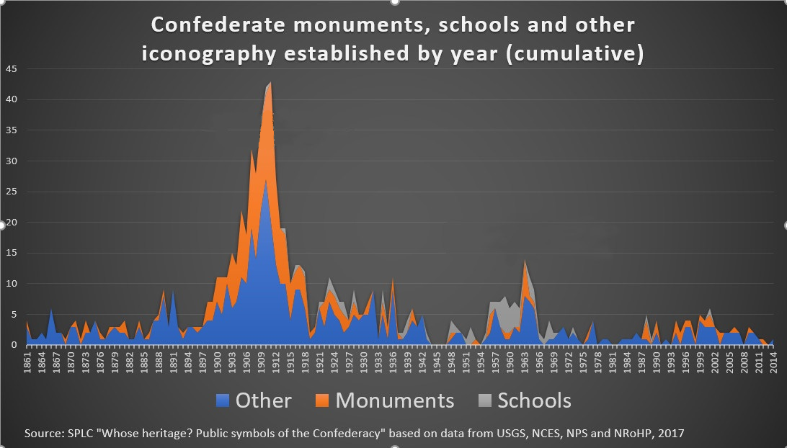

# Materiale 3. Postkort der afbilder afsløringen af statuen af Sydstatsgeneralen Robert E. Lee i Charlottesville i 1924

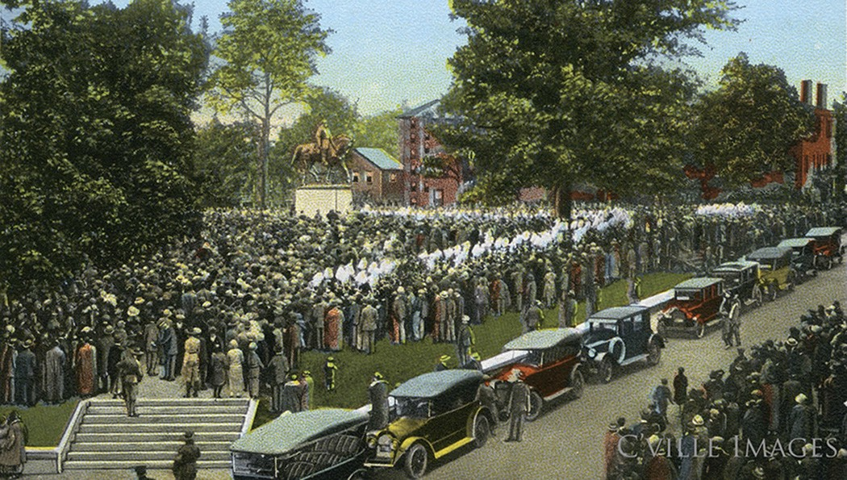

# Materiale 4. Behind the decision to remove a statue of Robert E. Lee

CBSnews.com 11. marts 2018

Last May, a crane removed a 16½ foot-tall bronze statue of Gen. Robert E. Lee from its perch 60 feet above New Orleans. The statue was one of four Confederate monuments the city's mayor, Mitch Landrieu, had removed last year.

"In a city that I represent that's 67 percent African American, to have a young African-American girl pass by that statue and look at it every day, I ask myself, 'Am I really preparing her for a really good future? Is she feeling like she's getting lifted up by the government, or is she being put down?'" Landrieu tells Anderson Cooper this week on 60 Minutes. "I mean, I think the answer's pretty clear."

[On the broadcast this week,](https://www.cbsnews.com/news/the-history-and-future-of-confederate-monuments/) Cooper reports on the debate throughout the South to remove Confederate monuments, including the two that were at the center of the violence that broke out in Charlottesville last August.

Landrieu told Cooper that his decision to remove the Lee monument began with a conversation with an old friend, renowned jazz musician and New Orleans native Wynton Marsalis…

"It was absolutely Wynton who said to me, 'I really want you to think about taking that thing down,'" Landrieu says in the video above.

…

The statue featured Lee, arms crossed, in his Civil War regalia, and it faced north "as an affront to the Union," Landrieu says.

The monument was also an insult to Marsalis' uncle, who grew up on a plantation. Marsalis lived with him for a year when he was 6 years old.

"The only reason I noticed the statue was my great-uncle, who was born in 1883, always talked about that statue," Marsalis says. "He'd point it out every time. He hated that statue."

…

Today, Lee's statue sits in a hastily built plywood shed, along with the other three Confederate statues that were removed from New Orleans…

On the broadcast, the mayor tells Cooper the monuments were a "lie."

"In the sense that Robert E. Lee was used as an example to send a message to the rest of the country, and to all the people that lived here, that the Confederacy was a noble cause," Landrieu says. "And that's just not true."

Beyond the Confederacy's racially charged defense of slavery, Marsalis emphasizes that Lee led the Confederate forces against the United States -- and they lost.

"Where in the world are you going to find a losing general with a statue in a major city of the country that won?" Marsalis asks. "No. Go look around. You tell me, when you find that statue, take a picture of it and show me."

…

# Materiale 5. Spørgeskemaundersøgelse om fjernelsen af statuer og mindesmærker for konføderale ledere

15.-16. august 2017

Spørgeskemaet er besvaret af 1.000 voksne amerikanere

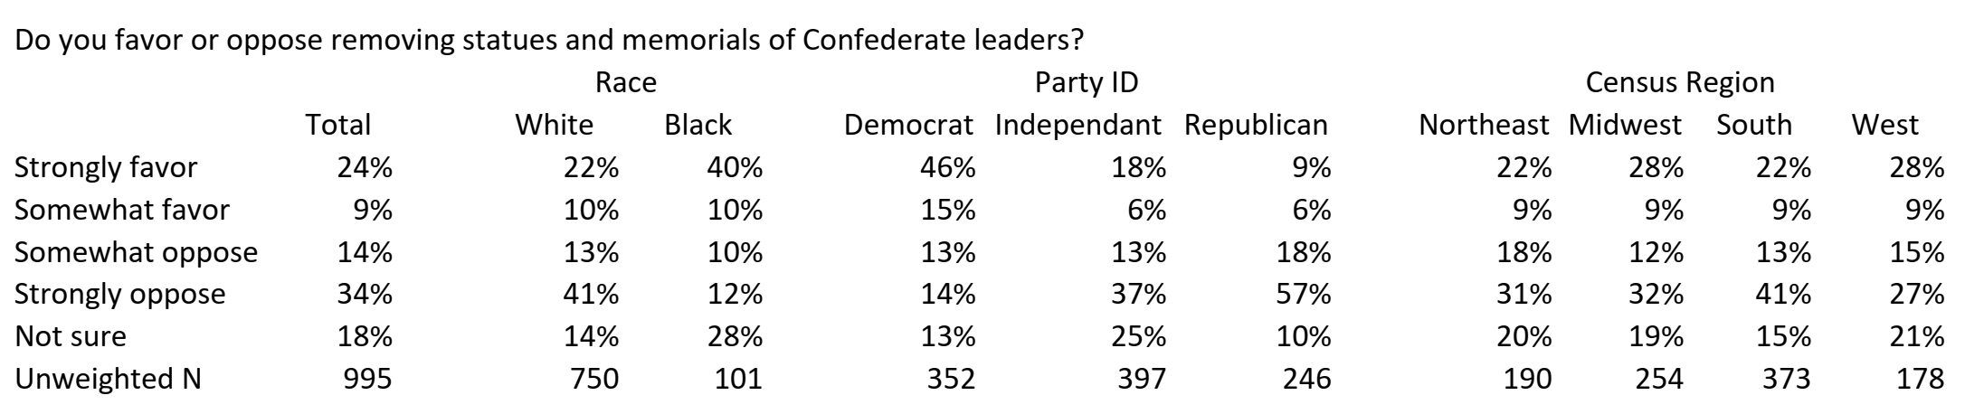

1. Indgreb/indtrængen/overgreb
2. Undlod
3. Bekræfter
4. Fordømt
5. Svoren
6. Fjerne
7. Udsendinge
8. Samlingen af sydstaterne under den amerikanske borgerkrig blev kaldt for konføderationen