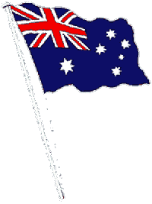
‘Advance Australia Fair' is the national anthem of Australia. A revised version of a late nineteenth century patriotic song, it was officially declared the national anthem on 19 April 1984.

ADVANCE AUSTRALIA FAIR
Revisions 1984:
Australians all let us rejoice, Australia's sons all let us rejoice,
For we are one and free; Revision 2021: young/one and free
We've golden soil and wealth for toil; rejoice: glæde sig; fryde sig
Our home is girt by sea; soil: jord, muldjord
Our land abounds in nature's gifts toil: strengt arbejde
Of beauty rich and rare; gird (-ed/girt, -ed/girt): omgive
In history's page, let every stage abound in: være rig på; vrimle med
Advance Australia Fair. advance: (fig.) gå fremad, gøre
In joyful strains then let us sing, fremskridt;
Advance Australia Fair. strain: (poet.) tone; melodi
radiant: strålende
Beneath our radiant Southern Cross commonwealth: republik
We'll toil with hearts and hands;
To make this Commonwealth of ours To make our youthful Commonwealth
Renowned of all the lands;
For those who've come across the seas For loyal sons beyond the seas young
We've boundless plains to share;
With courage let us all combine
To Advance Australia Fair.
In joyful strains then let us sing,
Advance Australia Fair.

History
The original composition of 'Advance Australia Fair' was written by Peter Dodds McCormick in 1878 and was four verses long.
In 1973 the Australia Council for the Arts held the Australian National Anthem Quest competition to find the lyrics and music for a new Australian National Anthem.
The competition received more than 1400 entries for lyrics and 1200 entries for music, but the judges decided the entries did not meet the high standards of Australia’s traditional songs ‘Advance Australia Fair’, ‘Waltzing Matilda’ and ‘Song of Australia’.
As a result, the Australia Council for the Arts recommended the final choice for the Anthem should be made from these three songs.
The Bureau of Statistics then ran a national poll of 60 000 people, which found ‘Advance Australia Fair’ was favoured by 51.4 per cent of people, followed by ‘Waltzing Matilda’ (19.6 per cent).
In 1974 ‘Advance Australia Fair’ was adopted as the Australian National Anthem, but in 1976 ‘God Save The Queen’ was reinstated.
In 1977 the Australian Electoral Office conducted another poll, which again found ‘Advance Australia Fair’ was the preferred anthem (43.6 per cent), followed by ‘Waltzing Matilda (28.45 percent).
In 1981 the National Australia Day Council recommended the Australian National Anthem consist of verses one and two of ‘Advance Australia Fair’ with some modification.
On 19 April 1984 the then Governor-General, the Rt Hon Sir Ninian M Stephen KG AK GCMG GCVO KBE, proclaimed the Australian National Anthem the tune of ‘Advance Australia Fair’ and the verses drafted by the National Australia Day Council. At the same time, ‘God Save The Queen’ was first proclaimed as the Royal Anthem.
From 1 January 2021, the words of the second line of the Australian National Anthem were amended from ‘For we are young and free’ to ‘For we are one and free’, by Proclamation made by the Governor General, General the Honourable David Hurley AC DSC (Retd), on the Government’s advice.
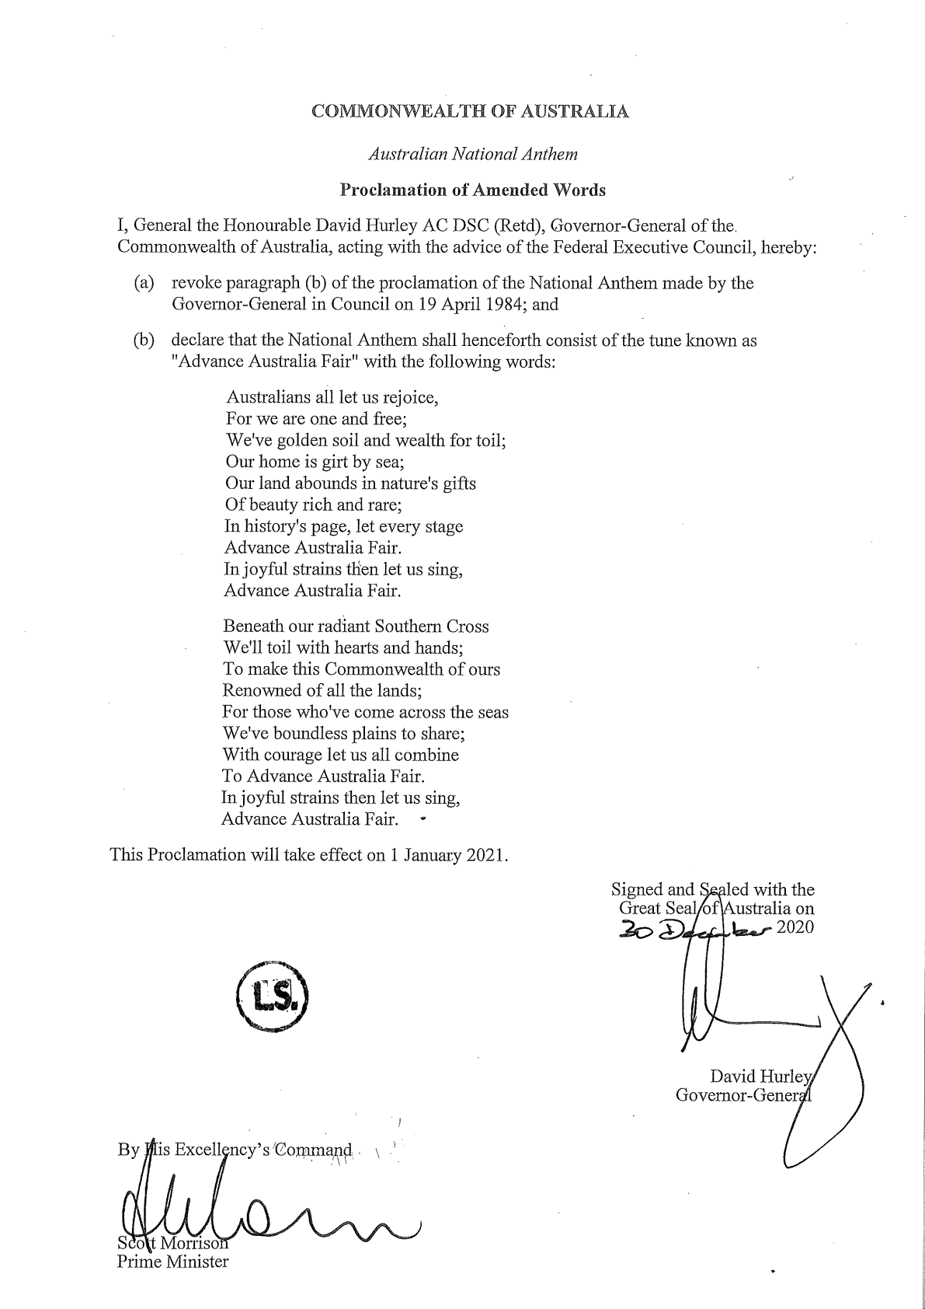
https://www.pmc.gov.au/honours-and-symbols/australian-national-symbols/australian-national-anthem

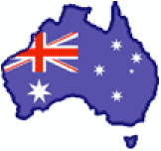

Bits and pieces from wikipedia.com:
The Commonwealth of Australia is a country in the southern hemisphere comprising the mainland of the world's smallest continent, the major island of Tasmania and a number of other islands in the Indian and Pacific Oceans.
The Australian mainland has been inhabited for more than 42,000 years by Indigenous Australians. After sporadic visits by fishermen from the north and by Dutch explorers and merchants starting in the 17th century, the eastern half of Australia was claimed by the British in 1770 and initially settled through penal transportation as part of the colony of New South Wales, commencing on 26 January 1788. As the population grew and new areas were explored, another five largely self-governing Crown Colonies were established during the 19th century.
On 1 January 1901, the six colonies became a federation, and the Commonwealth of Australia was formed. Since federation, Australia has maintained a stable liberal democratic political system and remains a Commonwealth Realm. Australia is also a multicultural country. The capital city is Canberra, located in the Australian Capital Territory. The population is 21 million, and is concentrated in the mainland state capitals of Sydney, Melbourne, Brisbane, Perth, and Adelaide.
The Commonwealth of Australia is a constitutional monarchy with a parliamentary system of government. Queen Elizabeth II is the Queen of Australia, a role that is distinct from her position as monarch of the other Commonwealth realms. The Queen is represented by the Governor-General at Federal level and by the Governors at State level. Although the Constitution gives extensive executive powers to the Governor-General, these are normally exercised only on the advice of the Prime Minister.

the southern hemisphere den sydlige halvkugle
comprise, vb omfatte
Indigenous, adj indfødte
Claim, vb gøre krav på
penal transportation transport af straffefanger
commence, vb begynde
federation, sb føderation; forbund

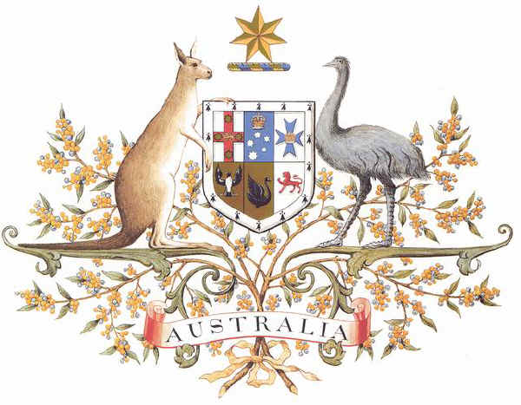
Australian Coat of Arms

Top row: Bottom row:
New South Wales South Australia
Victoria Western Australia
Queensland Tasmania

National colours
(since 1984) Almost the national
Gold and green plant: the wattle
[akacie].

