Summary:
Write a summary of Ngoola in approx.. 125 words in the box below. Make sure to do everything in the check list.

Summary: Have you… | Yes | No
Presented the original texts (such as author, title, year of publication…)
Conveyed the most important elements in the original texts. With Spoilers!
Assumed that the reader is unfamiliar with the original texts.
Written approx. 125 words
Been objective aka NO own opinions, comments and thoughts about the text
Used neutral language.
Included NO quotes

When in doubt: Look at the section on summaries in Do it, Write: https://app.minlaering.dk/bog/25/kapitel/6947/sektion/7052

Review:
Write a Review of Ngoola in 200-400 words in the box below. Make sure to do everything in the check list.

Review: Have you… | Yes | No
Presented the original texts (such as author, title, year of publication…)
Conveyed the most important elements in the original text, but with NO spoilers?
Tried to create curiosity/suspense
Written your own opinions, comments, and thoughts about the text
Used creative language to catch the attention of your reader/to try to reflect the mood of the movie (eg. metaphors, puns, rhetorical devices.. )
Given a recommendation: “Watch or don’t watch.”

Do it, Write:
For the differences in language between Summary (minimalist) and Review (descriptive) look at: https://app.minlaering.dk/bog/25/kapitel/64281/sektion/64283
For inspiration to figurative language in the review:
https://app.minlaering.dk/bog/25/kapitel/64281/sektion/64284

Cargo review – the living dead have us spooked, but in a painful way
Adelaide film festival: This zombie movie, with soul and pathos, is one of those in which the Z word is never uttered.
Luke Buckmaster Sat 7 Oct 2017 07.01 CEST
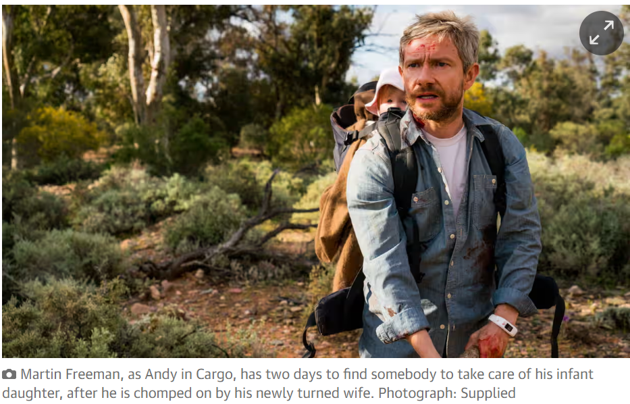
The time it takes for a bitten person to transform into a slobbering, brains-hungry ghoul in a zombie movie is often commensurate to the importance of the character. Expect a quick chomp-chomp, now-you’re-an-oogie-boogie for those on the peripheries of the story, and a protracted departure – with speeches, rueful expressions and rushed inheritance planning – for the most important players.
In Cargo, from first-time feature film-makers (and co-directors) Ben Howling and Yolanda Ramke, the time it takes to turn from normal to Romero monster is supposedly the same for everybody: about 48 hours. Therefore Andy (Martin Freeman) has two days to find somebody to take care of his infant daughter, after he is chomped on by his newly turned wife Kay (Susie Porter).
There are even bracelet-like countdown devices that infected parties attach to their wrists to keep track of how long they have left; in a world of zombie infestation, the wearable devices industry is doing fine. Finding a vaguely suitable – i.e. non-drooling, non-undead – foster parent is no easy task, as the family have been drifting down a river on a houseboat in the middle of nowhere.
Andy and the bub trek across outback Australia, sussing out potential candidates while the clock ticks, accompanied by young Indigenous girl Thoomi (an exceptional performance from newcomer Simone Landers). Cargo is Walkabout meets The Road meets one of more scientific ruminations on flesh-chewers – 1985’s Day of the Dead, perhaps. It is one of those zombie films in which the Z word is never uttered, and conversion of humans into staggering monsters is viewed through the prism of medical anomaly.
There is no chance of Andy surviving the pandemic/plague/outbreak/influenza (anything other than ‘zombie apocalypse’) because there is no cure. And the pandemic/plague/outbreak/ influenza/not-a-zombie-apocalypse has, with decades of horror films conditioning us to expect this, caused some people to behave more ghoulishly than the ghouls.
None more so than violent gun-toting hick Vic, played with expert grubbiness by Anthony Hayes, whose sweat and BO practically seeps from the screen. This rank, festy, gun-toting fellow has captured himself a bride (Caren Pistorius) and is looting the corpses of zombies, luring them with human bait.
Thoomi believes people turn into monsters when they lose their souls. The script, written by Ramke, reveals ways society has slid morally southwards – from a rural teacher (Kris McQuade) explaining to Andy that the government ripped funding from the community a long time ago, to a sign attached to a disused CGI mine reading FRACK OFF.
In director Ivan Sen’s outback neo-noir Goldstone, veteran Indigenous actor Tom E Lewis played a corrupt Aboriginal Land Council boss who prayed for the community’s sins to be washed away. In Cargo his pleas have come true, at a hideous price: the zombie infestation as a kind of biblical flood, cleansing the land and resetting society back to more basic, tribal variables.
Cargo joins a small collection of Australian genre films that add extramundane heft to otherwise run-of-the-mill plotlines by infusing them with notions of Aboriginal spirituality, including ‘80s creature features Dark Age and Frog Dreaming. At a most basic level, Cargo is about being a good parent. It is also, like Peter Weir’s classic The Last Wave and Damien Power’s recent camping thriller Killing Ground, about white guilt.

[…] The characters’ wandering journey is reflected in Simpson’s drone photography, which crawls over beautiful, vegetation-splotched, sun-parched rural land, in search of human connection. The film’s score rather obviously signifies each scene’s emotional significance, applying the proverbial highlighter pen. And there is a stretch when editors Danny Cooper and Sean Lahiff seem to struggle to smoothly integrate Andy and Rosie’s story with that of a remote Indigenous tribe, which is core to the film’s overall meaning, and incorporates a small performance from the great David Gulpilil.
Nevertheless Cargo is a very strong, at times stirring achievement: a zombie film with soul and pathos. The living dead are frightening again, not because of jump scares, surprise attacks or haunted house style shenanigans, but because they remind us of truly terrifying things: losing ourselves, and our loved ones.
https://www.theguardian.com/film/2017/oct/07/cargo-review-the-living-dead-have-us-spooked-but-in-a-painful-way

