# Yellow Katherine Susannah Pritchard, ”N’Goola” (1959), lines 149-to the end (p. 4-7)

Once again, our purpose with analyzing this short story is to find the message and the ways in which the author tries to get her message across. We do that by analyzing the different elements in the text – and remember to support your analysis with references to the text.

Come and ask me if you need help. Answer the easiest questions first. You must work in groups or in pairs. Speak English and write proper notes.

## Class work/group work:

1. Summarize what you found out last time.
2. Continue your characterization Mary. Use the words “half-caste” and “the stolen generation” in your characterization. What does it mean that she is a “crawler to the whites” (p.6 )?
3. Continue your characterization of Gwelnit.
4. Characterize Mittoon. Explain why she leaves her daughter with the ants.
5. Interpret the ending. Who is N’Goola? What does the name mean? (p. 4,5). What does Mary realize?

## Extra questions:

1. This picture is the front page of the collection of short stories that “N’Goola” was printed in. Describe the picture below and relate it to the short story “N’Goola”. Think composition, colours etc.
2. What does this short story tell us about the difficulties of being a member of the stolen generation?

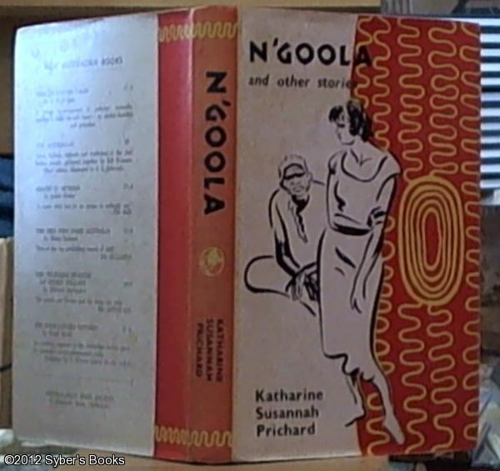

## The red group will present its results in the last 15 min. of class – we, and the Green group, will help them