Kevin Rudd’s “Sorry Speech”
Apology to Australia's Indigenous Peoples
House of Representatives, Parliament House, Canberra
13 February 2008
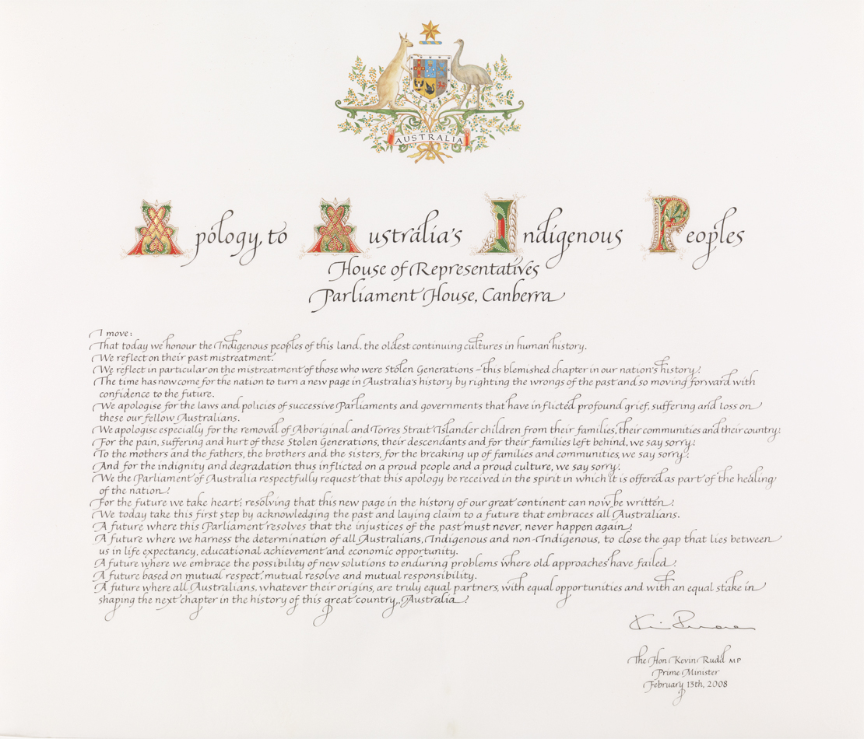
https://www.aph.gov.au/Visit_Parliament/Art/Icons/Apology_to_Australias_Indigenous_Peoples

— I move:
That today we honour the Indigenous peoples of this land, the oldest continuing cultures in human history.
We reflect on their past mistreatment.
We reflect in particular on the mistreatment of those who were Stolen Generations—this blemished chapter in our nation’s history.
The time has now come for the nation to turn a new page in Australia’s history by righting the wrongs of the past and so moving forward with confidence to the future.
We apologise for the laws and policies of successive Parliaments and governments that have inflicted profound grief, suffering and loss on these our fellow Australians.
We apologise especially for the removal of Aboriginal and Torres Strait Islander children from their families, their communities and their country.
For the pain, suffering and hurt of these Stolen Generations, their descendants and for their families left behind, we say sorry.
To the mothers and the fathers, the brothers and the sisters, for the breaking up of families and communities, we say sorry.
And for the indignity and degradation thus inflicted on a proud people and a proud culture, we say sorry.
We the Parliament of Australia respectfully request that this apology be received in the spirit in which it is offered as part of the healing of the nation.
For the future we take heart; resolving that this new page in the history of our great continent can now be written.
We today take this first step by acknowledging the past and laying claim to a future that embraces all Australians.
A future where this Parliament resolves that the injustices of the past must never, never happen again.
A future where we harness the determination of all Australians, Indigenous and non-Indigenous, to close the gap that lies between us in life expectancy, educational achievement and economic opportunity.
A future where we embrace the possibility of new solutions to enduring problems where old approaches have failed.
A future based on mutual respect, mutual resolve and mutual responsibility.
A future where all Australians, whatever their origins, are truly equal partners, with equal opportunities and with an equal stake in shaping the next chapter in the history of this great country, Australia. (...)
Some have asked, ‘Why apologise?’ Let me begin to answer by telling the parliament just a little of one person’s story—an elegant, eloquent and wonderful woman in her 80s, full of life, full of funny stories, despite what has happened in her life’s journey. (...) Nungala Fejo, as she prefers to be called, was born in the late 1920s. She remembers her earliest childhood days living with her family and her community in a bush camp just outside Tennant Creek. She remembers the love and the warmth and the kinship of those days long ago, including traditional dancing around the camp fire at night. She loved the dancing. (...)
But then, sometime around 1932, when she was about four, she remembers the coming of the welfare men. (...) The kids were found; they ran for their mothers, screaming, but they could not get away. They were herded and piled onto the back of the truck. Tears flowing, her mum tried clinging to the sides of the truck as her children were taken away to the Bungalow in Alice, all in the name of protection. (...)
Nanna Fejo’s is just one story. There are thousands, tens of thousands of them: stories of forced separation of Aboriginal and Torres Strait Islander children from their mums and dads over the better part of a century. (...) The hurt, the humiliation, the degradation and the sheer brutality of the act of physically separating a mother from her children is a deep assault on our senses and on our most elemental humanity. (...)
The nation is demanding of its political leadership to take us forward. Decency, human decency, universal human decency, demands that the nation now steps forward to right a historical wrong. That is what we are doing in this place today. But should there still be doubts as to why we must now act, let the parliament reflect for a moment on the following facts: that, between 1910 and 1970, between 10 and 30 per cent of Indigenous children were forcibly taken from their mothers and fathers. That, as a result, up to 50,000 children were forcibly taken from their families. (...)
Then we come to the argument of intergenerational responsibility, also used by some to argue against giving an apology today. But let us remember the fact that the forced removal of Aboriginal children was happening as late as the early 1970s. The 1970s is not exactly a point in remote antiquity. There are still serving members of this parliament who were first elected to this place in the early 1970s. It is well within the adult memory span of many of us. The uncomfortable truth for us all is that the parliaments of the nation, individually and collectively, enacted statutes and delegated authority under those statutes that made the forced removal of children on racial grounds fully lawful. (...)
To the Stolen Generations, I say the following: as Prime Minister of Australia, I am sorry. On behalf of the Government of Australia, I am sorry. On behalf of the Parliament of Australia, I am sorry. And I offer you this apology without qualification. We apologise for the hurt, the pain and suffering we, the parliament, have caused you by the laws that previous parliaments have enacted. We apologise for the indignity, the degradation and the humiliation these laws embodied. We offer this apology to the mothers, the fathers, the brothers, the sisters, the families and the communities whose lives were ripped apart by the actions of successive governments under successive parliaments. In making this apology, I would also like to speak personally to the members of the Stolen Generation and their families: to those here today, so many of you; to those listening across the nation—from Yuendumu, in the central west of the Northern Territory, to Yabara, in North Queensland, and to Pitjantjatjara in South Australia.
I know that, in offering this apology on behalf of the government and the parliament, there is nothing I can say today that can take away the pain you have suffered personally. Whatever words I speak today, I cannot undo that. Words alone are not that powerful. Grief is a very personal thing. I say to non-Indigenous Australians listening today who may not fully understand why what we are doing is so important, I ask those non-Indigenous Australians to imagine for a moment if this had happened to you. I say to honourable members here present: imagine if this had happened to us. Imagine the crippling effect. Imagine how hard it would be to forgive. But my proposal is this: if the apology we extend today is accepted in the spirit of reconciliation, in which it is offered, we can today resolve together that there be a new beginning for Australia. And it is to such a new beginning that I believe the nation is now calling us. (...)
So let us turn this page together: Indigenous and non-Indigenous Australians, Government and Opposition, Commonwealth and State, and write this new chapter in our nation’s story together. First Australians, First Fleeters, and those who first took the Oath of Allegiance just a few weeks ago. Let’s grasp this opportunity to craft a new future for this great land: Australia.
https://parlinfo.aph.gov.au/parlInfo/search/display/display.w3p;query=Id%3A%22chamber%2Fhansardr%2F2008-02-13%2F0003%22

