**Task: in groups**

Make an infographic about the effects on Climate change on Australia’s famous fauna (the link on the lesson can provide a starting point. And this is also a valuable resource:

1. Analyse the Infographic p. 2 (using the notes below as well)

In your analysis you must

* While using the rhetorical pentagon, comment on:
  + topic and context
  + audience
  + message
  + language:
    - the illustrations (focal point, angle, background, symbols etc.),

percentages

* + - the modes of persuasion
    - the effect each of these will have on the audience
  + purpose

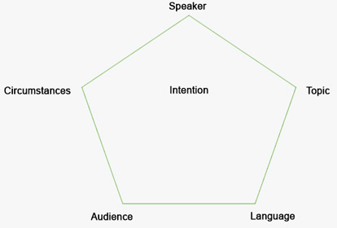

file:///C:/Users/mk/Desktop/Goal-13-infographic.pdf

Now it’s your own time:

1. Do some research and find some data/a fact, a story that can be transformed into an easy-to-understand infographic.
2. Fill in the rhetorical pentagon for your own infographic:



Make your own infographic 😊 ( on A3)

extra example of infographic: <https://www.climatecouncil.org.au/resources/how-polluting-is-australia-vs-uae/> )