”The New Colossus” by Emma Lazarus (1883)

- Draw the Statue of Liberty on a piece of paper and add the words that are used in the poem to describe the new Colossus (in pairs). Present to classmates.

- Questions to “The New Colossus” (in groups):

- What does she refer to in l. 1, when she says “the brazen giant of Greek fame” and what countries does she address in l. 9; “keep, ancient lands?
- What makes the new Colossus different from the old Colossus?
- Who does she welcome to America in ll. 10-13?
- What does the Statue of Liberty symbolize?

- Vocabulary exercise (in pairs)

- Poster/painting (in pairs)

- Describe the poster and the painting in detail
- Discuss what the poster/painting say about
a) the life of the frontier people/pioneers/settlers
b) the American Dream
c) the making of the United States?

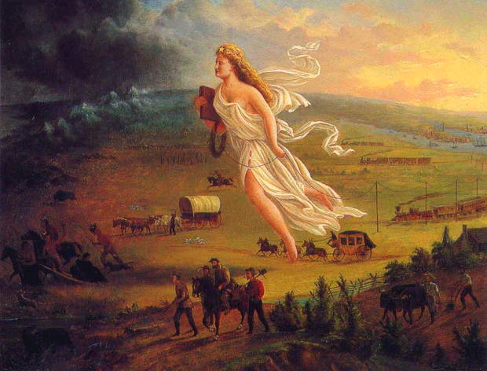
(John Cast: American Progress, 1872 – oil on canvas)

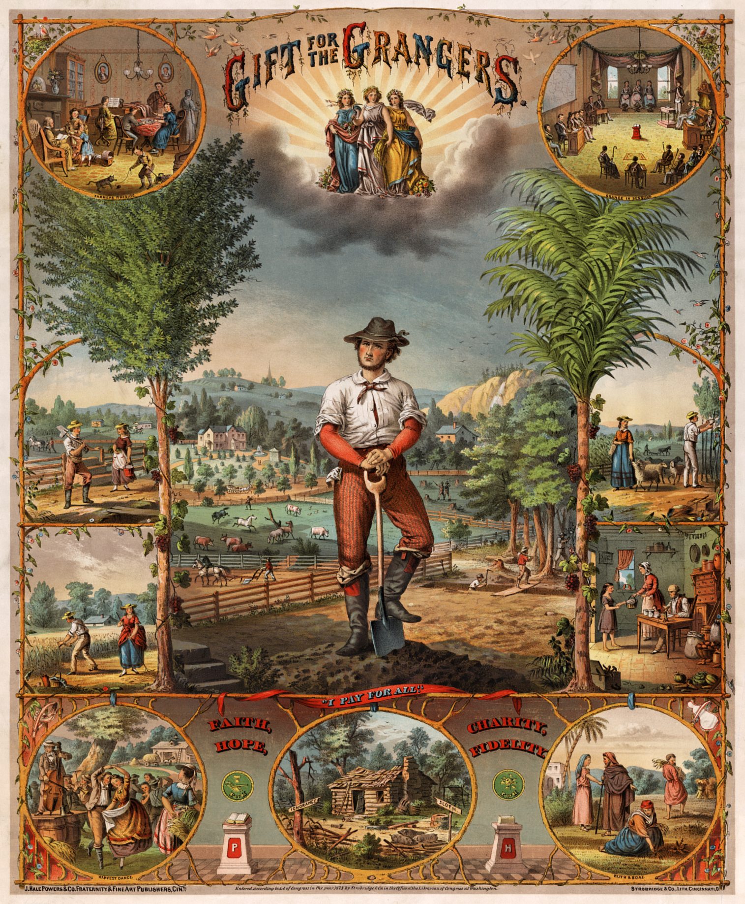
(Promotional poster, chrcmolithograph by Strobridge & Co., lithographers, Cincinnati, Ohio, 1873)

