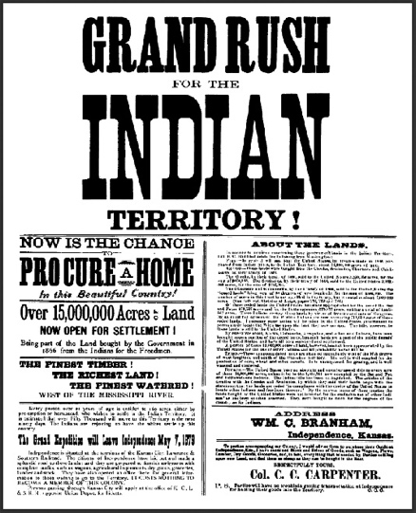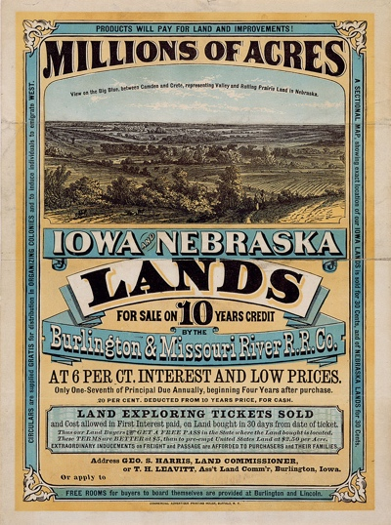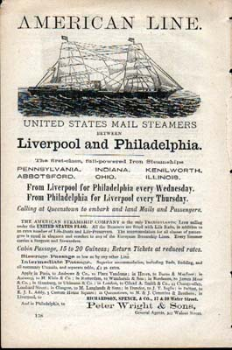

- Present your answers to your homework - "Far and Away"
- what is a land rush?
- how does it tie in with basic American values?
- what does it say about the idea of the American Frontier?

- Poster/painting

- describe the poster and the painting in detail
- discuss what the poster/painting say about
a) the life of the frontier people/pioneers/settlers
b) the American Dream
c) the making of the United States?

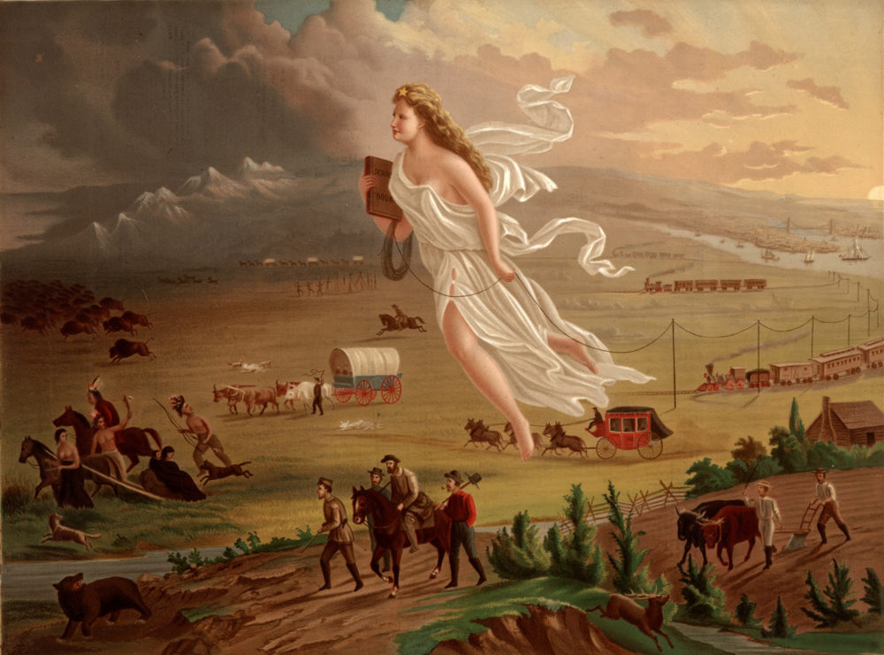
(John Cast: American Progress, 1872 – oil on canvas)

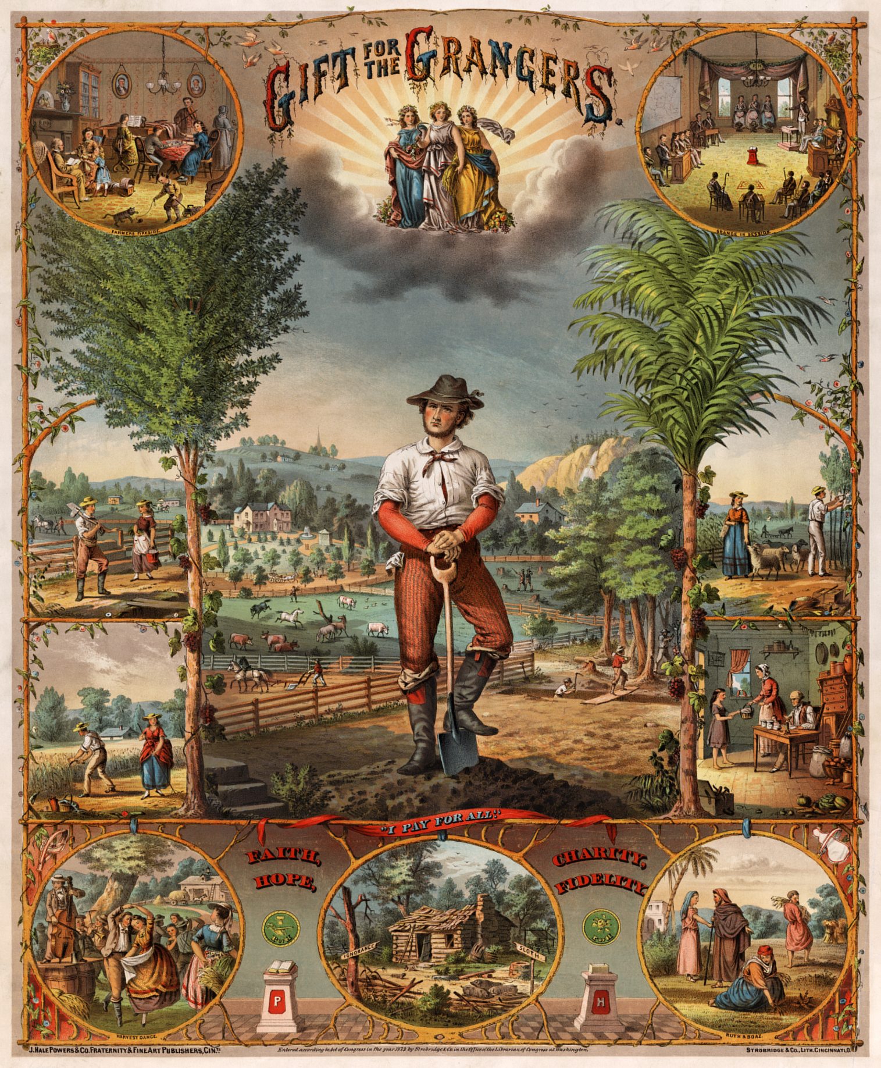
(Promotional poster, chrcmolithograph by Strobridge & Co., lithographers, Cincinnati, Ohio, 1873)

- Grammatik

