Worksheet - ’Hvad vil Donald Trump med Elon Musk’ + ’Er Trumps ’bondeknold’ et trumfkort?’
We have virtual lessons today. Follow the worksheet and make sure to send the completed worksheet by the end of the modules. Feel free to work in groups and mention who you're uploading for in the group. A completed worksheet counts as attendance
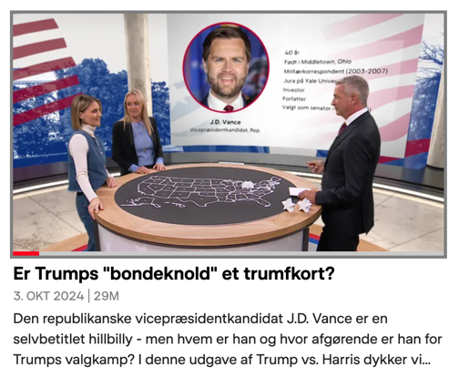
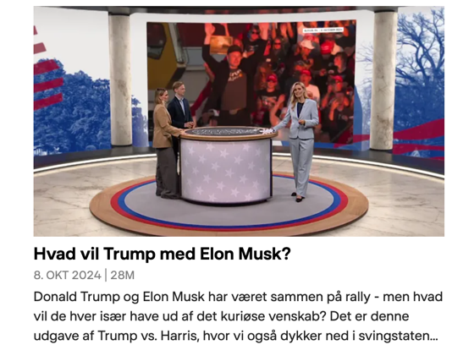

3 modul 10.45-11.55

- Watch the episode ’Er Trumps ”bondeknold” et trumfkort? Fra 3/10 2024 på DR: https://www.dr.dk/drtv/se/trump-vs-harris_-er-trumps-bondeknold-et-trumfkort_480569
- Answer the questions:
- What story are both JD Vance and Tim Waltz competing for?
- What is said about JD Vance – how is he portrayed – give examples.
- Why do you think Trump chose JD Vance as his vice-presidential candidate? Explain.
- Find examples of tweets from JD Vance where he is both against and for Trump, and briefly analyze the tweet (add as screen shots).
- What is said about Tim Waltz?
- Find examples of tweets from Tim Waltz about his vice-presidential candidacy, and briefly analyze the tweet (add as screen shot(s)).
- Why do you think Harris chose Waltz as her vice-presidential candidate? Explain.

4 modul: 12.25-13.35
- Watch the episode ”Hvad vil Trump med Elon Musk” fra 8/10 2024 på DR: https://www.dr.dk/drtv/se/trump-vs-harris_-hvad-vil-trump-med-elon-musk_481483
- Answer the questions
  - What does it mean to endorse someone?
  - Why has Elon Musk choosen to endorse Donald Trump – and what has his previous opinion been?
  - What is the ‘woke left mind’ virus?
  - Elon Musk is wearing a black MAGA hat. Look into what Elon Musk means by 'Dark Maga'.
  - Comment on the voters Trump might attract by using Elon Musk.
  - Which important Americans have endorsed Kamala Harris?
  - Write 200 words – who do you think will win – Team Harris/Swift or Trump/Musk?

I skal muligvis oprette et login til DR - bare med email og kodeord.

