US Election – What Has Happened so far?

**In pairs: Take turns describing the satirical drawings in detail, and answer the questions below each drawing:**

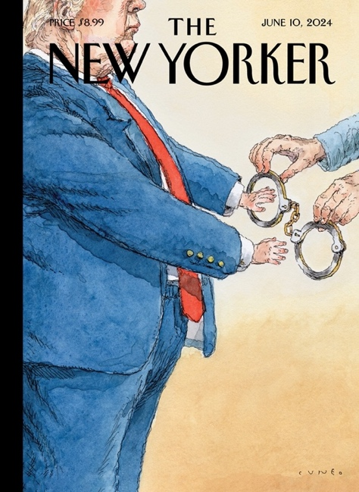 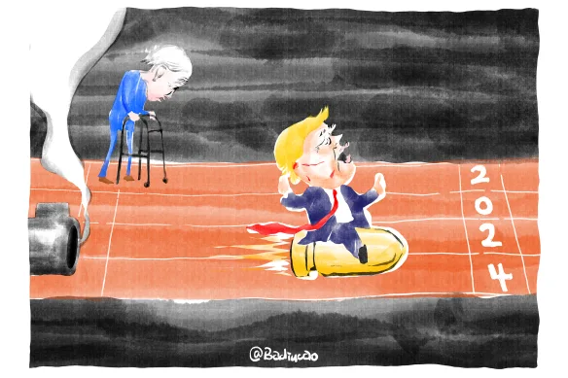

1 2

What event/situation does this drawing refer to? What event/situation does this drawing refer to?

(Why is Trump shown in hand-cuffs?) (What has happened to Trump’s ear?)   
How does the portrayal affect our impression of How are Biden and Trump portrayed? (look at body

him? (look at proportions and facial expression) - language, proportions and facial expression)

does it make him seem e.g. powerful, What does the drawing suggest about Trump taking the

vulnerable, ridiculous? lead in the election?

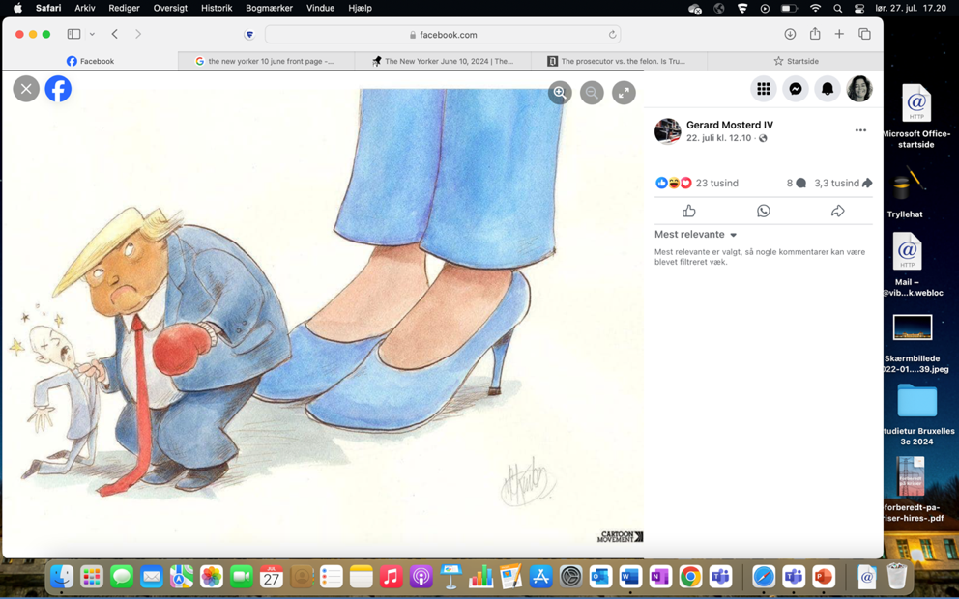

3 4

What event/situation does this drawing refer to? Who are the four people, and what is going on here?

(Who is the little man? Who wears the high heels?) What does the drawing suggest symbolically by depicting

How does the portrayal affect our impression of each them in a roller coaster?

of them and the power dynamics and balance between

them?