

Tasks:

1. Form groups of 3-4 students
2. Take turns asking each other about what you know about the American election and the candidates. Take notes.
3. Scroll down to the next page and work together to create a Facebook profile page for the candidate that you have been assigned. Use reliable online resources to find the information/photos you need.
4. Once the time is up, you will team up with people who worked with the other candidates and present your candidate profile to each other.

Meet the Candidates

Hometown:

Current location:  
  
Current position in the election:

**Name**

Insert Date Status update #2

Write a list of voter groups that are especially important to me

**Name**

Insert Date Status update #1

Insert a powerful quote from my latest political rally (vælgermøde)

**Name**

Insert Date Status update #3

Write a list of the most important topics in my election campaign



Insert photos of my life and the election campaign

Intro

Career achievements:

Wealth:

Party:

Family:

Favorite hobby:

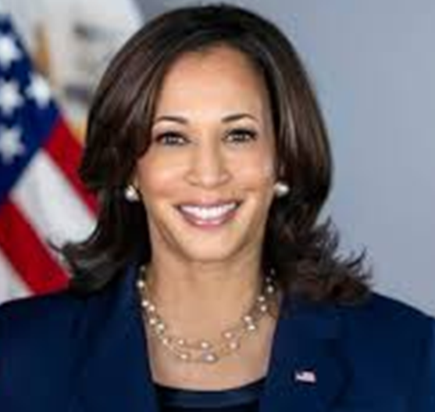

Name

**Name Home**

**Insert Name Here**

Timeline

About

Friends

#

Photos

**Name** Insert a quote of me roasting/criticising my opponent in the election

Insert Date

Status update #2

**Name**

Insert Date Status update #1

Insert a powerful quote from my latest political rally (vælgermøde)