Soap advertisements from the 1890’s

|  |  |  |  |  |  |  |  |
| --- | --- | --- | --- | --- | --- | --- | --- |
|  | **Advertisement 1** | **Advertisement 2** | **Advertisement 3** |  | **Advertisement 1** | **Advertisement 2** | **Advertisement 3** |
| **A** | Astrid | Nanna | Niels-Emil |  | Johannes | Alberte S | Laura R |
| **B** | Sofie D | Anne | Alberte M |  | Regitze | Anna | Naja |
| **C** | Emma | Florence + Marie | Freja |  | Sofie W | Julie | Søs |
| **D** | Silja | Laura F | Caroline A |  | Caroline R | Jakob | Harriet |

1. **Give a detailed description of the ad:**

* Explain the attitude to the British Empire shown in the ad.
* How are the coloniser and the colonised portrayed?

1. **Use the rhetorical pentagram**

* What is the intention of the ad?
* Who is the sender?
* Who is the target group/receiver?
* What is the topic/story of the ad?
* Circumstances: why was the ad made?
* Language: any stylistic devices used worth noticing? (e.g. metaphors, direct address, imperatives, puns, contrasts etc.)

1. **Forms of appeal**

* Does the advertisement appeal to logos, ethos or pathos? Use examples from the ad to underline you answer.

**1)**

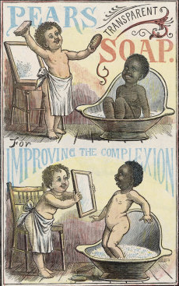

**2)**  
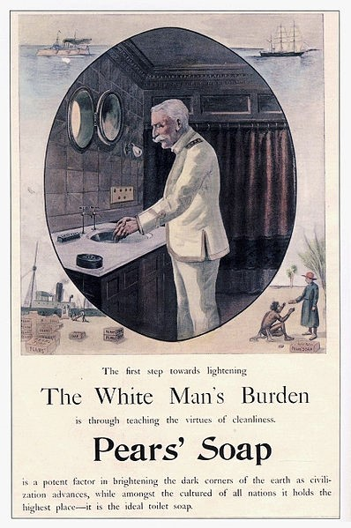

**3)**

