Assignment 1
Find alle verberne (udsagnsordene) i præsens (nutid) i nedenstående tekst, og omskriv dem til præteritum (datid). Skriv hele teksten som dit svar, og markér verberne tydeligt som i eksemplet.

Eksempel: Tom gropes amongst…
Tom groped amongst…
Tom gropes amongst the old shoe-boxes, fallen scarves, gloves, and belts, breathing in faded wafts of Sandra. Instead of the soft give of Sandra’s suede bag, his fingers find something hard. A smooth glass column. He draws it out carefully. The green of the bottle is so dark it’s almost black. It has the classic gold hood encasing the cork and neck. Moët & Chandon Grand Vintage 1988. The 1988 is inscribed in a dramatic flourish of white digits across the front of the label.
What a waste. Undrinkable now. Vintage, so a bit more longevity, but Champagne is generally short-lived. All tangy fizz and excitement at the beginning, but it’s not a keeper. He slumps onto his bottom on the bedroom floor and cradles the bottle in both hands. […]
He dives back in the wardrobe and finds the bag, agerashed and giving off a strange mix of Ysatis and mould. He takes the bottle and the bag downstairs. They sit together on the island as he scurries about unloading the dishwasher and tidying up. Not that there’s much to tidy up. Without Sandra and Freya everything stays in its place. He sprays the work surfaces and wonders if Sandra will be on time and whether she’ll stop for a bit. His eyes keep coming back to the Moët and the bloody clutch. He gets an ice-cooler from the freezer and shoves it over the bottle. Maybe it’s drinkable; he doesn’t like to waste.
Tom taps the details into his phone.

Melanie Whipman, “Tasting Notes”, 2018
Assignment 2
https://www.youtube.com/watch?v=xMA6Gz82iiQ (fra 00.16 til 01:52)
- Find og skriv fire forskellige typer pronominer (stedord). Angiv for hvert pronomen, hvilken type det er.
Pronomen | Type pronomen
1.
2.
3.
4.

- Find og skriv to forskellige typer nægtende sætninger. Forklar ud fra dine eksempler, hvordan man på engelsk danner nægtende sætninger.
1.
2.
Forklaring:

- Angiv ud fra sammenhængen i videoen, hvilken ordklasse følgende ord tilhører:
Ord | Ordklasse
modelling (0.44)
hope (1.00)
increase (1.10)
elderly (1.24)

Assignment 3
Nedenfor er angivet fire danske ord, som hver især er oversat til tre engelske ord efterfulgt af et billede.
Vælg for hvert billede det af de engelske ord, der passer bedst. Forklar kort, hvorfor det valgte ord passer bedst til billedet. Skriv dit svar på dansk.
Billede 1 – Deling
1. Deling: platoon/partition/fission
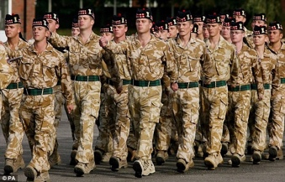
Ord:
Forklaring:

Billede 2 – Tegn
2. Tegn: omen/constellation/character

Ord:
Forklaring:

Billede 3 – Slutte
3. Slutte: infer/terminate/finish

Ord:
Forklaring:

Billede 4 – Samle
4. Samle: collect/gather/unite
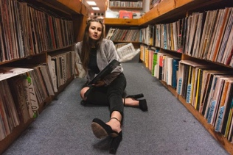
Ord:
Forklaring:

Assignment 4

Write a text to match the photo (50-75 words).
In your text, you must include and underline three different adjectives (tillægsord). One of them must be in the positive degree (1. grad), one must be in the comparative degree (2. grad) and one must be in the superlative degree (3. grad).

marked by old age
perfume

