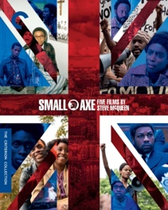

**Small Axe ”Education”(2020) + Laura Blake ”Home Is Not Here”(2021)**

1. Give examples from the film which show that it is difficult for the Caribbean society in Britain (in 1970s/80s) to pursue their own dreams of a better future in Britain.
2. How are Birdie’s experiences (from the short story “Home Is Not Here”) with Britain similar to those of the family in the film? Give specific examples.