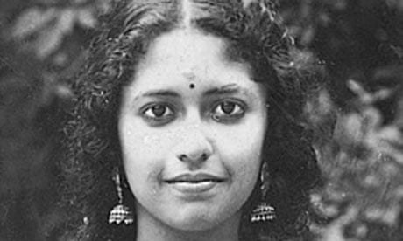 Et billede, der indeholder Ansigt, person, Modetilbehør, tøj

Indhold genereret af kunstig intelligens kan være forkert.

“I” by Kamala Das and “To the girl in English class” by Hafsat Abdullahi

1. One haft of the class will do an analysis of the poem “I”. The other half of the class will do an analysis of the poem “To the girl in English Class” <https://www.facebook.com/watch/?v=3402717709947882>:

* Is there a lyrical voice? Who does it belong to?
* What is the conflict in the poem? How does language affect identity?
* Look at the language (e.g. the use of metaphors, contrasts, direct address, imperatives, rhetorical questions + other poetical devices you find important) – how does the language contribute to the overall mood of the poem and to the theme(s)?
* How can the poem be related to terms such as ‘lingua franca’, (de)colonization, multiculturalism, feminism?

1. Presentations in pairs